Maintenance Change Request
for the update of ISO 20022 financial repository items
Note: the purpose of this document is to give guidelines to submitting organisations that will develop a new version of existing ISO 20022 messages based on change requests screened by the Standards Evaluation Group(s). Such development is subject to the approval of a Maintenance Change Request which must include a detailed description of the impact of each change on the related messages. The Maintenance Change Request must start with a general chapter covering topics related to the whole maintenance effort and a specific chapter for each change request, as described below. Please consult the iso20022.org website for additional details on the maintenance process. Valid Maintenance Change Requests for the following ISO 20022 yearly maintenance cycle must be sent to iso20022ra@iso20022.org by August 21st.

Name of the request:
“ISO 20022 Payments Maintenance 2018/2019”

Submitting organisation(s):
SWIFT, on behalf of SWIFT, TWIST and OAGi (ISTH) and the CBI consortium
Standards Department,
Avenue Adele, 1
1310 La Hulpe - Belgium

Related messages:

Under this project, below existing ISO 20022 message definitions will be maintained (resulting from the impact analysis performed on each CR).

- Bank to Customer Cash Management message set:
- camt.052.001.06 | BankToCustomerAccountReportV06
- camt.053.001.06 | BankToCustomerStatementV06
- camt.054.001.06 | BankToCustomerDebitCreditNotificationV06
- camt.060.001.03 | AccountReportingRequestV03

- Exceptions and Investigations message set:
- camt.026.001.05 | UnableToApplyV05
- camt.027.001.05 | ClaimNonReceiptV05
- camt.028.001.07 | AdditionalPaymentInformationV07
- camt.029.001.07 | ResolutionOfInvestigationV07
- camt.030.001.04 | NotificationOfCaseAssignmentV04
- camt.031.001.04 | RejectInvestigationV04
- camt.032.001.03 | CancelCaseAssignmentV03
- camt.033.001.04 | RequestForDuplicateV04
- camt.034.001.04 | DuplicateV04
- camt.035.001.03 | ProprietaryFormatInvestigationV03
- camt.036.001.03 | DebitAuthorisationResponseV03
- camt.037.001.05 | DebitAuthorisationRequestV05
- camt.038.001.03 | CaseStatusReportRequestV03
- camt.039.001.04 | CaseStatusReportV04
- camt.055.001.06 | CustomerPaymentCancellationRequestV06
- camt.056.001.05 | FIToFIPaymentCancellationRequestV05
- camt.087.001.04 | RequestToModifyPaymentV04

- Payment Clearing And Settlement message set:
- pacs.002.001.08 | FIToFIPaymentStatusReportV08
- pacs.004.001.07 | PaymentReturnV07
- pacs.007.001.07 | FIToFIPaymentReversalV07
- pacs.008.001.06 | FIToFICustomerCreditTransferV06
- pacs.009.001.06 | FinancialInstitutionCreditTransferV06
- pacs.010.001.06 | FinancialInstitutionCreditTransferV06
- pacs.028.001.01 | FIToFIPaymentStatusRequestV01

- Payment Initiation message set:
- pain.001.001.08 | CustomerCreditTransferInitiationV08
- pain.002.001.08 | CustomerPaymentStatusReportV08
- pain.007.001.07 | CustomerPaymentReversalV07
- pain.008.001.07 | CustomerPaymentReversalV07

- Customer Payment Activation Request message set:
- pain.013.001.06 | CreditorPaymentActivationRequestV06
- pain.014.001.06 | CreditorPaymentActivationRequestStatusReportV06
Note: SWIFT will implement the changes on behalf of the CBI consortium for this message set.

As agreed also during the evaluation of the Cash Management message set, below existing ISO 20022 candidate message definitions will be updated for alignment purpose (resulting from the impact analysis performed on each CR) before completion of the registration of the message set.

- Cash Management message set:
- camt.003.001.06 | GetAccountV06
- camt.004.001.07 | ReturnAccountV07
- camt.005.001.07 | GetTransactionV07
- camt.006.001.07 | ReturnTransactionV07
- camt.007.001.07 | ModifyTransactionV07
- camt.009.001.06 | GetLimitV06
- camt.010.001.07 | ReturnLimitV07
- camt.011.001.06 | ModifyLimitV06
- camt.012.001.06 | DeleteLimitV06
- camt.013.001.03 | GetMemberV03
- camt.014.001.03 | ReturnMemberV03
- camt.015.001.03 | ModifyMemberV03
- camt.016.001.03 | GetCurrencyExchangeRateV03
- camt.017.001.03 | ReturnCurrencyExchangeRateV03
- camt.018.001.04 | GetBusinessDayInformationV04
- camt.019.001.06 | ReturnBusinessDayInformationV06
- camt.020.001.03 | GetGeneralBusinessInformationV03
- camt.021.001.05 | ReturnGeneralBusinessInformationV05
- camt.023.001.06 | BackupPaymentV06
- camt.024.001.05 | ModifyStandingOrderV05
- camt.025.001.04 | ReceiptV04
- camt.046.001.04 | GetReservationV04
- camt.047.001.05 | ReturnReservationV05
- camt.048.001.04 | ModifyReservationV04
- camt.049.001.04 | DeleteReservationV04
- camt.050.001.04 | LiquidityCreditTransferV04
- camt.051.001.04 | LiquidityDebitTransferV04
- camt.069.001.02 | GetStandingOrderV02
- camt.070.001.03 | ReturnStandingOrderV03
- camt.071.001.02 | DeleteStandingOrderV02

Please note also that during assessment of the change requests, we identified a number of impacted messages not explicitly identified in the change requests for update, but those messages would require to be updated, and SWIFT is not the submitting organisation (not in charge of the maintenance) or SWIFT has decided not to implement the changes during this maintenance cycle in those messages

The below table provides the list of messages sets identified during the impact assessment:

Submitting Organisation | Message Set
- Payments UK (NPSO) | Account Switching
- SWIFT | Bank Account Management
- French SWIFT Users Group | Change or Verify Account Identification
- Federation of Finnish Financial Services | Authorities Financial Investigations
- Russian Corporate Market Practice Group | Cross-Border Transactions Currency Control Reporting
- SWIFT | Payments Mandates
- IFX & OAGi | Stand-Alone Remittance Advice

Commitments of the submitting organisation:

The submitting organisations confirm that they can and will:
- undertake the development of the new version of the candidate ISO 20022 message models that it will submit to the RA for compliance review and evaluation. New valid Message Definition models will be made available to the RA by December 1.
- provide a new version of part 1 of the related Message Definition Reports (MDR) by December 1, and new examples of valid message instances of each candidate message (only when valid samples were published for current version) by May 1 at the latest.
- address any queries related to the description of the new models and messages as published by the RA on the ISO 20022 website.

SWIFT intends to implement most of the above new versions on its SWIFTNet network once the related documentation has been published by the RA.

The submitting organisations confirm their knowledge and acceptance of the ISO 20022 Intellectual Property Rights policy for contributing organisations, as follows.
“Organisations that contribute information to be incorporated into the ISO 20022 Repository shall keep any Intellectual Property Rights (IPR) they have on this information. A contributing organisation warrants that it has sufficient rights on the contributed information to have it published in the ISO 20022 Repository through the ISO 20022 Registration Authority in accordance with the rules set in ISO 20022. To ascertain a widespread, public and uniform use of the ISO 20022 Repository information, the contributing organisation grants third parties a non-exclusive, royalty-free license to use the published information”.

Contact persons:
Vincent Kuntz – SWIFT Standards, vincent.kuntz@swift.com
Andrew Muir – SWIFT Standards, andrew.muir@swift.com

Change request CR00724: Add Name Prefix code

Origin of the request:
A.1 Submitter: Bank of England Real Time Gross Settlement (RTGS) Renewal Programme
A.2 Contact person(s): Helen Bygrave helen.bygrave@bankofengland.co.uk +44 (0)20 3217 8398
Neil Pearston, Analyst, neil.pearston@bankofengland.co.uk + 44 (0) 20 3461 4893
A.3 Sponsors: The New Payment System Operator (NPSO) United Kingdom
James Whittle, Director, International Standards and Services James.Whittle@newpso.uk

Related messages:
pacs.002.001.09 - FIToFIPaymentStatusReportV09
pacs.003.001.07 - FIToFICustomerDirectDebitV07
pacs.004.001.08 - PaymentReturnV08
pacs.007.001.08 - FIToFIPaymentReversalV08
pacs.008.001.07 - FIToFICustomerCreditTransferV07
pacs.009.001.07 - FinancialInstitutionCreditTransferV07
pacs.028.001.02 - FIToFIPaymentStatusRequestV02

pain.001.001.08 - CustomerCreditTransferInitiationV08
pain.002.001.09 - CustomerPaymentStatusReportV09
pain.007.001.08 - CustomerPaymentReversalV08
pain.008.001.07 - CustomerDirectDebitInitiationV07

camt.052.001.07 - BankToCustomerAccountReportV07
camt.053.001.07 - BankToCustomerStatementV07
camt.054.001.07 - BankToCustomerDebitCreditNotificationV07
camt.056.001.07 - FIToFIPaymentCancellationRequestV07
camt.060.001.04 - AccountReportingRequestV04

Description of the change request:
This change request proposes to add a gender neutral name prefix to the code list NamePrefix1Code.
Code | Name | Definition
MIKS | MIKS | Title of the person that is MIKS or Mx.

Purpose of the change:
To provide a title for people who don’t identify as a particular gender, or who don’t want to be identified or referred to by gender.
A gender neutral title is an honorific title that does not indicate the gender of the person being formally addressed, such as in a letter or other communication, or when introducing the person to others. By comparison, the traditional honorifics of Miss, Mrs, Ms and Mr all indicate the binary gender of the individual.
Mx was developed as an alternative to common gendered honorifics in the early 1980’s with the ‘x’ signifying a wildcard character. Mx is now included in all major English dictionaries and was adopted as a title by Hong Kong and Shanghai Banking Corporation (HSBC) in 2017.

Urgency of the request:
It is proposed to include this change request in the next regular maintenance cycle.

Business examples:
Example illustrating the change request.

<CtctDtls>
<NmPrfx>MIKS</NmPrfx>
<Nm>Jerri Smith</Nm>
<PhneNb>01224123456</PhneNb>
<MobNb>07960123456</MobNb>
</FaxNb>
</EmailAdr>
</Othr>
</CtctDtls>

SEG/TSG recommendation:
This section is not to be taken care of by the submitter of the change request. It will be completed in due time by the SEG(s) in charge of the related ISO 20022 messages or the TSG for changes related to the BAH.

Consider |  | X | Timing
 |  |  | - Next yearly cycle: 2018/2019  (the change will be considered for implementation in the yearly maintenance cycle which starts in 2018 and completes with the publication of new message versions in the spring of 2019) |  | X
- At the occasion of the next maintenance of the messages
(the change will be considered for implementation, but does not justify maintenance of the messages in its own right – will be pending until more critical change requests are received for the messages)
- Urgent unscheduled
(the change justifies an urgent implementation outside of the normal yearly cycle)
 |  |  | - Other timing:
Comments:

Reject
Reason for rejection:

Impact analysis and type of impact:
Following the detailed analysis of the impact of the changes to the existing messages, we identified further impacted messages, as already proposed by the change request submitter. The below list provides the full list of impacted messages per message set:

Messages for which the change was requested in the change request:
- Bank-to-Customer Cash Management message set
  - BankToCustomerAccountReportV07 (camt.052.001.07)
  - BankToCustomerStatementV07 (camt.053.001.07)
  - BankToCustomerDebitCreditNotificationV07 (camt.054.001.07)
  - AccountReportingRequestV04 (camt.060.001.04)
- Exceptions and Investigations message set
  - FIToFIPaymentCancellationRequestV07 (camt.056.001.07)
- Payments Clearing and Settlement message set
  - FIToFIPaymentStatusReportV09 (pacs.002.001.09)
  - FIToFICustomerDirectDebitV07 (pacs.003.001.07)
  - PaymentReturnV08 (pacs.004.001.08)
  - FIToFIPaymentReversalV08 (pacs.007.001.08)
  - FIToFICustomerCreditTransferV07 (pacs.008.001.07)
  - FinancialInstitutionCreditTransferV07 (pacs.009.001.07)
  - FIToFIPaymentStatusRequestV02 (pacs.028.001.02)
Additional messages impacted, for which the change has not been explicitly requested. If we want to keep a consistent component throughout all payments messages, the change request would also have to be implemented.
- Bank Account Management message set
  - AccountOpeningRequestV02 (acmt.007.001.02)
  - AccountOpeningAmendmentRequestV02 (acmt.008.001.02)
  - AccountOpeningAdditionalInformationRequestV02 (acmt.009.001.02)
  - AccountRequestAcknowledgementV02 (acmt.010.001.02)
  - AccountRequestRejectionV02 (acmt.011.001.02)
  - AccountAdditionalInformationRequestV02 (acmt.012.001.02)
  - AccountReportRequestV02 (acmt.013.001.02)
  - AccountReportV02 (acmt.014.001.02)
  - AccountExcludedMandateMaintenanceRequestV02 (acmt.015.001.02)
  - AccountExcludedMandateMaintenanceAmendmentRequestV02 (acmt.016.001.02)
  - AccountMandateMaintenanceRequestV02 (acmt.017.001.02)
  - AccountMandateMaintenanceAmendmentRequestV02 (acmt.018.001.02)
  - AccountClosingRequestV02 (acmt.019.001.02)
  - AccountClosingAmendmentRequestV02 (acmt.020.001.02)
  - AccountClosingAdditionalInformationRequestV02 (acmt.021.001.02)
- Change or Verify Account Identification message set
  - IdentificationModificationAdviceV02 (acmt.022.001.02)
  - IdentificationVerificationRequestV02 (acmt.023.001.02)
  - IdentificationVerificationReportV02 (acmt.024.001.02)
- Account Switching message set
  - AccountSwitchInformationRequestV01 (acmt.027.001.01)
  - AccountSwitchInformationResponseV01 (acmt.028.001.01)
  - AccountSwitchCancelExistingPaymentV01 (acmt.029.001.01)
  - AccountSwitchRequestRedirectionV01 (acmt.030.001.01)
  - AccountSwitchRequestBalanceTransferV01 (acmt.031.001.01)
  - AccountSwitchBalanceTransferAcknowledgementV01 (acmt.032.001.01)
  - AccountSwitchRequestPaymentV01 (acmt.034.001.01)
- Authorities Financial Investigations message set
  - InformationRequestOpeningV01 (auth.001.001.01)
  - InformationRequestResponseV01 (auth.002.001.01)
- Cross-Border Transactions Currency Control Reporting message set
  - ContractRegistrationRequestV01 (auth.018.001.01)
  - ContractRegistrationConfirmationV01 (auth.019.001.01)
  - ContractRegistrationClosureRequestV01 (auth.020.001.01)
  - ContractRegistrationAmendmentRequestV01 (auth.021.001.01)
  - ContractRegistrationStatementV01 (auth.022.001.01)
  - ContractRegistrationStatementRequestV01 (auth.023.001.01)
  - PaymentRegulatoryInformationNotificationV01 (auth.024.001.01)
  - CurrencyControlSupportingDocumentDeliveryV01 (auth.025.001.01)
  - CurrencyControlRequestOrLetterV01 (auth.026.001.01)
  - CurrencyControlStatusAdviceV01 (auth.027.001.01)
- Cash Management message set (candidate messages)
  - GetAccountV06 (camt.003.001.06)
  - ReturnAccountV07 (camt.004.001.07)
  - GetTransactionV07 (camt.005.001.07)
  - ReturnTransactionV07 (camt.006.001.07)
- Exceptions and Investigations message set
  - UnableToApplyV06 (camt.026.001.06)
  - ClaimNonReceiptV06 (camt.027.001.06)
  - AdditionalPaymentInformationV08 (camt.028.001.08)
  - ResolutionOfInvestigationV08 (camt.029.001.08)
  - NotificationOfCaseAssignmentV04 (camt.030.001.04)
  - RejectInvestigationV05 (camt.031.001.05)
  - CancelCaseAssignmentV03 (camt.032.001.03)
  - RequestForDuplicateV05 (camt.033.001.05)
  - DuplicateV05 (camt.034.001.05)
  - ProprietaryFormatInvestigationV04 (camt.035.001.04)
  - DebitAuthorisationResponseV04 (camt.036.001.04)
  - DebitAuthorisationRequestV06 (camt.037.001.06)
  - CaseStatusReportRequestV03 (camt.038.001.03)
  - CaseStatusReportV04 (camt.039.001.04)
  - CustomerPaymentCancellationRequestV07 (camt.055.001.07)
  - RequestToModifyPaymentV05 (camt.087.001.05)
- Notification to Receive message set
  - NotificationToReceiveV05 (camt.057.001.05)
  - NotificationToReceiveCancellationAdviceV05 (camt.058.001.05)
  - NotificationToReceiveStatusReportV05 (camt.059.001.05)
- Business Application Header message set
  - BusinessApplicationHeaderV01 (head.001.001.01)
- Payment Initiation message set
  - CustomerCreditTransferInitiationV08 (pain.001.001.08)
  - CustomerPaymentStatusReportV09 (pain.002.001.09)
  - CustomerPaymentReversalV08 (pain.007.001.08)
  - CustomerDirectDebitInitiationV07 (pain.008.001.07)
- Payments Mandates message set
  - MandateInitiationRequestV05 (pain.009.001.05)
  - MandateAmendmentRequestV05 (pain.010.001.05)
  - MandateCancellationRequestV05 (pain.011.001.05)
  - MandateAcceptanceReportV05 (pain.012.001.05)
  - MandateCopyRequestV01 (pain.017.001.01)
  - MandateSuspensionRequestV01 (pain.018.001.01)
- Creditor Payment Activation Request message set
  - CreditorPaymentActivationRequestV06 (pain.013.001.06)
  - CreditorPaymentActivationRequestStatusReportV06 (pain.014.001.06)
- Stand-Alone Remittance Advice message set
  - RemittanceAdviceV03 (remt.001.001.03)
  - RemittanceLocationAdviceV01 (remt.002.001.01)
The severity of the impact of the proposed change for the message users should be indicated in the table below (either “no impact”, “conditional’ or “mandatory”).
Type of impact
 | No impact | The change(s) will not impact the schema (the version number will not change) and will not impact the business applications of any users, e.g. the clarification of a definition
X | Conditional | The change(s) will impact the schema (at least the version number) and the business applications of certain users but not all, e.g. the addition of an optional component
 | Mandatory | The change(s) will impact the schema and the business applications of all users, e.g. addition of a mandatory component.

Proposed implementation:
We support the proposed implementation, with the addition of following code in the name prefix element:

Code | Name | Definition
MIKS | GenderNeutral | Title of the person that is gender neutral (that is Mx).

Given that the contact details element will be updated through this change, we propose following additional considerations. In recent developments (such as cards messages), the contact details have been extended with new elements, which could be considered for integration in the new version of the component as well. Therefore we propose to add those missing elements in the new ContactDetails component. In the new proposal, we have taken into account the additional elements present in the ContactDetails3 message component (used in the Bank Services Billing message set) to support these additional requirements.
As a result, we propose to implement the new Contact4 component through following implementation:
- Current ContactDetails2 definition:
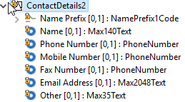

- Newly proposed Contact4 component definition:
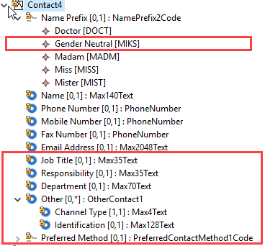
All changes have been highlighted in the new structure.
Question to the SEG: Should the NamePrefix element be converted into a choice component between code element typed by the current list of codes and a proprietary element ?
We propose to implement this change in all elements typed by the PartyIdentification43 or PartyIdentification125 in the messages listed above.
In most cases, the update of ContactDetails2 will result in the update of party message components PartyIdentification43 or PartyIdentification125, which are used consistently through all Payments messages (those components are impacted by multiple change requests in this maintenance cyle, if approved).
In attachment, you will find an exhaustive list of the Xpath for all NamePrefix elements which should be updated in the messages.

Proposed timing:
The submitting organisation confirms that it can implement the requested changes in the requested timing, with following considerations:
- For the messages listed in the “Related messages” section, that is, which have been requested by the submitter of this change request or any other change request in this maintenance change request document (except for CR00751), we propose to implement the change in all messages which are part of the impacted message set during this maintenance cycle.
- For all other messages in the message sets only identified through the impact analysis, we propose to implement the change only at the occasion of the next maintenance of the messages, that is, the change will be approved by the SEG for implementation, but does not justify maintenance of the messages in its own right. It will be pending implementation until more critical change requests are received for the messages.
List of message sets in which the change will be implemented during this cycle:
- Bank-to-Customer Cash Management message set
- Payments Clearing and Settlement message set
- Payments Initiation message set
- Creditor Payment Activation Request message set
- Cash Management message set
- Exceptions and Investigations message set
- Notification to Receive message set
- Business Application Header (under the responsibility of the TSG)
List of message sets in which the change will NOT be implemented during this cycle:
- Account Switching message set
- Bank Account Management message set
- Change or Verify Account Identification message set
- Authorities Financial Investigations message set
- Cross-Border Transactions Currency Control Reporting message set
- Payments Mandates message set
- Stand-Alone Remittance Advice message set

Timing | - As requested (taking into account the above considerations)

Final decision of the SEG(s):
This section is not to be taken care of by the submitting organisation. It will be completed in due time by the SEG(s) in charge of the related ISO 20022 messages.
Approve
Comments:

Reject
Reason for rejection:

Change request CR00725: Add purpose in interbank message
This chapter must be completed for every change request that the submitting organisation has been requested to implement.

Origin of the request:
A.1 Submitter: Bank of England Real Time Gross Settlement (RTGS) Renewal Programme
A.2 Contact person(s): Helen Bygrave helen.bygrave@bankofengland.co.uk +44 (0)20 3217 8398
Neil Pearston, Analyst, neil.pearston@bankofengland.co.uk + 44 (0) 20 3461 4893
A.3 Sponsors: The New Payment System Operator (NPSO) United Kingdom
James Whittle, Director, International Standards and Services James.Whittle@newpso.uk

Related messages:
- pacs.009.001.07 - FinancialInstitutionCreditTransferV07

Description of the change request:
This change request seeks to add optional message element Purpose of existing registered data type Purpose2Choice to the FinancialInstitutionCreditTransfer message.
This requires the creation of a new version of message component CreditTransferTransaction31 containing element Purpose as shown below.
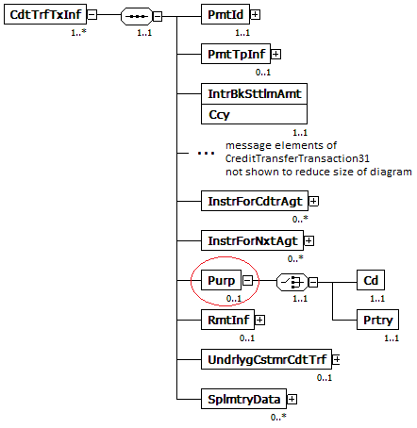

Purpose of the change:
Being able to clearly identify the underlying reason for a payment transaction is crucial in understanding the underlying economic activity a payment represents. There are a number of uses for this information including the identification of time sensitive, critical or systemic payments as well as mitigating the risk of fraud.
Through industry engagement, it was identified that there is a demand for more granularity in the purpose of payments between financial institutions. The ExternalCategoryPurpose1Code list that currently exists in the FinancialInstitutionCreditTransfer (pacs.009) message was not deemed suitable for this, being at too high a level, limiting its usefulness for deeper analysis.
The more detailed ExternalPurpose1Code list however, currently not available in the pacs.009, includes many codes which only correspond to payments between financial institutions and we believe therefore should be included in the pacs.009 message. Examples of such codes are CCPC - Cleared Initial Margin, CCPM - CCP Cleared Variation Margin, RPSB - Bi-lateral repo broker owned segregated cash collateral, RVPO - Reverse Repurchase Agreement and SBSC - Securities Buy Sell Sell Buy Back,
Including the ExternalPurpose1Code list in the pacs.009 message would allow financial institutions to identify critical payments and facilitate enhanced end-to-end risk management thereby improving financial stability. Further to this, we recognise the value of wider public use of this data. The Office for National Statistics (the body responsible for UK national statistics) recognised that their analysis could benefit from greater granularity on the purpose of these large and important payments and this may be the same for other countries.

Urgency of the request:
It is proposed to include this change request in the next regular maintenance cycle.

Business examples:
In the event of an operational outage where there is a delay to payment processing it would be beneficial to identify time critical payments such as margin calls. These payments could then be prioritised with the goal of reducing the effect of the outage. This prioritisation could be facilitated with the use if the ExternalPurpose1Code list which records the underlying reason for the payment.

SEG/TSG recommendation:
This section is not to be taken care of by the submitter of the change request. It will be completed in due time by the SEG(s) in charge of the related ISO 20022 messages or the TSG for changes related to the BAH.

Consider |  | X | Timing
 |  |  | - Next yearly cycle: 2018/2019  (the change will be considered for implementation in the yearly maintenance cycle which starts in 2018 and completes with the publication of new message versions in the spring of 2019) |  | X
- At the occasion of the next maintenance of the messages
(the change will be considered for implementation, but does not justify maintenance of the messages in its own right – will be pending until more critical change requests are received for the messages)
- Urgent unscheduled
(the change justifies an urgent implementation outside of the normal yearly cycle)
 |  |  | - Other timing:
Comments:

Reject
Reason for rejection:

Impact analysis and type of impact:
Following the detailed analysis of the impact of the changes to the existing messages, we identified further impacted messages, as already proposed by the change request submitter. The below list provides the full list of impacted messages per message set:

Messages for which the change was requested in the change request:
- Payments Clearing and Settlement message set
  - FinancialInstitutionCreditTransferV07 (pacs.009.001.07)
Additional messages impacted, for which the change has not been explicitly requested. If we want to keep a consistent component throughout all payments messages, the change request would also have to be implemented.

- Payments Clearing and Settlement message set
  - FinancialInstitutionDirectDebitV02 (pacs.010.001.02)

During the initial evaluation of the change request, the Payments SEG has requested to add the Purpose in the B2C Cash Management messages if not already present. During the impact analysis, we confirmed that Purpose element is already present, so there is no need to add it to those messages (camt.052, camt.053 and camt.054).
The severity of the impact of the proposed change for the message users should be indicated in the table below (either “no impact”, “conditional’ or “mandatory”).

Type of impact
 | No impact | The change(s) will not impact the schema (the version number will not change) and will not impact the business applications of any users, e.g. the clarification of a definition
X | Conditional | The change(s) will impact the schema (at least the version number) and the business applications of certain users but not all, e.g. the addition of an optional component
 | Mandatory | The change(s) will impact the schema and the business applications of all users, e.g. addition of a mandatory component.

Proposed implementation:
We support the proposed implementation, resulting in the following structure:

- Newly proposed CreditTransferTransaction36 component definition to be defined in the Financial Institution Credit Transfer (pacs.009) message:
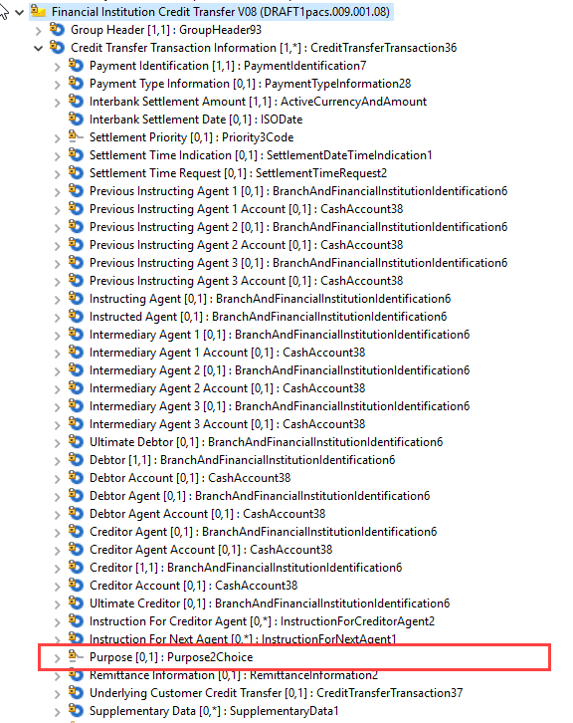
- Newly proposed DirectDebitTransactionInformation25 component definition to be defined in the Financial Institution Direct Debit (pacs.010) message:
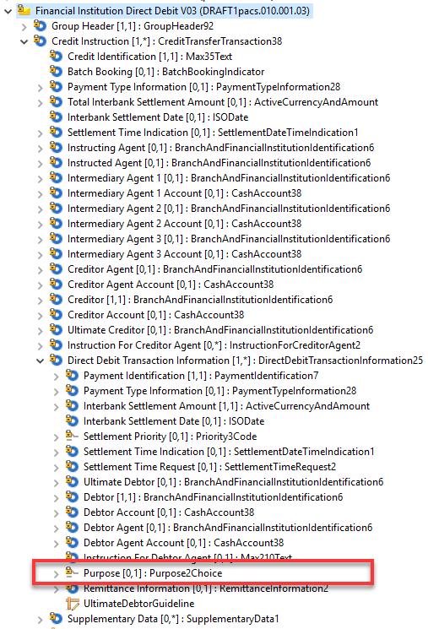

Proposed timing:
The submitting organisation confirms that it can implement the requested changes in the requested timing.

Timing | As requested

Final decision of the SEG(s):
This section is not to be taken care of by the submitting organisation. It will be completed in due time by the SEG(s) in charge of the related ISO 20022 messages.
Approve
Comments:

Reject
Reason for rejection:

Change request CR00726: Update Postal Address data type
This chapter must be completed for every change request that the submitting organisation has been requested to implement.
Change Request
for the update of ISO 20022 financial repository items

Origin of the request:
A.1 Submitter: Bank of England Real Time Gross Settlement (RTGS) Renewal Programme
A.2 Contact person(s): Helen Bygrave helen.bygrave@bankofengland.co.uk +44 (0)20 3217 8398
Neil Pearston, Analyst, neil.pearston@bankofengland.co.uk + 44 (0) 20 3461 4893
A.3 Sponsors: The New Payment System Operator (NPSO) United Kingdom
James Whittle, Director, International Standards and Services James.Whittle@newpso.uk

Related messages:
- pacs.002.001.09 - FIToFIPaymentStatusReportV09
- pacs.003.001.07 - FIToFICustomerDirectDebitV07
- pacs.004.001.08 - PaymentReturnV08
- pacs.007.001.08 - FIToFIPaymentReversalV08
- pacs.008.001.07 - FIToFICustomerCreditTransferV07
- pacs.009.001.07 - FinancialInstitutionCreditTransferV07
- pacs.010.001.02 - FinancialInstitutionDirectDebitV02
- pacs.028.001.02 - FIToFIPaymentStatusRequestV02

- pain.001.001.08 - CustomerCreditTransferInitiationV08
- pain.002.001.09 - CustomerPaymentStatusReportV09
- pain.007.001.08 - CustomerPaymentReversalV08
- pain.008.001.07 - CustomerDirectDebitInitiationV07

- camt.052.001.07 - BankToCustomerAccountReportV07
- camt.053.001.07 - BankToCustomerStatementV07
- camt.054.001.07 - BankToCustomerDebitCreditNotificationV07
- camt.056.001.07 - FIToFIPaymentCancellationRequestV07
- camt.060.001.04 - AccountReportingRequestV04

Submitter has requested an amendment of the change request on 22 August 2018 to add following messages in the scope of the change request:
- pain.013.001.06 - CreditorPaymentActivationRequestV06
- pain.014.001.06 - CreditorPaymentActivationRequestStatusReportV06

Description of the change request:
Replace message component PostalAddress6 with ISO 20022 registered message component PostalAddress11.
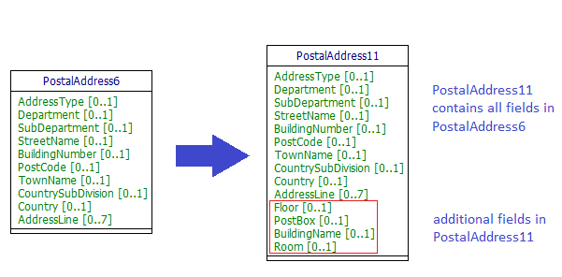

PostalAddress11 includes the additional optional elements as follows:
- Floor - Floor or storey within a building.
- PostBox - Numbered box in a post office, assigned to a person or organisation, where letters are kept until called for.
- BuildingName - Name of the building or house.
- Room - Building room number.

Purpose of the change:
The RTGS Renewal programme wishes to follow the internationally accepted HVPS+ Guidelines which recommend the use of structured address.
The United Kingdom (UK) has many addresses where there is no street number but only a building name. At present there is no way to carry this essential part of an address in a structured way.
To facilitate the use of structured address we seek to add building name to the address component. This will allow the UK to use structured address and will not only benefit the UK but also the international community who will as a result receive more structured address information from the UK.
We have not sought to include building name in an existing address field, such as street name or building number, as these fields were not intended for this purpose and such a change may lead to confusion as well as diluting the benefits of the structured address component.
We have requested a change from PostalAddress6 to the already registered component PostalAddress11 to eliminate the need to create a new component in the ISO 20022 Data Dictionary just for the UK. The additional elements provided by PostalAddress11 are all optional and should not therefore affect existing processes.

Urgency of the request:
It is proposed to include this change request in the next regular maintenance cycle.

Business examples:
Examples of the proposed use of structured address fields where the address does not have a building number.

Example 1: Customer address with no building number
<Ultimate Debtor>
<Name>Mr John Smith</Name>
<Postal Address>
Street Name="Tupwood Lane"
Post Code="WI1 1IW"
Town Name="Winchester"
Country="GB"
Building Name="The Willows"
</Postal Address>
...
</Ultimate Debtor>

Example 2: Financial institution address with no street number

<Intermediary Agent 1>
…
<Name>The Governor and Company</Name>
<Postal Address>
StreetName="Threadneedle Street"
PostCode="EC2R 8AH"
TownName="London"
Country="GB"
BuildingName="Bank of England"/>
</Postal Address>
…
</Intermediary Agent 1>

Example 3: Customer address with no street name or building number

<Ultimate Creditor>
<Name>Mr John Smith</Name>
<Postal Address>
Post Code="XX1 1XX "
Town Name="Lingfield"
Country="GB"
Building Name="The Old Rectory"
</Postal Address>
...
</Ultimate Creditor>

SEG/TSG recommendation:
This section is not to be taken care of by the submitter of the change request. It will be completed in due time by the SEG(s) in charge of the related ISO 20022 messages or the TSG for changes related to the BAH.

Consider |  | X | Timing
 |  |  | - Next yearly cycle: 2018/2019  (the change will be considered for implementation in the yearly maintenance cycle which starts in 2018 and completes with the publication of new message versions in the spring of 2019) |  | X
- At the occasion of the next maintenance of the messages
(the change will be considered for implementation, but does not justify maintenance of the messages in its own right – will be pending until more critical change requests are received for the messages)
- Urgent unscheduled
(the change justifies an urgent implementation outside of the normal yearly cycle)
 |  |  | - Other timing:
Comments:

Reject
Reason for rejection:

Impact analysis and type of impact:
Following the detailed analysis of the impact of the changes to the existing messages, we identified further impacted messages, as already proposed by the change request submitter. The below list provides the full list of impacted messages per message set:

Messages for which the change was requested in the change request:
- B2C Cash Management message set
  - BankToCustomerAccountReportV07 (camt.052.001.07)
  - BankToCustomerStatementV07 (camt.053.001.07)
  - BankToCustomerDebitCreditNotificationV07 (camt.054.001.07)
  - AccountReportingRequestV04 (camt.060.001.04)
- Exceptions and Investigations message set
  - FIToFIPaymentCancellationRequestV07 (camt.056.001.07)
- Payments Clearing and Settlement message set
  - FIToFIPaymentStatusReportV09 (pacs.002.001.09)
  - FIToFICustomerDirectDebitV07 (pacs.003.001.07)
  - PaymentReturnV08 (pacs.004.001.08)
  - FIToFIPaymentReversalV08 (pacs.007.001.08)
  - FIToFICustomerCreditTransferV07 (pacs.008.001.07)
  - FinancialInstitutionCreditTransferV07 (pacs.009.001.07)
  - FinancialInstitutionDirectDebitV02 (pacs.010.001.02)
  - FIToFIPaymentStatusRequestV02 (pacs.028.001.02)
- Payments Initiation message set
  - CustomerCreditTransferInitiationV08 (pain.001.001.08)
  - CustomerPaymentStatusReportV09 (pain.002.001.09)
  - CustomerPaymentReversalV08 (pain.007.001.08)
  - CustomerDirectDebitInitiationV07 (pain.008.001.07)
Additional messages impacted, for which the change has not been explicitly requested. If we want to keep a consistent component throughout all payments messages, the change request would also have to be implemented.
- Bank Account Management message set
  - AccountOpeningRequestV02 (acmt.007.001.02)
  - AccountOpeningAmendmentRequestV02 (acmt.008.001.02)
  - AccountOpeningAdditionalInformationRequestV02 (acmt.009.001.02)
  - AccountRequestAcknowledgementV02 (acmt.010.001.02)
  - AccountRequestRejectionV02 (acmt.011.001.02)
  - AccountAdditionalInformationRequestV02 (acmt.012.001.02)
  - AccountReportRequestV02 (acmt.013.001.02)
  - AccountReportV02 (acmt.014.001.02)
  - AccountExcludedMandateMaintenanceRequestV02 (acmt.015.001.02)
  - AccountExcludedMandateMaintenanceAmendmentRequestV02 (acmt.016.001.02)
  - AccountMandateMaintenanceRequestV02 (acmt.017.001.02)
  - AccountMandateMaintenanceAmendmentRequestV02 (acmt.018.001.02)
  - AccountClosingRequestV02 (acmt.019.001.02)
  - AccountClosingAmendmentRequestV02 (acmt.020.001.02)
  - AccountClosingAdditionalInformationRequestV02 (acmt.021.001.02)
- Change or Verify Account Identification message set
  - IdentificationModificationAdviceV02 (acmt.022.001.02)
  - IdentificationVerificationRequestV02 (acmt.023.001.02)
  - IdentificationVerificationReportV02 (acmt.024.001.02)
- Account Switching message set
  - AccountSwitchInformationRequestV01 (acmt.027.001.01)
  - AccountSwitchInformationResponseV01 (acmt.028.001.01)
  - AccountSwitchCancelExistingPaymentV01 (acmt.029.001.01)
  - AccountSwitchRequestRedirectionV01 (acmt.030.001.01)
  - AccountSwitchRequestBalanceTransferV01 (acmt.031.001.01)
  - AccountSwitchBalanceTransferAcknowledgementV01 (acmt.032.001.01)
  - AccountSwitchRequestPaymentV01 (acmt.034.001.01)
- Authorities Financial Investigations message set
  - InformationRequestOpeningV01 (auth.001.001.01)
  - InformationRequestResponseV01 (auth.002.001.01)
- Cross-Border Transactions Currency Control Reporting message set
  - ContractRegistrationRequestV01 (auth.018.001.01)
  - ContractRegistrationConfirmationV01 (auth.019.001.01)
  - ContractRegistrationClosureRequestV01 (auth.020.001.01)
  - ContractRegistrationAmendmentRequestV01 (auth.021.001.01)
  - ContractRegistrationStatementV01 (auth.022.001.01)
  - ContractRegistrationStatementRequestV01 (auth.023.001.01)
  - PaymentRegulatoryInformationNotificationV01 (auth.024.001.01)
  - CurrencyControlSupportingDocumentDeliveryV01 (auth.025.001.01)
  - CurrencyControlRequestOrLetterV01 (auth.026.001.01)
  - CurrencyControlStatusAdviceV01 (auth.027.001.01)
- Cash Management message set (candidate messages)
  - GetAccountV06 (camt.003.001.06)
  - ReturnAccountV07 (camt.004.001.07)
  - GetTransactionV07 (camt.005.001.07)
  - ReturnTransactionV07 (camt.006.001.07)
  - ModifyTransactionV07 (camt.007.001.07)
  - GetLimitV06 (camt.009.001.06)
  - ReturnLimitV07 (camt.010.001.07)
  - ModifyLimitV06 (camt.011.001.06)
  - DeleteLimitV06 (camt.012.001.06)
  - ModifyStandingOrderV05 (camt.024.001.05)
  - ReceiptV04 (camt.025.001.04)
  - GetReservationV04 (camt.046.001.04)
  - ReturnReservationV05 (camt.047.001.05)
  - ModifyReservationV04 (camt.048.001.04)
  - DeleteReservationV04 (camt.049.001.04)
  - LiquidityCreditTransferV04 (camt.050.001.04)
  - LiquidityDebitTransferV04 (camt.051.001.04)
  - GetStandingOrderV02 (camt.069.001.02)
  - ReturnStandingOrderV03 (camt.070.001.03)
  - DeleteStandingOrderV02 (camt.071.001.02)
- Exceptions and Investigations message set
  - UnableToApplyV06 (camt.026.001.06)
  - ClaimNonReceiptV06 (camt.027.001.06)
  - AdditionalPaymentInformationV08 (camt.028.001.08)
  - ResolutionOfInvestigationV08 (camt.029.001.08)
  - NotificationOfCaseAssignmentV04 (camt.030.001.04)
  - RejectInvestigationV05 (camt.031.001.05)
  - CancelCaseAssignmentV03 (camt.032.001.03)
  - RequestForDuplicateV05 (camt.033.001.05)
  - DuplicateV05 (camt.034.001.05)
  - ProprietaryFormatInvestigationV04 (camt.035.001.04)
  - DebitAuthorisationResponseV04 (camt.036.001.04)
  - DebitAuthorisationRequestV06 (camt.037.001.06)
  - CaseStatusReportRequestV03 (camt.038.001.03)
  - CaseStatusReportV04 (camt.039.001.04)
  - CustomerPaymentCancellationRequestV07 (camt.055.001.07)
  - RequestToModifyPaymentV05 (camt.087.001.05)
- Notification to Receive message set
  - NotificationToReceiveV05 (camt.057.001.05)
  - NotificationToReceiveCancellationAdviceV05 (camt.058.001.05)
  - NotificationToReceiveStatusReportV05 (camt.059.001.05)
- Business Application Header message set
  - BusinessApplicationHeaderV01 (head.001.001.01)
- Notification to Receive message set
  - CustomerCreditTransferInitiationV08 (pain.001.001.08)
  - CustomerPaymentStatusReportV09 (pain.002.001.09)
  - CustomerPaymentReversalV08 (pain.007.001.08)
  - CustomerDirectDebitInitiationV07 (pain.008.001.07)
- Payments Mandates message set
  - MandateInitiationRequestV05 (pain.009.001.05)
  - MandateAmendmentRequestV05 (pain.010.001.05)
  - MandateCancellationRequestV05 (pain.011.001.05)
  - MandateAcceptanceReportV05 (pain.012.001.05)
  - MandateCopyRequestV01 (pain.017.001.01)
  - MandateSuspensionRequestV01 (pain.018.001.01)
- Creditor Payment Activation Request message set
  - CreditorPaymentActivationRequestV06 (pain.013.001.06)
  - CreditorPaymentActivationRequestStatusReportV06 (pain.014.001.06)
- Stand-Alone Remittance Advice message set
  - RemittanceAdviceV03 (remt.001.001.03)
  - RemittanceLocationAdviceV01 (remt.002.001.01)

The severity of the impact of the proposed change for the message users should be indicated in the table below (either “no impact”, “conditional’ or “mandatory”).
Type of impact
 | No impact | The change(s) will not impact the schema (the version number will not change) and will not impact the business applications of any users, e.g. the clarification of a definition
X | Conditional | The change(s) will impact the schema (at least the version number) and the business applications of certain users but not all, e.g. the addition of an optional component
 | Mandatory | The change(s) will impact the schema and the business applications of all users, e.g. addition of a mandatory component.

Proposed implementation:
We support the proposed implementation, with following additional considerations. When we designed the messages part of the Cross-Border Transactions Currency Control Reporting message set, we identified a number of missing elements which were added to the Address field only in this messages at the time. It was agreed by the evaluation team which reviewed the Cross-Border Transactions Currency Control Reporting messages (see PostalAddress19), that at the next maintenance of the address component in the Payments messages, those missing elements should be added in the new PostalAddress component. Similarly, in recent developments, it was proposed to extend the AddressType to support additional proprietary types (See PostalAddress23). In the new proposal, we have updated the PostalAddress component to support these additional requirements.
As a result, we propose to implement the new PostalAddress component through following implementation:
- Current PostalAddress6 definition:
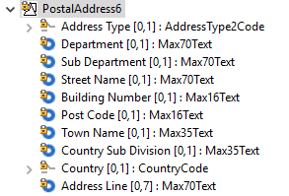
- Current definition of PostalAddress19 and PostalAddress23, to support additional requirements:
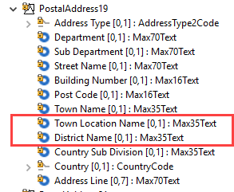

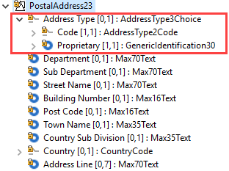

- Newly proposed PostalAddress24 definition:
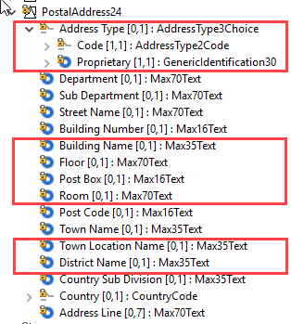
All changes have been highlighted in the new structure. Please note also that the order of the elements has been reorganised compare to the initial request to ensure for a more logical structure.

We propose to implement this change in all elements typed by the PostalAddress6 in the messages listed in the impact assessment.
In most cases, the update of PostalAddress6 will result in the update of party and agent message components BranchAndFinancialInstitutionIdentification5 or PartyIdentification43 or PartyIdentification125, which are used consistently through all Payments messages (those components are impacted by multiple change requests in this maintenance cyle, if approved).
In attachment, you will find an exhaustive list of the Xpath for all PostalAddress elements which should be updated in the messages.

Proposed timing:
The submitting organisation confirms that it can implement the requested changes in the requested timing, with following considerations:
- For the messages listed in the “Related messages” section, that is, which have been requested by the submitter of this change request or any other change request in this maintenance change request document (except for CR00751), we propose to implement the change in all messages which are part of the impacted message set during this maintenance cycle.
- For all other messages in the message sets only identified through the impact analysis, we propose to implement the change only at the occasion of the next maintenance of the messages, that is, the change will be approved by the SEG for implementation, but does not justify maintenance of the messages in its own right. It will be pending implementation until more critical change requests are received for the messages.
List of message sets in which the change will be implemented during this cycle:
- Bank-to-Customer Cash Management message set
- Payments Clearing and Settlement message set
- Payments Initiation message set
- Creditor Payment Activation Request message set
- Cash Management message set
- Exceptions and Investigations message set
- Notification to Receive message set
- Business Application Header (under the responsibility of the TSG)
List of message sets in which the change will NOT be implemented during this cycle:
- Account Switching message set
- Bank Account Management message set
- Change or Verify Account Identification message set
- Authorities Financial Investigations message set
- Cross-Border Transactions Currency Control Reporting message set
- Notification to Receive message set
- Payments Mandates message set
- Stand-Alone Remittance Advice message set

Timing | - As requested (taking into account the above considerations)

Final decision of the SEG(s):
This section is not to be taken care of by the submitting organisation. It will be completed in due time by the SEG(s) in charge of the related ISO 20022 messages.
Approve
Comments:

Reject
Reason for rejection:

Change request CR00728: Add an optional SettlementTime element
This chapter must be completed for every change request that the submitting organisation has been requested to implement.

Origin of the request:
A.1 Submitter: Deutsche Bundesbank, on behalf of the Eurosystem
A.2 Contact person: Steffen Fährmann / Mustafa Sahin
E-mail: evolution.emip@bundesbank.de
Phone: +49 9566 4046 / 49 9566 4538
A.3 Sponsors: The banking community of future EMIP-RTGS (Eurosystems’ Market Infrastructures Platform)
The CR is also supported by
- EBA – contact person: Jette Simson
E-mail: j.simson@ebaclearing.eu
- Bank of England – contact person: Gwyn Jones
E-mail: Gwyn.Jones@bankofengland.gsi.gov.uk

Related messages:
- pacs.004.001.08 Payment Return
- pacs.010.001.02 Financial Institution Direct Debit
It is acknowledged other messages maybe impacted by this Change Request; the above represent the messages where this Change Request is required.

Description of the change request:
Request to add the following new elements:
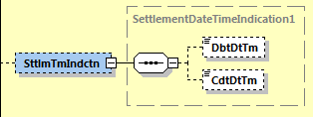
Needed to provide information on the occurred settlement time(s) of the payment transaction.

Purpose of the change:
The change would be an alignment to pacs.008/009 where these elements are already available in <CreditTransferTransactionInformation> block of the payload.

Type of the element would also be ISODateTime (based on dateTime).
In the case of EMIP-RTGS, the date and time at which the payment has been debited (pacs.010) or credited (pacs.004), expressed in Central European Time (CET).

Urgency of the request:
It is proposed to include this change request in the next regular maintenance cycle.

Business examples:
The following payment flow illustrates the payment return messaging on basis of a pacs.004 between two direct participants, previously a pacs.008 or pacs.009 was settled between the participants:
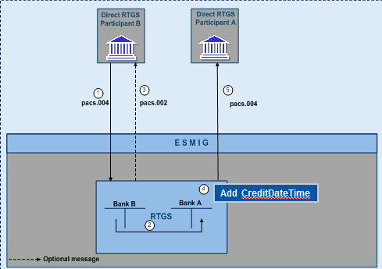
- The direct participant B sends a pacs.004 to the RTGS service for execution of a return settlement in the RTGS.
- Simultaneously booking on the RTGS DCAs of Bank A and Bank B if business validation positive.
- Booking confirmation to Bank B generated by the RTGS service (optional)
- CreditDateTime to be added in the message
- Forwarding of pacs.004 by the RTGS service to direct participant A

The processing of pacs.010 would be similar, only difference would be that a DebitDateTime would be added to the message.

SEG/TSG recommendation:
This section is not to be taken care of by the submitter of the change request. It will be completed in due time by the SEG(s) in charge of the related ISO 20022 messages or the TSG for changes related to the BAH.

Consider | X | Timing
 |  | - Next yearly cycle: 2018/2019  (the change will be considered for implementation in the yearly maintenance cycle which starts in 2018 and completes with the publication of new message versions in the spring of 2019) |  | X
- At the occasion of the next maintenance of the messages
(the change will be considered for implementation, but does not justify maintenance of the messages in its own right – will be pending until more critical change requests are received for the messages)
- Urgent unscheduled
(the change justifies an urgent implementation outside of the normal yearly cycle)
 |  | - Other timing:
Comments:

Reject
Reason for rejection:

Impact analysis and type of impact:
Following the detailed analysis of the impact of the changes to the existing messages, we identified further impacted messages, as already proposed by the change request submitter. The below list provides the full list of impacted messages per message set:

Messages for which the change was requested in the change request:
- Payments Clearing and Settlement message set
  - PaymentReturnV08 (pacs.004.001.08)
  - FinancialInstitutionDirectDebitV02 (pacs.010.001.02)
Additional messages impacted, for which the change has not been explicitly requested. If we want to keep a consistent component throughout all payments messages, the change request would also have to be implemented.
- Payments Clearing and Settlement message set
  - FIToFICustomerDirectDebitV07 (pacs.003.001.07)
  - FIToFIPaymentReversalV08 (pacs.007.001.08)
- Exceptions and Investigations message set
  - RequestToModifyPaymentV05 (camt.087.001.05)
The severity of the impact of the proposed change for the message users should be indicated in the table below (either “no impact”, “conditional’ or “mandatory”).
Type of impact
 | No impact | The change(s) will not impact the schema (the version number will not change) and will not impact the business applications of any users, e.g. the clarification of a definition
X | Conditional | The change(s) will impact the schema (at least the version number) and the business applications of certain users but not all, e.g. the addition of an optional component
 | Mandatory | The change(s) will impact the schema and the business applications of all users, e.g. addition of a mandatory component.

Proposed implementation:
We support the proposed implementation, including the implementation in the 3 additional messages identified in the impact assessment as indicated above, resulting in the following structure:
- Structure of the already used SettlementTimeIndication1 message component:
- PaymentReturnV08 (pacs.004.001.08)
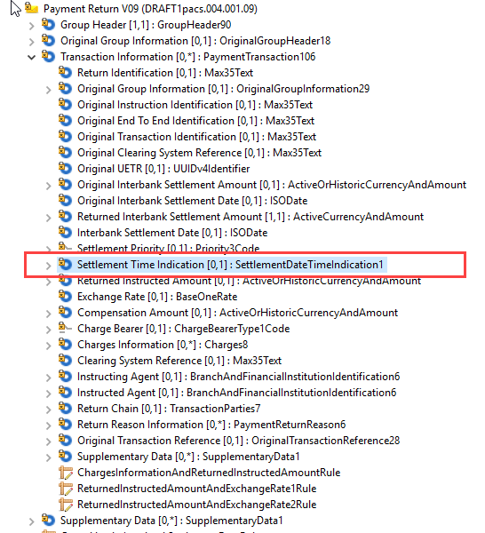
- FinancialInstitutionDirectDebitV02 (pacs.010.001.02)
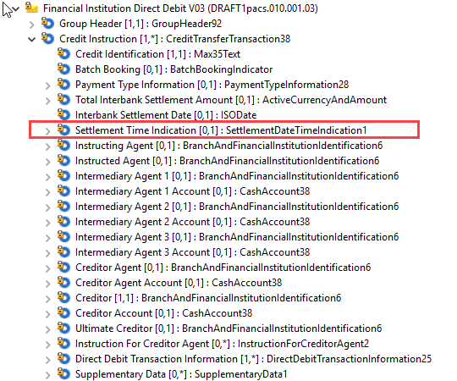
- FIToFICustomerDirectDebitV07 (pacs.003.001.07)
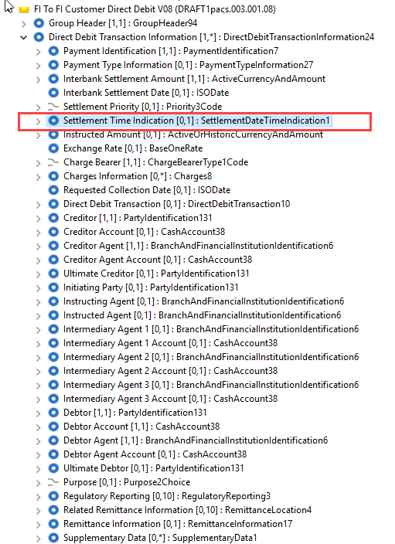
- FIToFIPaymentReversalV08 (pacs.007.001.08)
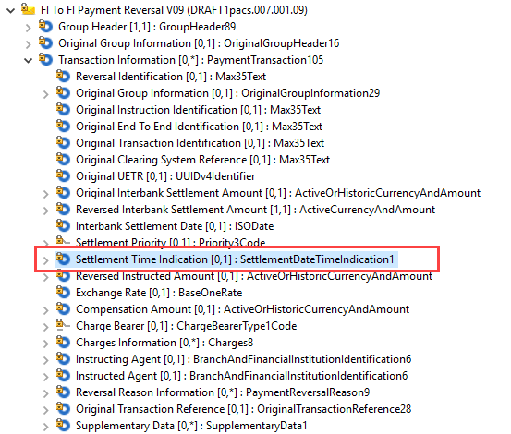
- RequestToModifyPaymentV05 (camt.087.001.05)
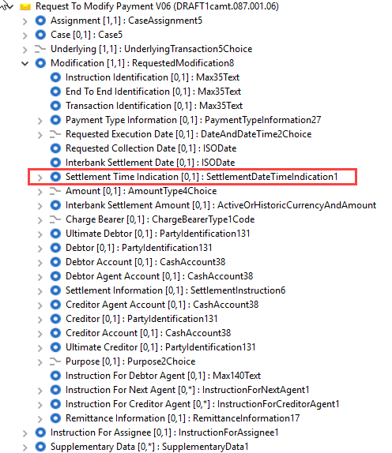

Proposed timing:
The submitting organisation confirms that it can implement the requested changes in the requested timing.

Timing | As requested

Final decision of the SEG(s):
This section is not to be taken care of by the submitting organisation. It will be completed in due time by the SEG(s) in charge of the related ISO 20022 messages.
Approve
Comments:

Reject
Reason for rejection:

Change request CR00729: Add an optional EffectiveSettlementDate
This chapter must be completed for every change request that the submitting organisation has been requested to implement.

Origin of the request:
A.1 Submitter: Deutsche Bundesbank, on behalf of the Eurosystem
A.2 Contact person: Steffen Fährmann / Mustafa Sahin
E-mail: evolution.emip@bundesbank.de
Phone: +49 9566 4046 / 49 9566 4538
A.3 Sponsors: The banking community of future EMIP-RTGS (Eurosystems’ Market Infrastructures Platform)
The CR is also supported by
- EBA – contact person: Jette Simson
E-mail: j.simson@ebaclearing.eu
- Bank of England – contact person: Gwyn Jones
E-mail: Gwyn.Jones@bankofengland.gsi.gov.uk

Related messages:
- pacs.002.001.09 FIToFIPaymentStatusReportV09

Description of the change request:
Request to add the following new element to pacs.002:
<EffectiveInterbankSettlementDate>
Datatype: DateAndDateTime2Choice defined as following:
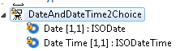

Proposed definition:
“Date and time at which a transaction is completed and cleared, for example, payment is effected.”

Purpose of the change:
The pacs.002 message already provides a certain TransactionStatus code to indicate the completion to indicate the settlement of a payment:
ACCC | AcceptedSettlementCompleted | Settlement on the creditor's account has been completed.
The new element is needed by the RTGS system to provide information of the effective settlement date/time of the payment transaction to the sending party of the origin interbank payment message. This information is needed by the banks for their internal reconciliation processes.

Urgency of the request:
Request can be supported in a new message version

Business examples:
The following payment flow illustrates the payment messaging between two direct participants.

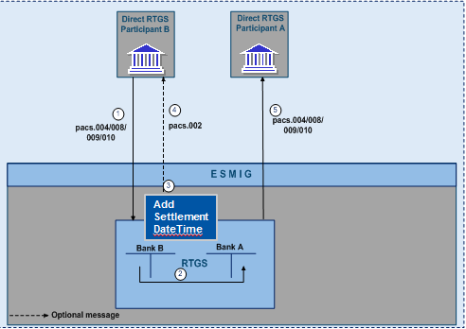
- The direct participant B sends a payment message to the RTGS service for execution of settlement in the RTGS.
- Simultaneously booking on the RTGS DCAs of Bank A and Bank B if business validation positive.
- Create pacs.002 with transaction status code “ACCC” and add settlement execution date time.
- Forwarding message to sending party.
- Forwarding of payment message by the RTGS service to direct participant A.

SEG/TSG recommendation:
This section is not to be taken care of by the submitter of the change request. It will be completed in due time by the SEG(s) in charge of the related ISO 20022 messages or the TSG for changes related to the BAH.

Consider | X | Timing
 |  | - Next yearly cycle: 2018/2019  (the change will be considered for implementation in the yearly maintenance cycle which starts in 2018 and completes with the publication of new message versions in the spring of 2019) |  | X
- At the occasion of the next maintenance of the messages
(the change will be considered for implementation, but does not justify maintenance of the messages in its own right – will be pending until more critical change requests are received for the messages)
- Urgent unscheduled
(the change justifies an urgent implementation outside of the normal yearly cycle)
 |  | - Other timing:
Comments:

Reject
Reason for rejection:

Impact analysis and type of impact:
Following the detailed analysis of the impact of the changes to the existing messages, we did not identify further impacted messages. The below list provides the full list of impacted messages:

Messages for which the change was requested:
- Payments Clearing and Settlement message set
  - FinancialInstitutionCreditTransferV07 (pacs.009.001.07)
The severity of the impact of the proposed change for the message users should be indicated in the table below (either “no impact”, “conditional’ or “mandatory”).
Type of impact
 | No impact | The change(s) will not impact the schema (the version number will not change) and will not impact the business applications of any users, e.g. the clarification of a definition
X | Conditional | The change(s) will impact the schema (at least the version number) and the business applications of certain users but not all, e.g. the addition of an optional component
 | Mandatory | The change(s) will impact the schema and the business applications of all users, e.g. addition of a mandatory component.

Proposed implementation:
We support the proposed implementation, resulting in the following structure:
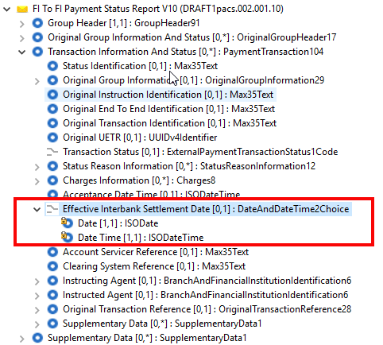

Proposed timing:
The submitting organisation confirms that it can implement the requested changes in the requested timing.

Timing | As requested

Final decision of the SEG(s):
This section is not to be taken care of by the submitting organisation. It will be completed in due time by the SEG(s) in charge of the related ISO 20022 messages.
Approve
Comments:

Reject
Reason for rejection:

Change request CR00730: Add an optional UETR identification
This chapter must be completed for every change request that the submitting organisation has been requested to implement.

Origin of the request:
A.1 Submitter: extended High Value Payment System (HVPS+ group).
A.2 Contact person: Neil Buchan, neil.buchan@swift.com +442077622135
A.3 Sponsors:

Related messages:
- pain.001.001.08 CustomerCreditTransferInitiationV08
- pain.002.001.09 CustomerPaymentStatusReportV09
- pain.013.001.06 CreditorPaymentActivationRequestV06
- pain.014.001.06 CreditorPaymentActivationRequestStatusReportV06
- pacs.002.001.09 FIToFIPaymentStatusReportV09
- pacs.003.001.07 FIToFICustomerDirectDebitV07
- pacs.004.001.08 PaymentReturnV08
- pacs.007.001.08 FIToFIPaymentReversalV08
- pacs.008.001.07 FIToFICustomerCreditTransferV07
- pacs.009.001.07 FinancialInstitutionCreditTransferV07
- pacs.010.001.02 FinancialInstitutionDirectDebitV02
- pacs.028.001.02 FIToFIPaymentStatusRequestV02
- camt.005.001.07 Get Transaction V7
- camt.006.001.07 Return Transaction V7
- camt.029.001.08 ResolutionOfCaseAssignmentV04
- camt.036.001.04 DebitAuthorisationResponseV04
- camt.037.001.06 DebitAuthorisationRequestV06
- camt.052.001.07 BankToCustomerAccountReportV07
- camt.053.001.07 BankToCustomerStatementV07
- camt.054.001.07 BankToCustomerDebitCreditNotificationV07
- camt.055.001.07 CustomerPaymentCancellationRequestV07
- camt.056.001.07 FIToFIPaymentCancellationRequestV07
- camt.059.001.08 NotificationToReceiveStatusReportV05
- camt.087.001.05 RequestToModifyPaymentV05

Description of the change request:
Additional new optional transactional data element named ‘UETR’ (type UUID, Universally Unique Identifier v4) as a fixed length 36 character element, in accordance to Internet Engineering Task Force Standard RFC4122 v4
(<xsd:pattern value="[a-f0-9]{8}-[a-f0-9]{4}-4[a-f0-9]{3}-[ab89]{1}[a-f0-9]{3}-[a-f0-9]{12}"/>)
This element should only be available as an optional single occurrence at transactional level.

In addition, the group requests to make Optional the existing element “Transaction ID” that is today mandatory. This is an end-to-end, bank-to-bank identification and the UETR will be the new bank-to-bank end-to-end identification.
To make sure the message will always contain a bank-to-bank end to end identification, a rule should be added to make sure that at least one the two elements “UETR” or “Transaction Id” is present, and both may be present.

Purpose of the change:
The ability to uniquely identify a transaction without a central authority issuing a unique transaction identifier is a challenge experience by the payments industry. Whilst a unique identifier enables transaction tracking, it also allows different parties within the payment lifecycle to have one common reference to refer to when interacting on that transaction. For example requesting more information not provided within the payment.
The SWIFT gpi initiative leveraged the Internet Engineering Task Force standard for a Universally Unique Identifier (RFC4122 v4 https://www.ietf.org/rfc/rfc4122.txt) to address this challenge, which sees a Unique End-to-end Transaction Reference (UETR) assigned on the payment initiated, (typically by the debtor Agent) that lives with the payment throughout the end to end payment lifecycle.
The use of UETR in payment messaging standards already represents a significant daily message volume, both on the SWIFT FIN network, but also in a number of international Payment Market Infrastructures.
The ability to generate the UETR for use in the end to end transaction is being piloted within a SWIFT gpi corporate Proof of Concept, where discussions have occurred with CGI on the use of the UETR in both the pain.001 and pain.002 messages, as well as ‘camt’ reporting messages.
The extended High Value Payments System (HVPS+ group), as submitters of the change request represent a number of global Payment Market Infrastructures who already use or intend to use ISO 20022 as their core messaging standard.
This proposal is to add a new UETR element to existing ISO messages at a transactional level in order that; transition from proprietary messaging standard to ISO 20022 can occur, and to allow other ISO 20022 payment users to optionally benefit from this Unique End-to-end Transaction reference.

UETR format:
xxxxxxxx-xxxx-4xxx-yxxx-xxxxxxxxxxxx where x is any hexadecimal character (lower case only) and y is one of 8, 9, a, or b
(<xsd:pattern value="[a-f0-9]{8}-[a-f0-9]{4}-4[a-f0-9]{3}-[ab89]{1}[a-f0-9]{3}-[a-f0-9]{12}"/>)

Urgency of the request:
Request can be supported in a new message version

Business examples:
Example of a Unique End-to-end Transaction Reference (UETR):
eb6305c9-1f7f-49de-aed0-16487c27b42d
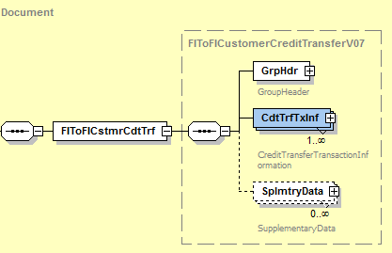

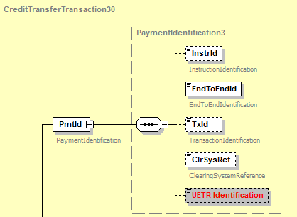

SEG/TSG recommendation:
This section is not to be taken care of by the submitter of the change request. It will be completed in due time by the SEG(s) in charge of the related ISO 20022 messages or the TSG for changes related to the BAH.

Consider |  | X | Timing
 |  |  | - Next yearly cycle: 2018/2019  (the change will be considered for implementation in the yearly maintenance cycle which starts in 2018 and completes with the publication of new message versions in the spring of 2019) |  | X
- At the occasion of the next maintenance of the messages
(the change will be considered for implementation, but does not justify maintenance of the messages in its own right – will be pending until more critical change requests are received for the messages)
- Urgent unscheduled
(the change justifies an urgent implementation outside of the normal yearly cycle)
 |  |  | - Other timing:
Comments:

Reject
Reason for rejection:

Impact analysis and type of impact:
Following the detailed analysis of the impact of the changes to the existing messages, we identified further impacted messages, as already proposed by the change request submitter. The below list provides the full list of impacted messages per message set:

Messages for which the change was requested in the change request:
- Cash Management message set
  - GetTransactionV07 (camt.005.001.07)
  - ReturnTransactionV07 (camt.006.001.07)
- Exceptions and Investigations message set
  - ResolutionOfInvestigationV08 (camt.029.001.08)
  - DebitAuthorisationResponseV04 (camt.036.001.04)
  - DebitAuthorisationRequestV06 (camt.037.001.06)
  - CustomerPaymentCancellationRequestV07 (camt.055.001.07)
  - FIToFIPaymentCancellationRequestV07 (camt.056.001.07)
  - RequestToModifyPaymentV05 (camt.087.001.05)
- Bank-to-Customer Cash Management message set
  - BankToCustomerAccountReportV07 (camt.052.001.07)
  - BankToCustomerStatementV07 (camt.053.001.07)
  - BankToCustomerDebitCreditNotificationV07 (camt.054.001.07)
- Notification to Receive message set
  - NotificationToReceiveStatusAdviceV05 (camt.059.001.05)
- Payments Clearing and Settlement message set
  - FIToFIPaymentStatusReportV09 (pacs.002.001.09)
  - FIToFICustomerDirectDebitV07 (pacs.003.001.07)
  - PaymentReturnV08 (pacs.004.001.08)
  - FIToFIPaymentReversalV08 (pacs.007.001.08)
  - FIToFICustomerCreditTransferV07 (pacs.008.001.07)
  - FinancialInstitutionCreditTransferV07 (pacs.009.001.07)
  - FinancialInstitutionDirectDebitV02 (pacs.010.001.02)
  - FIToFIPaymentStatusRequestV02 (pacs.028.001.02)
- Payments Initiation message set
  - CustomerCreditTransferInitiationV08 (pain.001.001.08)
  - CustomerPaymentStatusReportV09 (pain.002.001.09)
- Creditor Payment Activation Request message set
  - CreditorPaymentActivationRequestV06 (pain.013.001.06)
  - CreditorPaymentActivationRequestStatusReportV06 (pain.014.001.06)
Additional messages impacted, for which the change has not been explicitly requested. If we want to keep a consistent component throughout all payments messages, the change request would also have to be implemented.
- Account Switching message set
  - AccountSwitchInformationRequestV01 (acmt.027.001.01)
  - AccountSwitchInformationResponseV01 (acmt.028.001.01)
  - AccountSwitchCancelExistingPaymentV01 (acmt.029.001.01)
  - AccountSwitchRequestBalanceTransferV01 (acmt.031.001.01)
  - AccountSwitchBalanceTransferAcknowledgementV01 (acmt.032.001.01)
  - AccountSwitchRequestPaymentV01 (acmt.034.001.01)
- Cash Management message set
  - ModifyTransactionV07 (camt.007.001.07)
  - ReceiptV04 (camt.025.001.04)
  - LiquidityCreditTransferV04 (camt.050.001.04)
  - LiquidityDebitTransferV04 (camt.051.001.04)
- Exceptions and Investigations message set
  - UnableToApplyV06 (camt.026.001.06)
  - ClaimNonReceiptV06 (camt.027.001.06)
  - AdditionalPaymentInformationV08 (camt.028.001.08)
- Notification to Receive message set
  - NotificationToReceiveV05 (camt.057.001.05)
  - NotificationToReceiveCancellationAdviceV05 (camt.058.001.05)
- Payments Initiation message set
  - CustomerPaymentReversalV08 (pain.007.001.08)
  - CustomerDirectDebitInitiationV07 (pain.008.001.07)
- Stand-Alone Remittance Advice message set
  - RemittanceAdviceV03 (remt.001.001.03)
  - RemittanceLocationAdviceV01 (remt.002.001.01)

The severity of the impact of the proposed change for the message users should be indicated in the table below (either “no impact”, “conditional’ or “mandatory”).
Type of impact
 | No impact | The change(s) will not impact the schema (the version number will not change) and will not impact the business applications of any users, e.g. the clarification of a definition
X | Conditional | The change(s) will impact the schema (at least the version number) and the business applications of certain users but not all, e.g. the addition of an optional component
 | Mandatory | The change(s) will impact the schema and the business applications of all users, e.g. addition of a mandatory component.

Proposed implementation:
We support the implementation of the change request, resulting in the following structure:
- Definition of a new identifier - UUIDv4Identifier - designed to support the specifications, the pattern and definitions as requested in the change request:
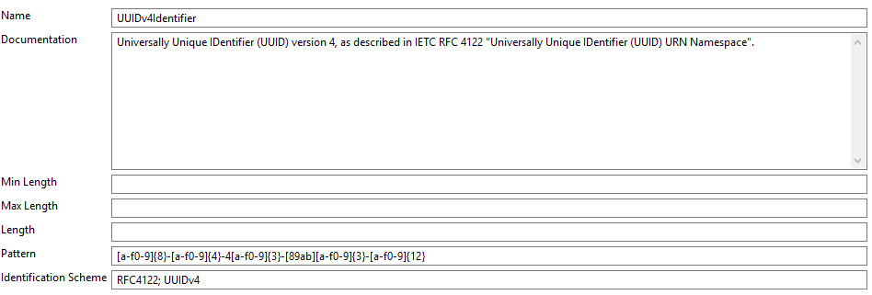
- Based on the analysis, the implementation of the UETR should be implemented as following:
  - Instruction messages: include the UETR, as requested by the submitter of the change request, in the PaymentIdentification components:
Following new message components will be implemented: PaymentIdentification1->6 and 8, PaymentIdentification3->7, LongPaymentIdentification1->2
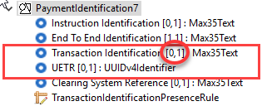
Within the above 3 elements, when the Transaction Identification element is present, as requested, TransactionIdentification will be made optional, and a rule will be added to specify that TransactioIdentification or UETR must be present, and both may be present.
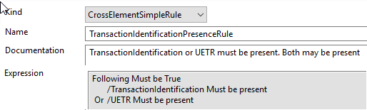
  - R-Messages: include the OriginalUETR, as requested by the submitter of the change request, in the TransactionInformation related components right after the previous existing instruction/transaction/reference elements:
  - Underlying transaction elements in the Exceptions and Investigation messages: include the OriginalUETR, as requested by the submitter of the change request, in the transaction related components right after the previous existing instruction/transaction/reference elements
- In attachment, you will find an exhaustive list of the Xpath for all UETR elements which should be added to the messages.

Proposed timing:
The submitting organisation confirms that it can implement the requested changes in the requested timing, with following considerations:
- For the messages listed in the “Related messages” section, that is, which have been requested by the submitter of this change request or any other change request in this maintenance change request document (except for CR00751), we propose to implement the change in all messages which are part of the impacted message set during this maintenance cycle.
- For all other messages in the message sets only identified through the impact analysis, we propose to implement the change only at the occasion of the next maintenance of the messages, that is, the change will be approved by the SEG for implementation, but does not justify maintenance of the messages in its own right. It will be pending implementation until more critical change requests are received for the messages.
List of message sets in which the change will be implemented during this cycle:
- Bank-to-Customer Cash Management message set
- Payments Clearing and Settlement message set
- Payments Initiation message set
- Creditor Payment Activation Request message set
- Cash Management message set
- Exceptions and Investigations message set
- Notification to Receive message set
List of message sets in which the change will NOT be implemented during this cycle:
- Account Switching message set
- Stand-Alone Remittance Advice

Timing | - As requested (taking into account the above considerations)

Final decision of the SEG(s):
This section is not to be taken care of by the submitting organisation. It will be completed in due time by the SEG(s) in charge of the related ISO 20022 messages.
Approve
Comments:

Reject
Reason for rejection:

Change request CR00731: Add an optional LEI identification
This chapter must be completed for every change request that the submitting organisation has been requested to implement.

Origin of the request:
A.1 Submitter: Payments Market Practice Group (PMPG)
A.2 Contact person: Neil Buchan, neil.buchan@swift.com +442077622135
A.3 Sponsors: the Change Request is supported by the Eurosystem

Related messages:
- pain.001.001.08 Customer Credit Transfer Initiation
- pain.002.001.09 Customer Payment Status Report
- pain.013.001.06 Creditor Payment Activation Request
- pain.014.001.06 Creditor Payment Request Status Report
- pacs.002.001.09 FI to FI Payments Status Report
- pacs.003.001.07 FI to FI Customer Direct Debit
- pacs.004.001.08 Payment Return
- pacs.007.001.08 FI to FI Payment Reversal
- pacs.008.001.07 FI to FI Customer Credit Transfer
- pacs.009.001.07 Financial Institution Credit Transfer
- pacs.010.001.02 Financial Institution Direct Debit
- pacs.028.001.02 FI to FI Payment Status Request
- camt.052.001.07 Bank to Customer Account Report

It is acknowledged other messages maybe impacted by this Change Request; the above represent the messages where this Change Request is required.

Description of the change request:
Additional new optional Lei element typed by the existing LEI identifier data type:
OrganisationIdentification <OrgID> (‘OrganisationIdentification8’ message component)
and
FinancialInstitutionIdentification <FinInstnId> (‘FinancialInstitutionIdentification8 in BranchAndFinancialInstitutionIdentification5’ message component)
Available in both the Business Application Header and Transaction Information

Purpose of the change:
The Basel Committee on Payments and Market Infrastructure (CPMI) recommended in their report on Correspondent banking in July 2016 that the financial service industry should consider the use of the LEI as additional information in payment messages (https://www.bis.org/cpmi/publ/d147.pdf). The report cited the inclusion of the LEI in payment messages as one of the measures “that could help improve the efficiency of procedures, reduce compliance costs and help address perceived uncertainty, without altering the applicable rules and the basic channels for correspondent banking services between correspondent and respondent banks.”
CPMI invited relevant industry groups such as the Wolfsberg Group and the Payments Market Practice Group (PMPG) “to review their principles governing the use-cases for payment messages, what information should be included and which data fields should be used.” In response the PMPG conducted a market survey of the global payments community in 2017 followed by a discussion paper (https://www.swift.com/about-us/community/swift-advisory-groups/payments-market-practice-group/document-centre/document-centre) in November 2017 listing the following benefits for including the LEI in payment messages:
- Increase data validation at payments capture and during processing.
- Potentially higher STP rates
- Mitigate data truncation in name and address data when it exceeds the field size of message party fields when it will be possible to substitute the LEI to the name and address data.
- Simplify screening and control processes resulting in reduced lead time for Compliance related investigations and eliminating potential delays during payment processing from false hits in compliance and sanctions screening.
- Optimized and more accurate AML controls and detection of suspicious activities by leveraging LEI to standard industry code mappings
- A connection between LEI data and external data services bases providing by specific data vendors including line of business and industry codes can permit a more systematic and robust review of payments for inconsistent or suspicious patterns.
- Improve credit and counterparty risk management capabilities.
The PMPG, in response to a mandate from the Committee on Payment and Market Infrastructure (CPMI) to include LEI in payment messages proposes to introduce the option ability to populate the Legal Entity Identifier (ISO 17442) in ISO 20022 payment messages as an unambiguous identifier for legal entities.

Urgency of the request:
Request can be supported in a new message version

Business examples:
<DbtrAgt>
<FinInstnId>
<LEI> 254900Y8NKGV541U8Q32</LEI>
</FinInstnId>
</DbtrAgt>

<Assgne>
<Agt>
<FinInstnId>
<LEI> 254900Y8NKGV541U8Q32</LEI>
</FinInstnId>
</Agt>
</Assgne>

<Dbtr>
<OrgId>
<LEI> HB7FFAZI0OMZ8PP8OE26</LEI>
</OrgId>
</Dbtr>

<Invcee>
<OrgId>
<LEI> HB7FFAZI0OMZ8PP8OE26</LEI>
</OrgId>
</Invcee>

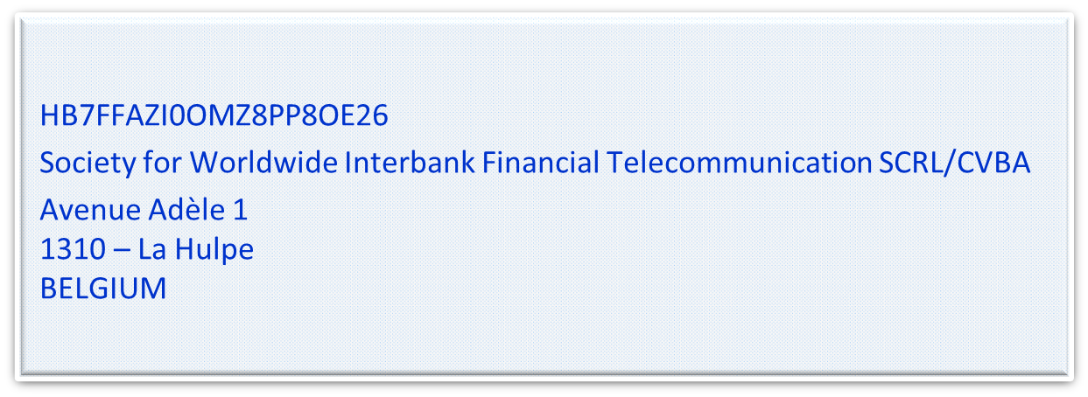

SEG/TSG recommendation:
This section is not to be taken care of by the submitter of the change request. It will be completed in due time by the SEG(s) in charge of the related ISO 20022 messages or the TSG for changes related to the BAH.

Consider | X | Timing
 |  | - Next yearly cycle: 2018/2019  (the change will be considered for implementation in the yearly maintenance cycle which starts in 2018 and completes with the publication of new message versions in the spring of 2019) |  | X
- At the occasion of the next maintenance of the messages
(the change will be considered for implementation, but does not justify maintenance of the messages in its own right – will be pending until more critical change requests are received for the messages)
- Urgent unscheduled
(the change justifies an urgent implementation outside of the normal yearly cycle)
 |  | - Other timing:
Comments:

Reject
Reason for rejection:

Impact analysis and type of impact:
Following the detailed analysis of the impact of the changes to the existing messages, we identified further impacted messages, as already proposed by the change request submitter. The below list provides the full list of impacted messages per message set:

Messages for which the change was requested in the change request:
- Bank-to-Customer Cash Management message set
  - BankToCustomerAccountReportV07 (camt.052.001.07)
- Payments Clearing and Settlement message set
  - FIToFIPaymentStatusReportV09 (pacs.002.001.09)
  - FIToFICustomerDirectDebitV07 (pacs.003.001.07)
  - PaymentReturnV08 (pacs.004.001.08)
  - FIToFIPaymentReversalV08 (pacs.007.001.08)
  - FIToFICustomerCreditTransferV07 (pacs.008.001.07)
  - FinancialInstitutionCreditTransferV07 (pacs.009.001.07)
  - FinancialInstitutionDirectDebitV02 (pacs.010.001.02)
  - FIToFIPaymentStatusRequestV02 (pacs.028.001.02)
- Payments Initiation message set
  - CustomerCreditTransferInitiationV08 (pain.001.001.08)
  - CustomerPaymentStatusReportV09 (pain.002.001.09)
- Creditor Payment Activation Request message set
  - CreditorPaymentActivationRequestV06 (pain.013.001.06)
  - CreditorPaymentActivationRequestStatusReportV06 (pain.014.001.06)
Additional messages impacted, for which the change has not been explicitly requested. If we want to keep a consistent component throughout all payments messages, the change request would also have to be implemented.
- Bank Account Management message set
  - AccountOpeningRequestV02 (acmt.007.001.02)
  - AccountOpeningAmendmentRequestV02 (acmt.008.001.02)
  - AccountOpeningAdditionalInformationRequestV02 (acmt.009.001.02)
  - AccountRequestAcknowledgementV02 (acmt.010.001.02)
  - AccountRequestRejectionV02 (acmt.011.001.02)
  - AccountAdditionalInformationRequestV02 (acmt.012.001.02)
  - AccountReportRequestV02 (acmt.013.001.02)
  - AccountReportV02 (acmt.014.001.02)
  - AccountExcludedMandateMaintenanceRequestV02 (acmt.015.001.02)
  - AccountExcludedMandateMaintenanceAmendmentRequestV02 (acmt.016.001.02)
  - AccountMandateMaintenanceRequestV02 (acmt.017.001.02)
  - AccountMandateMaintenanceAmendmentRequestV02 (acmt.018.001.02)
  - AccountClosingRequestV02 (acmt.019.001.02)
  - AccountClosingAmendmentRequestV02 (acmt.020.001.02)
  - AccountClosingAdditionalInformationRequestV02 (acmt.021.001.02)
- Change or Verify Account Identification message set
  - IdentificationModificationAdviceV02 (acmt.022.001.02)
  - IdentificationVerificationRequestV02 (acmt.023.001.02)
  - IdentificationVerificationReportV02 (acmt.024.001.02)
- Account Switching message set
  - AccountSwitchInformationRequestV01 (acmt.027.001.01)
  - AccountSwitchInformationResponseV01 (acmt.028.001.01)
  - AccountSwitchCancelExistingPaymentV01 (acmt.029.001.01)
  - AccountSwitchRequestRedirectionV01 (acmt.030.001.01)
  - AccountSwitchRequestBalanceTransferV01 (acmt.031.001.01)
  - AccountSwitchBalanceTransferAcknowledgementV01 (acmt.032.001.01)
  - AccountSwitchRequestPaymentV01 (acmt.034.001.01)
- Authorities Financial Investigations message set
  - InformationRequestOpeningV01 (auth.001.001.01)
  - InformationRequestResponseV01 (auth.002.001.01)
- Cross-Border Transactions Currency Control Reporting
  - ContractRegistrationRequestV01 (auth.018.001.01)
  - ContractRegistrationConfirmationV01 (auth.019.001.01)
  - ContractRegistrationClosureRequestV01 (auth.020.001.01)
  - ContractRegistrationAmendmentRequestV01 (auth.021.001.01)
  - ContractRegistrationStatementV01 (auth.022.001.01)
  - ContractRegistrationStatementRequestV01 (auth.023.001.01)
  - PaymentRegulatoryInformationNotificationV01 (auth.024.001.01)
  - CurrencyControlSupportingDocumentDeliveryV01 (auth.025.001.01)
  - CurrencyControlRequestOrLetterV01 (auth.026.001.01)
  - CurrencyControlStatusAdviceV01 (auth.027.001.01)
- Cash Management message set
  - GetAccountV06 (camt.003.001.06)
  - ReturnAccountV07 (camt.004.001.07)
  - GetTransactionV07 (camt.005.001.07)
  - ReturnTransactionV07 (camt.006.001.07)
  - ModifyTransactionV07 (camt.007.001.07)
  - GetLimitV06 (camt.009.001.06)
  - ReturnLimitV07 (camt.010.001.07)
  - ModifyLimitV06 (camt.011.001.06)
  - DeleteLimitV06 (camt.012.001.06)
  - ModifyStandingOrderV05 (camt.024.001.05)
  - ReceiptV04 (camt.025.001.04)
  - GetReservationV04 (camt.046.001.04)
  - ReturnReservationV05 (camt.047.001.05)
  - ModifyReservationV04 (camt.048.001.04)
  - DeleteReservationV04 (camt.049.001.04)
  - LiquidityCreditTransferV04 (camt.050.001.04)
  - LiquidityDebitTransferV04 (camt.051.001.04)
  - GetStandingOrderV02 (camt.069.001.02)
  - ReturnStandingOrderV03 (camt.070.001.03)
  - DeleteStandingOrderV02 (camt.071.001.02)
- Exceptions and Investigations message set
  - UnableToApplyV06 (camt.026.001.06)
  - ClaimNonReceiptV06 (camt.027.001.06)
  - AdditionalPaymentInformationV08 (camt.028.001.08)
  - ResolutionOfInvestigationV08 (camt.029.001.08)
  - NotificationOfCaseAssignmentV04 (camt.030.001.04)
  - RejectInvestigationV05 (camt.031.001.05)
  - CancelCaseAssignmentV03 (camt.032.001.03)
  - RequestForDuplicateV05 (camt.033.001.05)
  - DuplicateV05 (camt.034.001.05)
  - ProprietaryFormatInvestigationV04 (camt.035.001.04)
  - DebitAuthorisationResponseV04 (camt.036.001.04)
  - DebitAuthorisationRequestV06 (camt.037.001.06)
  - CaseStatusReportRequestV03 (camt.038.001.03)
  - CaseStatusReportV04 (camt.039.001.04)
  - CustomerPaymentCancellationRequestV07 (camt.055.001.07)
  - FIToFIPaymentCancellationRequestV07 (camt.056.001.07)
  - RequestToModifyPaymentV05 (camt.087.001.05)
- Bank-to-Customer Cash Management message set
  - BankToCustomerStatementV07 (camt.053.001.07)
  - BankToCustomerDebitCreditNotificationV07 (camt.054.001.07)
  - AccountReportingRequestV04 (camt.060.001.04)
- Notification to Receive message set
  - NotificationToReceiveV05 (camt.057.001.05)
  - NotificationToReceiveCancellationAdviceV05 (camt.058.001.05)
  - NotificationToReceiveStatusReportV05 (camt.059.001.05)
- Bank Services Billing
  - BankServicesBillingStatementV02 (camt.086.001.02)
- Business Application Header
  - BusinessApplicationHeaderV01 (head.001.001.01)
- Payments Initiation message set
  - CustomerPaymentReversalV08 (pain.007.001.08)
  - CustomerDirectDebitInitiationV07 (pain.008.001.07)
- Payments Mandates message set
  - MandateInitiationRequestV05 (pain.009.001.05)
  - MandateAmendmentRequestV05 (pain.010.001.05)
  - MandateCancellationRequestV05 (pain.011.001.05)
  - MandateAcceptanceReportV05 (pain.012.001.05)
  - MandateCopyRequestV01 (pain.017.001.01)
  - MandateSuspensionRequestV01 (pain.018.001.01)
- Stand-Alone Remittance Advice
  - RemittanceAdviceV03 (remt.001.001.03)
  - RemittanceLocationAdviceV01 (remt.002.001.01)

The severity of the impact of the proposed change for the message users should be indicated in the table below (either “no impact”, “conditional’ or “mandatory”).
Type of impact
 | No impact | The change(s) will not impact the schema (the version number will not change) and will not impact the business applications of any users, e.g. the clarification of a definition
X | Conditional | The change(s) will impact the schema (at least the version number) and the business applications of certain users but not all, e.g. the addition of an optional component
 | Mandatory | The change(s) will impact the schema and the business applications of all users, e.g. addition of a mandatory component.

Proposed implementation:
We support the implementation of the change request, resulting in the following structure:
- For the update of the party identification using the base PartyIdentification43 and PartyIdentification125 components, the following update is proposed, through the use of the new PartyIdentification131
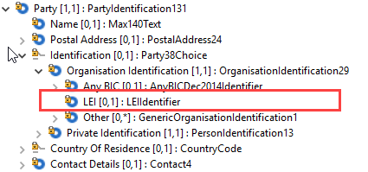
- For the update of the agent identification using the base BranchAndFinancialInstitutionIdentification5 component, the following update is proposed, through the use of the new BranchAndFinancialInstitutionIdentification5
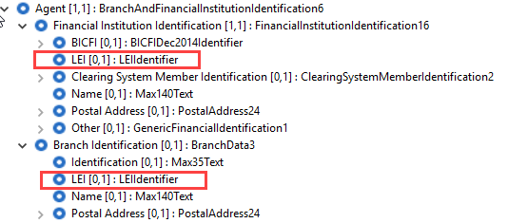
- For the rare cases in the Payments messages, where the above base components are not used, the LEI element will be added next to the BIC identifier in all occurences where the BIC identifier appears.
- In attachment, you will find an exhaustive list of the Xpath for all LEI elements which should be added to the messages.

Proposed timing:
The submitting organisation confirms that it can implement the requested changes in the requested timing, with following considerations:
- For the messages listed in the “Related messages” section, that is, which have been requested by the submitter of this change request or any other change request in this maintenance change request document (except for CR00751), we propose to implement the change in all messages which are part of the impacted message set during this maintenance cycle.
- For all other messages in the message sets only identified through the impact analysis, we propose to implement the change only at the occasion of the next maintenance of the messages, that is, the change will be approved by the SEG for implementation, but does not justify maintenance of the messages in its own right. It will be pending implementation until more critical change requests are received for the messages.
List of message sets in which the change will be implemented during this cycle:
- Bank-to-Customer Cash Management message set
- Payments Clearing and Settlement message set
- Payments Initiation message set
- Creditor Payment Activation Request message set
- Cash Management message set
- Exceptions and Investigations message set
- Notification to Receive message set
- Business Application Header (under the responsibility of the ISO 20022 TSG)

List of message sets in which the change will NOT be implemented during this cycle:
- Bank Account Management message set
- Change or Verify Account Identification message set
- Account Switching message set
- Authorities Financial Investigations message set
- Cross-Border Transactions Currency Control Reporting
- Bank Services Billing
- Payments Mandates message set
- Stand-Alone Remittance Advice

Timing | - As requested (taking into account the above considerations)

Final decision of the SEG(s):
This section is not to be taken care of by the submitting organisation. It will be completed in due time by the SEG(s) in charge of the related ISO 20022 messages.
Approve
Comments:

Reject
Reason for rejection:

Change request CR00732: Modify ServiceLevel cardinality
This chapter must be completed for every change request that the submitting organisation has been requested to implement.

Origin of the request:
A.1 Submitter: SWIFT Standards.
A.2 Contact person: Neil Buchan, neil.buchan@swift.com +442077622135
A.3 Sponsors: SWIFT

Related messages:
- pain.001.001.08 CustomerCreditTransferInitiationV08
- pain.002.001.09 CustomerPaymentStatusReportV09
- pain.013.001.06 CreditorPaymentActivationRequestV06
- pain.014.001.06 CreditorPaymentActivationRequestStatusReportV06
- pacs.002.001.09 FIToFIPaymentStatusReportV09
- pacs.003.001.07 FIToFICustomerDirectDebitV07
- pacs.004.001.08 PaymentReturnV08
- pacs.007.001.08 FIToFIPaymentReversalV08
- pacs.008.001.07 FIToFICustomerCreditTransferV07
- pacs.009.001.07 FinancialInstitutionCreditTransferV07
- pacs.010.001.02 FinancialInstitutionDirectDebitV02
- pacs.028.001.02 FIToFIPaymentStatusRequestV02

It is acknowledged that other messages maybe impacted by this Change Request. The above represent the messages where this Change Request is required

Description of the change request:
The purpose of this Change Request is to enable multiple occurrences of the Service Level ID element.
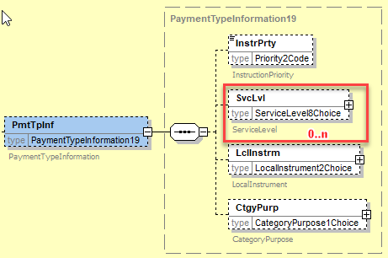

Purpose of the change:
More than one service level could be associated with a payment. In certain situations multiple service levels may apply to different agents within the end-to-end payment transaction.
The SWIFT gpi initiative aims to improve customer experience in cross-border payments by increasing their speed, transparency, and traceability. To achieve this, gpi customers agree to respect the service level; specific business rules and technical requirements captured in rulebooks, and are measured against these by the gpi observer in the form of Key Performance Indicators.
Following discussion with CGI it was recognized that multiple service levels maybe belong to a payment during different stages of it journey, of which more than one service level could be present during a particular leg of this journey.

Urgency of the request:
It is proposed to include this change request in the next regular maintenance cycle.

Business examples:
An externalised Service Level Id maybe used bilaterally, or within a Payment Market Infrastructure to enable particular processes. In additional an end-to-end Service Level, such as the proposed externalised Service Level codes for SWIFT gpi may need to be included within the payment message as well.
For example Service Level Id ‘URGP’ may be used within a pacs.008 from the Debtor Agent to the instructed Agent together with the proposed ‘G001’. This tells the instructed agent the payment should be executed as an urgent transaction cleared through a real-time gross settlement system (RTGS) which also should respect the service level expectations of a tracked SWIFT gpi transaction.

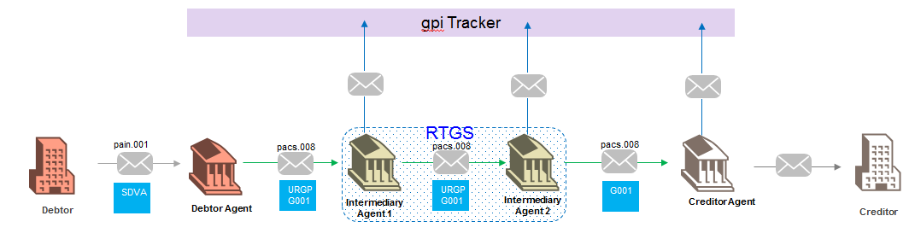.

SEG/TSG recommendation:
This section is not to be taken care of by the submitter of the change request. It will be completed in due time by the SEG(s) in charge of the related ISO 20022 messages or the TSG for changes related to the BAH.

Consider |  | X | Timing
 |  |  | - Next yearly cycle: 2018/2019  (the change will be considered for implementation in the yearly maintenance cycle which starts in 2018 and completes with the publication of new message versions in the spring of 2019) |  | X
- At the occasion of the next maintenance of the messages
(the change will be considered for implementation, but does not justify maintenance of the messages in its own right – will be pending until more critical change requests are received for the messages)
- Urgent unscheduled
(the change justifies an urgent implementation outside of the normal yearly cycle)
 |  |  | - Other timing:
Comments:

Reject
Reason for rejection:

Impact analysis and type of impact:
Following the detailed analysis of the impact of the changes to the existing messages, we identified further impacted messages, as already proposed by the change request submitter. The below list provides the full list of impacted messages per message set:

Messages for which the change was requested in the change request:
- Payments Clearing and Settlement message set
  - FIToFIPaymentStatusReportV09 (pacs.002.001.09)
  - FIToFICustomerDirectDebitV07 (pacs.003.001.07)
  - PaymentReturnV08 (pacs.004.001.08)
  - FIToFIPaymentReversalV08 (pacs.007.001.08)
  - FIToFICustomerCreditTransferV07 (pacs.008.001.07)
  - FinancialInstitutionCreditTransferV07 (pacs.009.001.07)
  - FinancialInstitutionDirectDebitV02 (pacs.010.001.02)
  - FIToFIPaymentStatusRequestV02 (pacs.028.001.02)
- Payments Initiation message set
  - CustomerCreditTransferInitiationV08 (pain.001.001.08)
  - CustomerPaymentStatusReportV09 (pain.002.001.09)
  - Creditor Payment Activation Request message set
  - CreditorPaymentActivationRequestV06 (pain.013.001.06)
  - CreditorPaymentActivationRequestStatusReportV06 (pain.014.001.06)
Additional messages impacted, for which the change has not been explicitly requested. If we want to keep a consistent component throughout all payments messages, the change request would also have to be implemented.
- Account Switching message set
  - AccountSwitchInformationRequestV01 (acmt.027.001.01)
  - AccountSwitchInformationResponseV01 (acmt.028.001.01)
  - AccountSwitchCancelExistingPaymentV01 (acmt.029.001.01)
  - AccountSwitchRequestBalanceTransferV01 (acmt.031.001.01)
  - AccountSwitchBalanceTransferAcknowledgementV01 (acmt.032.001.01)
  - AccountSwitchRequestPaymentV01 (acmt.034.001.01)
- Exceptions and Investigations message set
  - UnableToApplyV06 (camt.026.001.06)
  - ClaimNonReceiptV06 (camt.027.001.06)
  - AdditionalPaymentInformationV08 (camt.028.001.08)
  - ResolutionOfInvestigationV08 (camt.029.001.08)
  - DebitAuthorisationRequestV06 (camt.037.001.06)
  - CustomerPaymentCancellationRequestV07 (camt.055.001.07)
  - FIToFIPaymentCancellationRequestV07 (camt.056.001.07)
  - RequestToModifyPaymentV05 (camt.087.001.05)
- Payments Initiation message set
  - CustomerPaymentReversalV08 (pain.007.001.08)
- Stand-Alone Remittance Advice message set
  - RemittanceAdviceV03 (remt.001.001.03)
The severity of the impact of the proposed change for the message users should be indicated in the table below (either “no impact”, “conditional’ or “mandatory”).
Type of impact
 | No impact | The change(s) will not impact the schema (the version number will not change) and will not impact the business applications of any users, e.g. the clarification of a definition
X | Conditional | The change(s) will impact the schema (at least the version number) and the business applications of certain users but not all, e.g. the addition of an optional component
 | Mandatory | The change(s) will impact the schema and the business applications of all users, e.g. addition of a mandatory component.

Proposed implementation:
As agreed during the evaluation of the change request, we propose two options for the implementation. The Payments SEG will have to decide on the best approach to be taken for the final implementation:
- First implementation as requested by the submitter of the change request to change the cardinality of the Service Level element in the PaymentTypeInformation block to multiple:
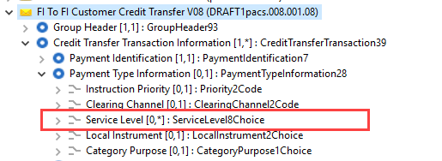
- Second implementation is an alternative, to add a new element TrackingLevel, and type the element with a choice component between a new external code set, containing the elements requested through the separate external code set change request (ISO 20022 CR 00736 – External Code ServiceLevel) and a proprietary element, leaving the service level unchanged:
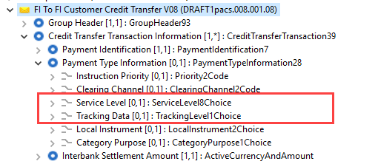
- In attachment, you will find an exhaustive list of the Xpath for all ServiceLevel elements which should be updated in the messages.

Question to the SEG: which option should be implemented?

Proposed timing:
The submitting organisation confirms that it can implement the requested changes in the requested timing, with following considerations:
- For the messages listed in the “Related messages” section, that is, which have been requested by the submitter of this change request or any other change request in this maintenance change request document (except for CR00751), we propose to implement the change in all messages which are part of the impacted message set during this maintenance cycle.
- For all other messages in the message sets only identified through the impact analysis, we propose to implement the change only at the occasion of the next maintenance of the messages, that is, the change will be approved by the SEG for implementation, but does not justify maintenance of the messages in its own right. It will be pending implementation until more critical change requests are received for the messages.
List of message sets in which the change will be implemented during this cycle:
- Exceptions and Investigations message set
- Payments Clearing and Settlement message set
- Payments Initiation message set
List of message sets in which the change will NOT be implemented during this cycle:
- Account Switching message set
- Stand-Alone Remittance Advice message set

Final decision of the SEG(s):
This section is not to be taken care of by the submitting organisation. It will be completed in due time by the SEG(s) in charge of the related ISO 20022 messages.
Approve
Comments:

Reject
Reason for rejection:

Change request CR00746: Add an optional EnclosedFile element
This chapter must be completed for every change request that the submitting organisation has been requested to implement.

Origin of the request:
A.1 Submitter:
European Payments Council (EPC)
Cours Saint-Michel 30A, B-1040 Brussels
Belgium
A.2 Contact person:
Mr Valentin Vlad (valentin.vlad@epc-cep.eu)
A.3 Sponsors:
EPC Multi-stakeholder Group on E-invoice Presentment and Payments (EIPP MSG) upon invitation by the ERPB
Organisations represented in the EIPP MSG:
- EPC (European Payments Council)
- EESPA (European E-invoicing Service Providers Association)
- EACT (European Association of Corporate Treasurers)
- EuroCommerce (association representing the retail, wholesale and international trade sector in Europe)
- EcommerceEurope (association representing companies selling goods and/or services online to consumers in Europe)

Related messages:
- pain.013.001.06 CreditorPaymentActivationRequestV06
- pain.014.001.06 CreditorPaymentActivationRequestStatusReportV06

Description of the change request:
Addition of an optional and repetitive element to pain.013.001.06 and pain.014.001.06, derived from the existing element Enclosed File This element will be used to transport the E-invoice along with the Request-to-pay within the ISO messages.
Enclosed File already exists in the ISO trade messages (tsrv) but the request is to add a new element that is inspired from the Enclosed File but with some differences (see below). The purpose is not to change the existing Enclosed File (Document9) in the tsrv messages.

The optional and repetitive element will contain following sub-elements:

Element Name | Element Definition | Multiplicity | DataType
Type* | Type of document or template. | [1..1] | Choice between Code (‘20-DocumentType’ External Code Set list) or Proprietary
Identifier* | Identification of the document or template. | [1..1] | Max35Text
Issue Date Time¹ | Issue date of the document. | [1..1] | DateAndDateTimeChoice
Name¹ | Name of the document or transaction, for example, tax invoice. | [0..1] | Max140Text
Language Code¹ | Unique identifier for a language used the document. | [0..1] | ISO 639 to be used in 2 or 3 letter variant (example: English = EN or ENG)
Format* | Format of the document or template, such as PDF, XML, XSLT. | [1..1] | Choice between Code (‘37-DocumentFormat’ External Code Set list) or Proprietary
File Name² | Technical name of the File. | [0..1] | Max140Text
Digital signature* | Digital signature | [0..1] | Includes Party Identification and signature
Enclosure* | Binary file representing the enclosed document or template, such as a PDF file, image file, XML file, MT message. | [1..1] | Max10MBBinary (see additional request infra)
*Element has been functionality inherited from the existing Enclosed File element (Document9).
^{1’}Name’, ‘IssueDateTime’ and ‘Language Code’ help users in a Business-To-Customer interface to display some info prior to open/download.
^{2’}FileName’ ensures a common end-to-end name from upload to download.

The below schema is only used as a visual representation of the additional element. No proper xml tags used at this stage for the elements added to the existing EnclosedFile. (IssueDateTime, Name, LanguageCode, FileName added).

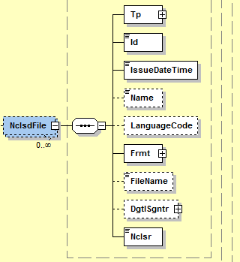

Note:

As part of this CR, it is being requested to:

a. For ‘Type’: Add an additional code to the ExternalDocumentType1Code list in the ISO external code set list. The additional code to be added it ‘OTHR’ (other). As part of the EIPP project, it is not currently possible to specify all types of documents that could be inserted..

b. For ‘Enclosure’: In the current element Document9, “Enclosure” has a capacity/data type of 2 MB Binary. In the EIPP context the Files (Invoices, credit notes, etc,…) could easily exceed the data type Max2MBBinary. Therefore, a datatype with higher capacity is being requested.
Request: Definitively register the data type Max10MBBinary (that is currently provisionally registered) and use it for Enclosure.

Requested Location of the “optional” Enclosed File in the pain.013 and pain.014 :

In the pain.013 -> Level 1 (after remittance information)
In the pain.014
- Level 3 (after Original Transaction Reference) -> This can include a document issued by the Payer to be delivered to the Payee, different from the original document received in the pain.013
- Level 4 (after remittance information in Original Transaction Reference) -> This optionally includes the same Enclosed File as was present in the pain.013.

For pain.013:
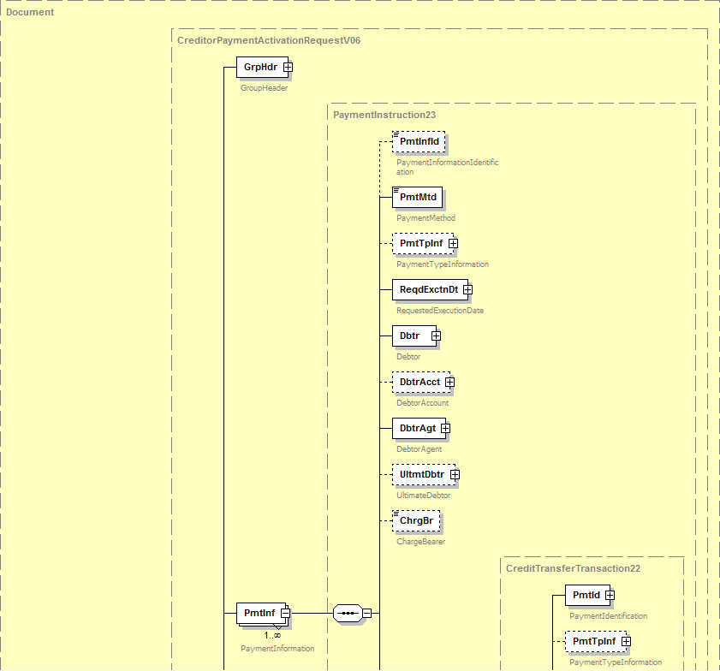
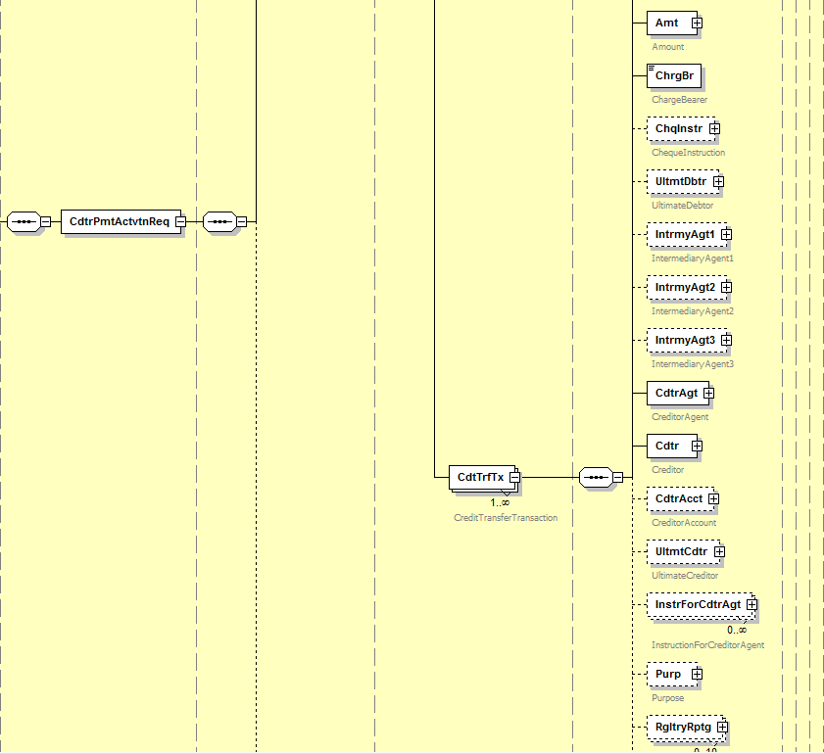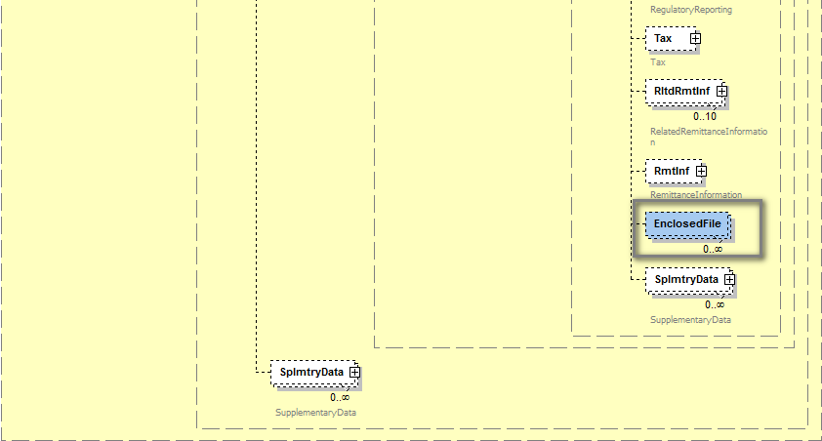

For pain.014:

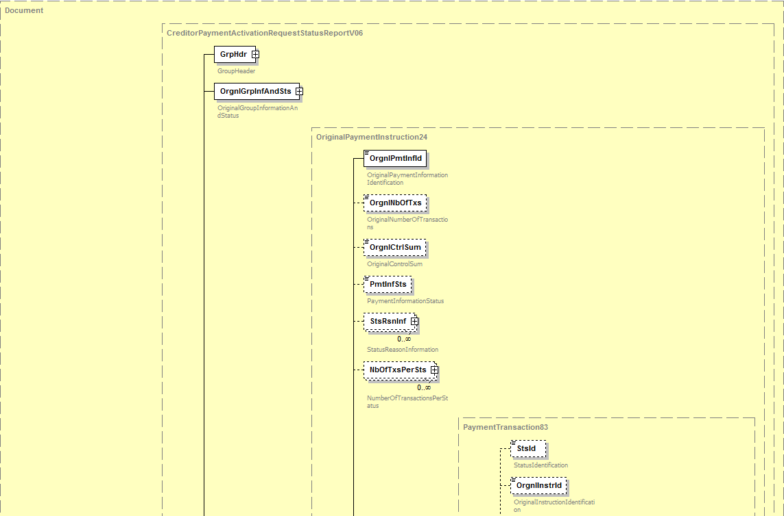
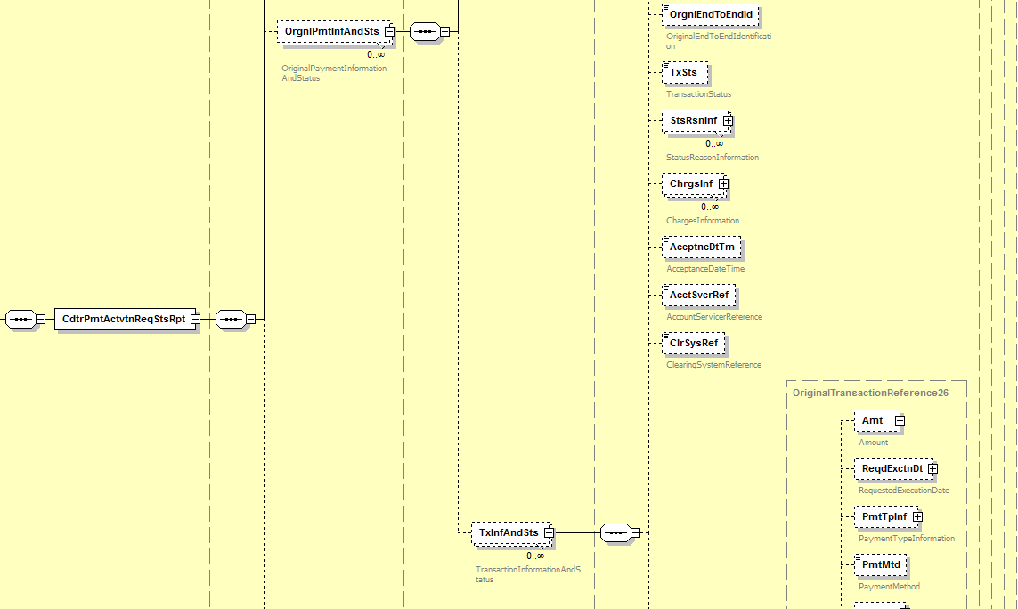
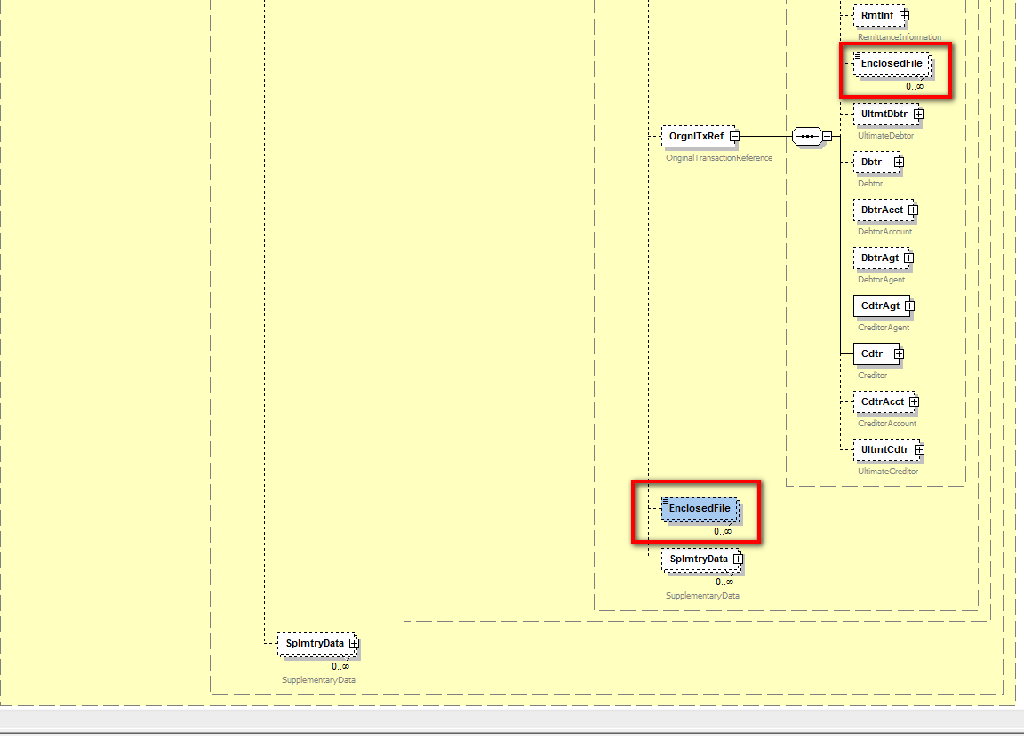

Purpose of the change:
At the end of the year 2016 the ERPB mandated a working group to define the minimum requirements for EIPP at the levels of business rules and technical standards and report on the outcome of its work in one year. The working group’s report was approved and published in November 2017. The ERPB took note of the report and endorsed the set of minimum requirements for the development of pan-European interoperability of EIPP services. Following a step-by-step approach, the work would first focus on the adoption of a technical ISO 20022-based message for Request-to-pay for EIPP and the harmonisation of other EIPP “servicing messages”. The ERPB invited the EPC to coordinate the required work among the payment services providers with the involvement of other stakeholders including e-invoicing solution providers.
Responding to the invitation of the ERPB to coordinate the follow-up work, the EPC created the EPC Multi-stakeholder Group on EIPP (EIPP MSG) which started its activity in February 2018. As indicated by the ERPB, the EIPP MSG is focusing in 2018 on the adoption of a standardised technical ISO 20022-based message for Request-to-pay and the harmonisation of other identified servicing messages related to EIPP.
After analysing the existing pain.013 and pain.014 messages (Creditor Payment Activation Request and Report), the EIPP MSG considers that they are to a large extent suitable for the requirements related to Request-to-pay identified in the ERPB report. Nevertheless, the delivery of the underlying E-invoice and other related E-documents was highlighted as an important requirement. Although the current version of the pain.013 message could partially respond to this need by making use of the field Related Remittance Information or Supplementary Data, in which references (e.g. URLs) to the E-invoices could be added, it was considered necessary to support the inclusion of E-invoices and other E-documents as attachments within the pain.013 message. Several arguments in favour of this option were found such as the need for a Request-to-pay to be a container for all information that it may refer to, the use of a single and secured channel for both request-to-pay and E-invoices, or the interoperability between various existing solutions that could be better achieved using attachments.
The fulfilment of the requirements, the analyses of the current practices and of the capabilities of a similar ISO 20022 element – EnclosedFile – present for example in tsrv.001, justified the request from the EIPP MSG for a new element with the structure described above. It is important to highlight that the “raw” document contained in the sub-element Enclosure can be in any format, binary (e.g. PDF) or XML (to transport any format of the E-invoices) by using the universal Base64 conversion. The other sub-elements help structuring the document with metadata.
By making use of this new element, the pain.013 message would support the needs of:
- Invoice issuers (Sellers/ Payees) by offering them a “vehicle” to transport the E-invoices and other documents along with the Request-to-pay
- Individual B2C Business-to-Consumer) customers (Payers) who will benefit from the function proposed by their PSP to view and pay the E-invoices directly within their PSP electronic channels
- Individual B2B (Business-to Business) customers (Payers) who can receive through a single interface XML request-to-pay and associated E-invoices, making possible the generation of payment orders and simultaneously the accountability related tasks
- Public administrations (e.g. tax services, public health services) as Payees for sending the payment requests along with administrative documents to individuals or businesses, or as Payers for receiving payment requests and associated E-invoices for procurement needs from services and goods suppliers.
- Payment Service Providers (PSPs) which will be able to propose to their customers a “one-stop” function combining the payment and the visualisation and download of E-invoices.
- E-invoicing Solution Providers which will have the possibility to enhance their products by encapsulating the E-invoices in a standardised envelop (request-to-pay) facilitating the payment.
Consequently, the pain.014 should be adapted for the same reasons.

Urgency of the request:
It is proposed to include this change request in the next regular maintenance cycle.

Business examples:
- In B2C (individual customers) or B2b (small enterprises), the Payee generates the Request-to-pay including the corresponding E-invoice and sends it to the Payer through the network (PSPs, EISPs, Clearing Houses, etc). The Payer can view and download the attached E-invoice. After having given its consent, he/she instructs its PSP to execute the payment and if needed to send a pain.014 using the existing ISO messages.

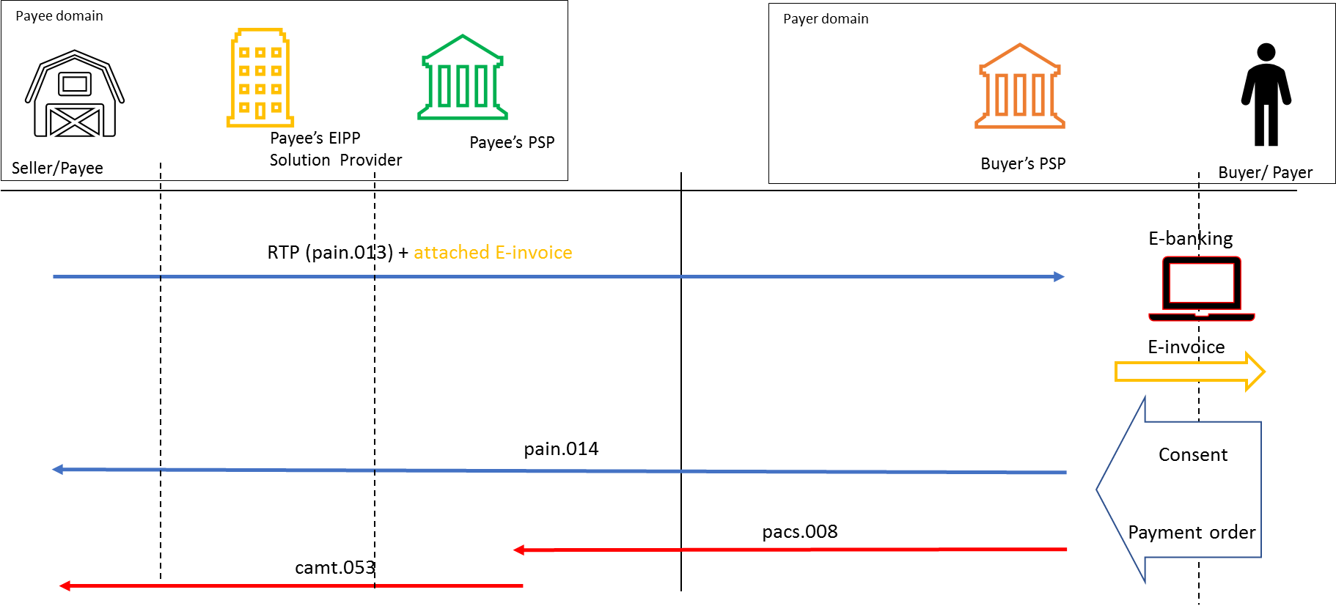

- In B2B (corporates), the Seller generates the Request-to-pay including the corresponding E-invoice and sends it to the Payer through the network (PSPs, EISPs, Clearing Houses, etc). The message reaches the Payer’s domain. The Payer gives its consent, its PSP generates the pain.014 message, generates the corresponding “Customer-To-Bank” payment message and extracts the attached E-invoice for processing.

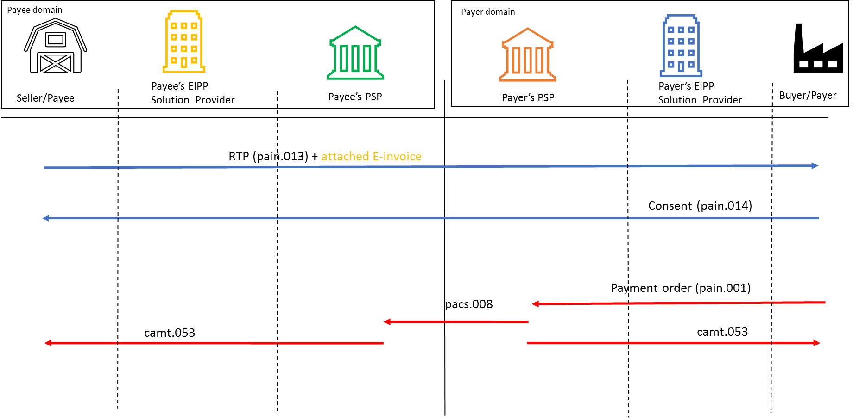

SEG/TSG recommendation:
This section is not to be taken care of by the submitter of the change request. It will be completed in due time by the SEG(s) in charge of the related ISO 20022 messages or the TSG for changes related to the BAH.

Consider |  | X | Timing
 |  |  | - Next yearly cycle: 2018/2019  (the change will be considered for implementation in the yearly maintenance cycle which starts in 2018 and completes with the publication of new message versions in the spring of 2019) |  | X
- At the occasion of the next maintenance of the messages
(the change will be considered for implementation, but does not justify maintenance of the messages in its own right – will be pending until more critical change requests are received for the messages)
- Urgent unscheduled
(the change justifies an urgent implementation outside of the normal yearly cycle)
 |  |  | - Other timing:
Comments:

Reject
Reason for rejection:

Impact analysis and type of impact:
Following the detailed analysis of the impact of the changes to the existing messages, we did not identify further impacted messages. The below list provides the full list of impacted messages:

Messages for which the change was requested:
- Creditor Payment Activation Request message set
  - CreditorPaymentActivationRequestV06 (pain.013.001.06)
  - CreditorPaymentActivationRequestStatusReportV06 (pain.014.001.06)
The severity of the impact of the proposed change for the message users should be indicated in the table below (either “no impact”, “conditional’ or “mandatory”).
Type of impact
 | No impact | The change(s) will not impact the schema (the version number will not change) and will not impact the business applications of any users, e.g. the clarification of a definition
X | Conditional | The change(s) will impact the schema (at least the version number) and the business applications of certain users but not all, e.g. the addition of an optional component
 | Mandatory | The change(s) will impact the schema and the business applications of all users, e.g. addition of a mandatory component.

Proposed implementation:
We support the implementation of the change request, with some additional considerations, resulting in the following structure:
- We propose to include following usage rule in the definition of the elements that will be added to the messages:
“Usage: The use of the EnclosedFile element must be bilaterally agreed.”
- A new Document12 message component will be created to type the EnclosedFile element and will contain following elements:
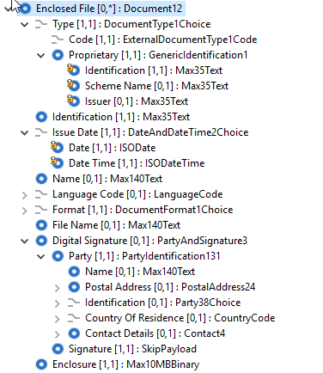
- CreditorPaymentActivationRequest (pain.013)
The EnclosedFile element will be added in the CreditTransferTransaction element as illustrated below:
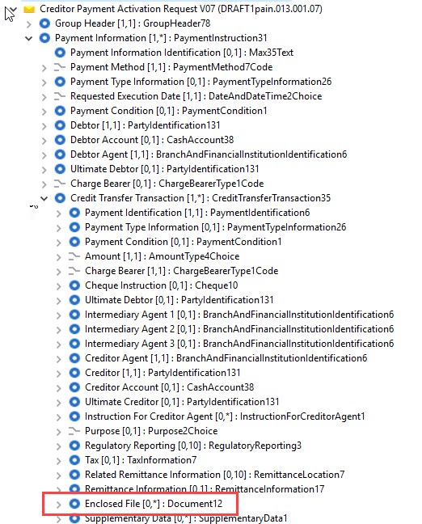
- CreditorPaymentActivationRequestStatusReport (pain.014)
The enclosed file element will be added both in the TransactionInformationAndStatus (this element will be used to new enclosed files related to the status message) and in the OriginalTransactionReference (this element will be used to provide an exact copy of the enclosed files of the original transaction) as illustrated below:
    - TransactionInformationAndStatus (enclosed files related to the status itself):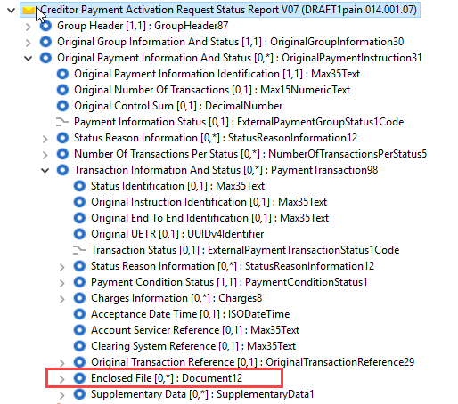
  - OriginalTransactionReference (copy of the enclosed file from the pain.013)
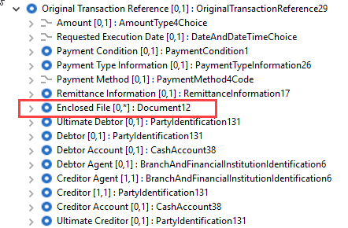

Proposed timing:
The submitting organisation confirms that it can implement the requested changes in the requested timing.

Timing | - As requested

Final decision of the SEG(s):
This section is not to be taken care of by the submitting organisation. It will be completed in due time by the SEG(s) in charge of the related ISO 20022 messages.
Approve
Comments:

Reject
Reason for rejection:

Change request CR00747: Add optional payment conditions
This chapter must be completed for every change request that the submitting organisation has been requested to implement.

Origin of the request:
A.1 Submitter:
European Payments Council (EPC)
Cours Saint-Michel 30A, B-1040 Brussels
Belgium
A.2 Contact person:
Mr Valentin Vlad (valentin.vlad@epc-cep.eu)
A.3 Sponsors:
EPC Multi-stakeholder Group on E-invoice Presentment and Payments
(EIPP MSG) upon invitation by the ERPB
Organisations represented in the EIPP MSG:
- EPC (European Payments Council)
- EESPA (European E-invoicing Service Providers Association)
- EACT (European Association of Corporate Treasurers)
- EuroCommerce (association representing the retail, wholesale and international trade sector in Europe)
- EcommerceEurope (association representing companies selling goods and/or services online to consumers in Europe)

Related messages:
- pain.013.001.06 CreditorPaymentActivationRequestV06
- pain.014.001.06 CreditorPaymentActivationRequestStatusReportV06

Description of the change request:
Changes to respond to real business needs in the market, and new usage of the pain.013 and pain.014

Changes applicable both to pain.013 and pain.014:

Change 1: Addition of Expiry Date

Element Name | Element Definition | Multiplicity | DataType
Expiry Date | Date by which the Debtor must have accepted/rejected the creditor payment activation request. Beyond this date, the request becomes void and therefore cannot be accepted/rejected anymore. | [0..1] | DateAndDateTimeChoice

Requested Location of the Expiry Date in the pain.013 and pain.014 :

Element Name | pain.013 | pain.014
Expiry Date | Level 2/below Requested Execution Date | Level3/in Original Transaction Reference below Requested Execution Date

Change 2: Addition of Amount Modification Allowed Indicator

Element Name | Element Definition | Multiplicity | DataType
Amount Modification Allowed Indicator | Indicates if the Debtor is allowed to pay a different amount than the amount requested by the Creditor. | [0..1] | Boolean (TRUE/FALSE)

Requested Location of the ‘Amount Modification Allowed Indicator’ in the pain.013 and pain.014 :

Element Name | pain.013 | pain.014
Amount Modification Allowed Indicator | Level 2, under Payment Information, after 'Payment Method' and  Level 3, under credit transfer transaction, after the element 'amount'  Rule to be created that if it is used at Payment Information level, it cannot be used at Credit Transfer Transaction Level and vice versa. If used at Level 2, the Amount Modification Allowed Indicator applies to each individual transaction included in the Credit Transfer Transaction section. | Level 4, under Original Transaction Reference, after 'amount'

Change 3: Addition of Early Payment Allowed Indicator
Element Name | Element Definition | Multiplicity | DataType
Early Payment Allowed Indicator | Indicates if the Debtor is allowed to make the payment before the Requested Execution Date specified by the Creditor. | [0..1] | Boolean (TRUE/FALSE)
Requested Location of the ‘Early Payment Allowed Indicator’ in the pain.013 and pain.014 :

Element Name | pain.013 | pain.014
Early Payment Allowed Indicator | Level 2, under Payment Information, after 'Requested Execution Date' and  Level 3, under Credit Transfer Transaction after ‘Amount’  Rule to be created that if it is used at Payment Information level, it cannot be used at Credit Transfer Transaction Level and vice versa. If used at Level 2, the Early Payment Allowed Indicator applies to each individual transaction included in the Credit Transfer Transaction section. | Level 4, under Original Transaction Reference, after 'Requested Execution Date'

Change 4: Addition of 'Delay Penalty’

Element Name | Element Definition | Multiplicity | DataType
Delay Penalty | Information regarding the delay penalty applied by the Creditor if the Debtor pays after the execution date requested by the Creditor. | [0..1] | Max140Text

Requested Location of the ‘Delay Penalty’ in the pain.013 and pain.014 :

Element Name | pain.013 | pain.014
Delay Penalty | Level 2, under Payment Information, after 'Requested Execution Date' and  Level 3, under Credit Transfer Transaction after ‘Amount’  Rule to be created that if it is used at Payment Information level, it cannot be used at Credit Transfer Transaction Level and vice versa. If used at Level 2, the Delay Penalty applies to each individual transaction included in the Credit Transfer Transaction section. | Level 4, under Original Transaction Reference, after 'Requested Execution Date'

Change 5: Addition of 'Immediate Payment Rebate’

Element Name | Element Definition | Multiplicity | DataType
Immediate Payment Rebate | Discount rate applied by the Creditor for immediate payments on reception of the pain.013. | [0..1] | PercentageRate

Requested Location of the ‘Immediate Payment Rebate’ in the pain.013 and pain.014 :

Element Name | pain.013 | pain.014
Immediate Payment Rebate | Level 2, under Payment Information, after 'Requested Execution Date' and  Level 3, under Credit Transfer Transaction after ‘Amount’  Rule to be created that if it is used at Payment Information level, it cannot be used at Credit Transfer Transaction Level and vice versa. If used at Level 2, the Immediate Payment Rebate rate applies to each individual transaction included in the Credit Transfer Transaction section. | Level 4, under Original Transaction Reference, after 'Requested Execution Date'

Change 6: Addition of 'Guaranteed Payment Requested Indicator’

Element Name | Element Definition | Multiplicity | DataType
Guaranteed Payment Requested Indicator | Indicates if a payment guarantee is requested by the Creditor, assuming that a payment guarantee contract exists between the different actors. | [0..1] | Boolean (TRUE/FALSE)

Requested Location of the ‘Guaranteed Payment Requested Indicator’ in the pain.013 and pain.014 :

Element Name | pain.013 | pain.014
Guaranteed Payment Requested Indicator | Level 2, under Payment Information, after 'Requested Execution Date' and  Level 3, under Credit Transfer Transaction after ‘Amount’  Rule to be created that if it is used at Payment Information level, it cannot be used at Credit Transfer Transaction Level and vice versa. If used at Level 2, the Guaranteed Payment Requested Indicator applies to each individual transaction included in the Credit Transfer Transaction section. | Level 4, under Original Transaction Reference, after 'Requested Execution Date'

Changes applicable only applicable to pain.014:

Change 7: Addition of ‘Accepted Amount’

Element Name | Element Definition | Multiplicity | DataType
Accepted Amount | Amount accepted to be paid by the Debtor. Usage Rule: can be used only if the element ‘Amount Modification Allowed Indicator’ received in the pain.013 is TRUE. | [0..1] | ActiveCurrencyAndAmount

Requested Location of the ‘Paid Amount’ in the pain.014 :

Element Name | pain.013 | pain.014
Accepted Amount | N/A | Level 3, under Transaction Information and Status, after Status Reason Information

Change 8: Addition of ‘Debtor Decision DateTime’

Element Name | Element Definition | Multiplicity | DataType
Debtor Decision DateTime | DateTime of the Debtor's acceptation or rejection of the request.  Usage Rule: If present it must be less than the value of ‘Expiry Date’ in the pain.013 message. | [0..1] | ISODateTime

Requested Location of the ‘Debtor Decision DateTime in the pain.014 :

Element Name | pain.013 | pain.014
Debtor Decision DateTime | N/A | Level 3, under Transaction Information and Status, after Acceptance Date Time

Change 9: Addition of ‘Guaranteed Payment Indicator’

Element Name | Element Definition | Multiplicity | DataType
Guaranteed Payment Indicator | Indicates if the Debtor Agent guarantees the payment, assuming that an agreement regarding the guarantee of payment exists between the different actors. | [0..1] | boolean (TRUE/FALSE)

Requested Location of the ‘Guaranteed Payment Indicator’ in the pain.014 :

Element Name | pain.013 | pain.014
Guaranteed Payment Indicator | N/A | Level 3, under Transaction Information and Status, after Status Reason Information

Change 10: Addition of ‘Early Payment Indicator’
Element Name | Element Definition | Multiplicity | DataType
Early Payment Indicator | Indicates if the Debtor will make the payment before the Requested Execution Date specified by the Creditor.  Usage Rule: If present, it cannot be TRUE if the value of ‘Allowed Early Payment Indicator’ received in the pain.013 message is FALSE. | [0..1] | Boolean (TRUE/FALSE)
Requested Location of the ‘Early Payment Indicator’ in the pain.014 :

Element Name | pain.013 | pain.014
Early Payment Indicator | N/A | Level 3, under Transaction Information and Status, after Status Reason Information

For the pain.013:

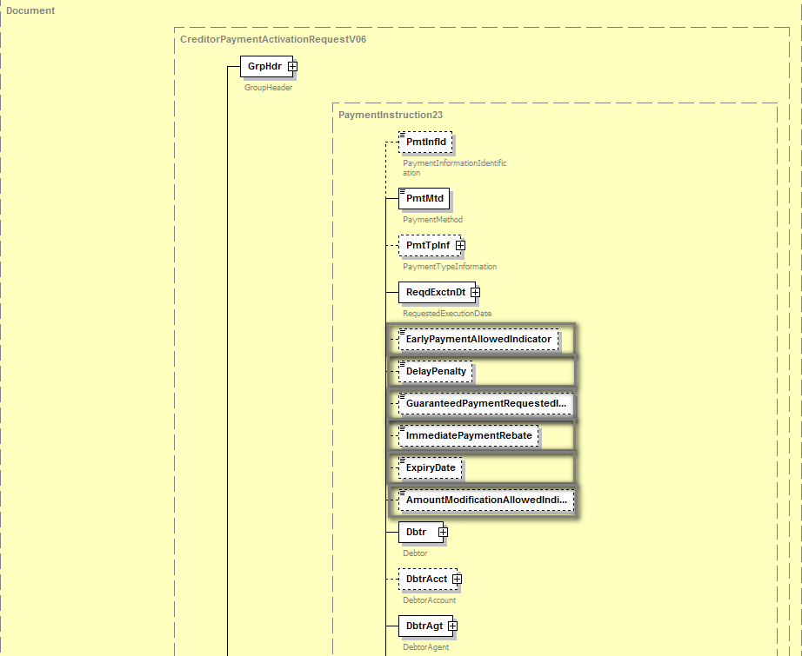
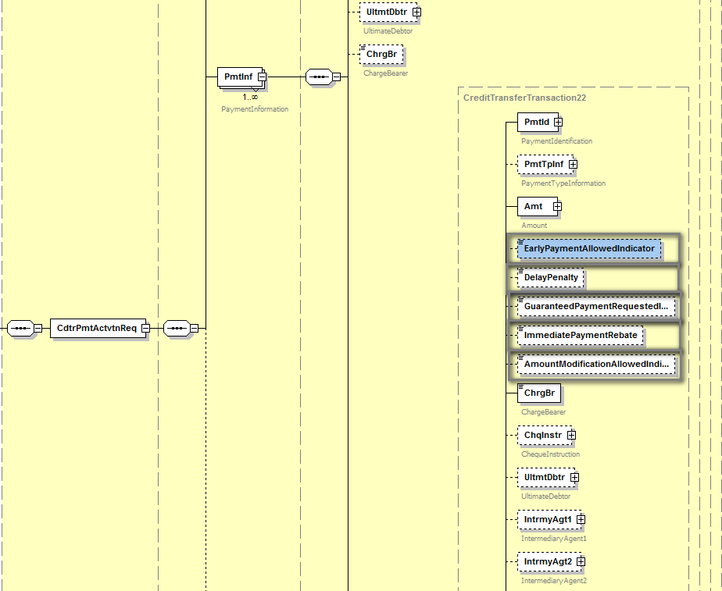
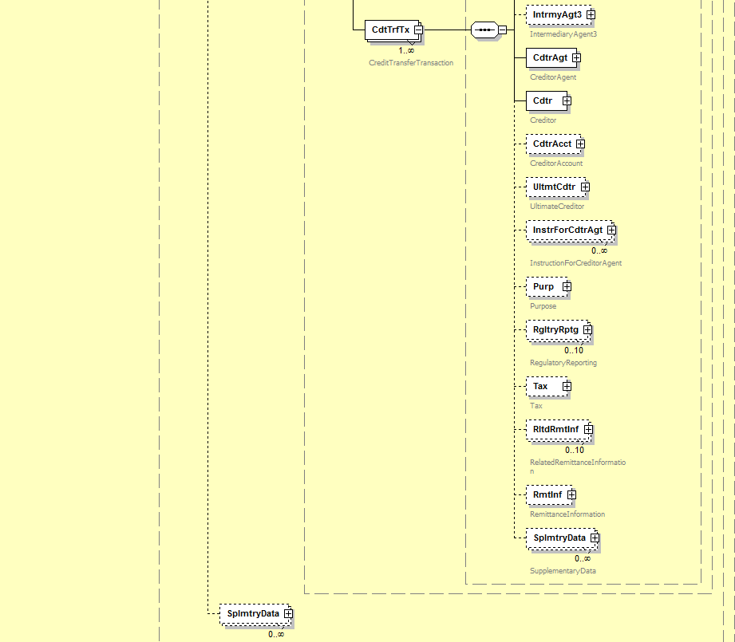
For the pain.014:

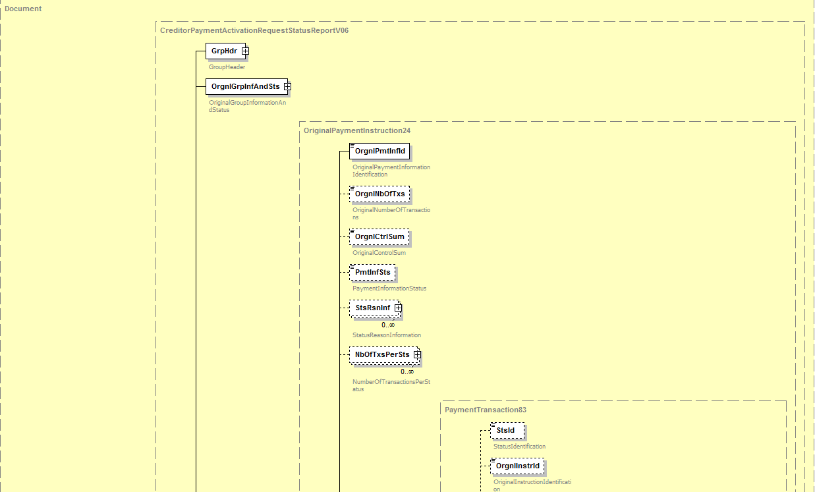
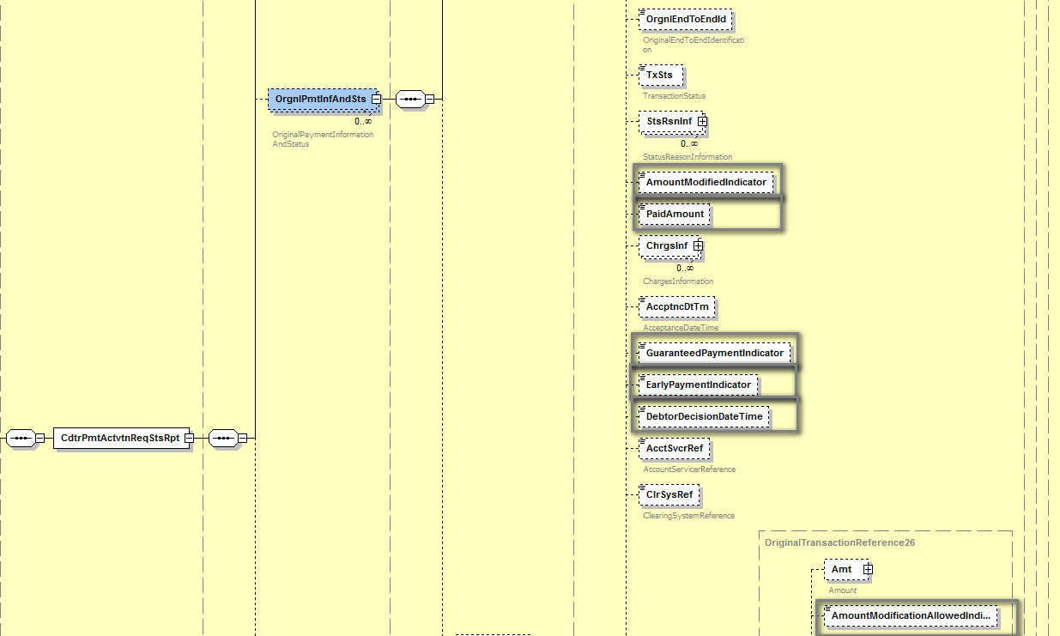
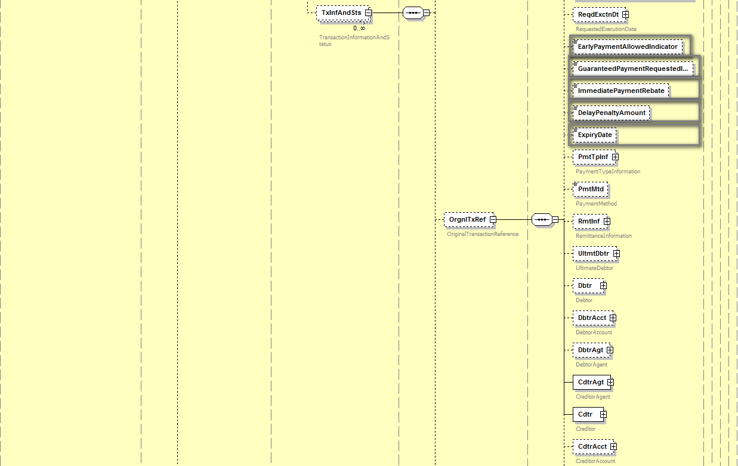

Purpose of the change:
At the end of the year 2016 the ERPB mandated a working group to define the minimum requirements for EIPP at the levels of business rules and technical standards and report on the outcome of its work in one year. The working group’s report was approved and published in November 2017. The ERPB took note of the report and endorsed the set of minimum requirements for the development of pan-European interoperability of EIPP services. Following a step-by-step approach, the work would first focus on the adoption of a technical ISO 20022-based message for Request-to-pay for EIPP and the harmonisation of other EIPP “servicing messages”. The ERPB invited the EPC to coordinate the required work among the payment services providers with the involvement of other stakeholders including e-invoicing solution providers.
Responding to the invitation of the ERPB to coordinate the follow-up work, the EPC created the EPC Multi-stakeholder Group on EIPP (EIPP MSG) which started its activity in February 2018. As indicated by the ERPB, the EIPP MSG is focusing in 2018 on the adoption of a standardised technical ISO 20022-based message for Request-to-pay and the harmonisation of other identified servicing messages related to EIPP.
After analysing the existing pain.013 and pain.014 messages (Creditor Payment Activation Request and Report), the EIPP MSG considered that they are to a large extent suitable for the requirements related to Request-to-pay identified in the ERPB report.
It has been estimated however that some elements are required to add more flexibility regarding the expectations of the Seller/Payee in terms of payment parameters and the decisions of the Debtor/Payer. For example, the Payee may wish to inform the Payer that the amount of the Request-to-pay can be different from the amount really paid, and the Payer may wish to inform the Payee in the response message that the amount will be different and the real value that will be paid. Two fields allowing minimal information about penalties for late payments or discounts for early payments were also considered useful to respond to requirements related to financing techniques such as factoring.
A new data element was added to fulfil a need from some markets in relation to the payment expected time. More precisely the Payee can inform the Payer if the payment is allowed before the requested execution time. A corresponding element has been added in the pain.014 message.
By making use of these new fields, the new pain.013 and pain.014 messages would answer to the needs of:
- Invoice issuers (Payees/Sellers) by offering them more flexibility in informing the Payers/Debtors about commercial terms of the transaction.
- Invoice receivers (Payers/Debtors) by proposing them more possibilities to inform the Payees/Sellers on specific decisions in relation with the commercial terms or upcoming payment transaction.
- All actors by offering elements for further uses of the Request-to-pay beyond the E-invoicing, such as E-commerce and retail commerce in physical shops.

Urgency of the request:
It is proposed to include this change request in the next regular maintenance cycle.

Business examples:

In B2C (individual customers) or B2b (small enterprises), the Seller adds payment conditions to the Request-to-pay. The message is sent through the network (PSPs, EISPs, Clearing Houses, etc) and reaches the Payer’s domain. After checking the conditions and making selections, the Payer gives its consent and instructs its PSP on the response to be sent via the pain.014 message and on the upcoming payment message (pacs.008).

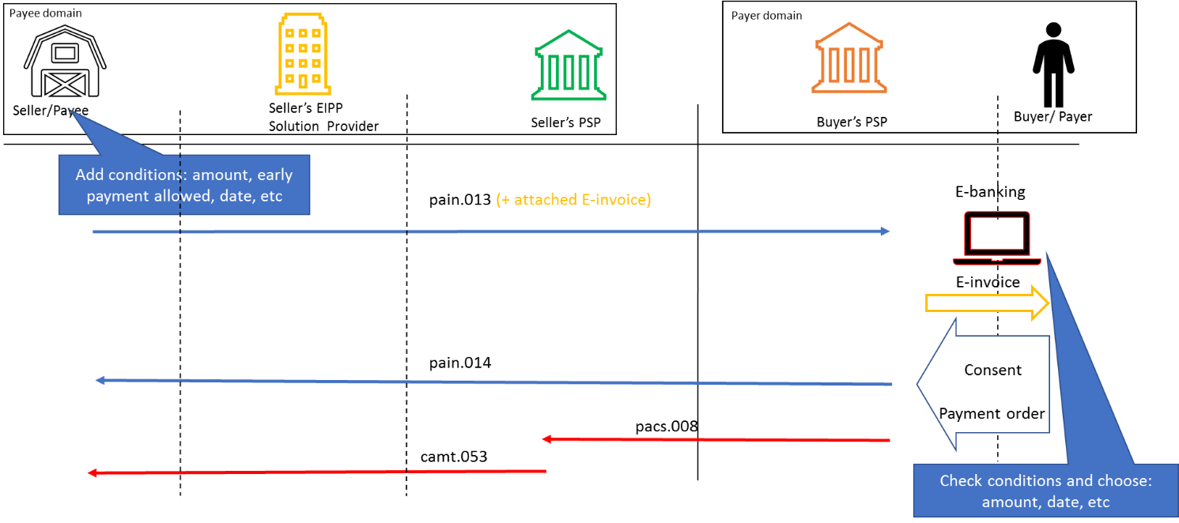

SEG/TSG recommendation:
This section is not to be taken care of by the submitter of the change request. It will be completed in due time by the SEG(s) in charge of the related ISO 20022 messages or the TSG for changes related to the BAH.

Consider |  | X | Timing
 |  |  | - Next yearly cycle: 2018/2019  (the change will be considered for implementation in the yearly maintenance cycle which starts in 2018 and completes with the publication of new message versions in the spring of 2019) |  | X
- At the occasion of the next maintenance of the messages
(the change will be considered for implementation, but does not justify maintenance of the messages in its own right – will be pending until more critical change requests are received for the messages)
- Urgent unscheduled
(the change justifies an urgent implementation outside of the normal yearly cycle)
 |  |  | - Other timing:
Comments:

Reject
Reason for rejection:

Impact analysis and type of impact:
Following the detailed analysis of the impact of the changes to the existing messages, we did not identify further impacted messages. The below list provides the full list of impacted messages:

Messages for which the change was requested in the change request:
- Creditor Payment Activation Request message set
  - CreditorPaymentActivationRequestV06 (pain.013.001.06)
  - CreditorPaymentActivationRequestStatusReportV06 (pain.014.001.06)
The severity of the impact of the proposed change for the message users should be indicated in the table below (either “no impact”, “conditional’ or “mandatory”).
Type of impact
 | No impact | The change(s) will not impact the schema (the version number will not change) and will not impact the business applications of any users, e.g. the clarification of a definition
X | Conditional | The change(s) will impact the schema (at least the version number) and the business applications of certain users but not all, e.g. the addition of an optional component
 | Mandatory | The change(s) will impact the schema and the business applications of all users, e.g. addition of a mandatory component.

Proposed implementation:
We support the implementation of the change request with an alternative proposal to group the newly required elements into two specific blocks, as previously agreed with the submitter of the change request, resulting in the following structure:
Payment Conditions:
- In the CreditorPaymentActivationRequest message (pain.013):
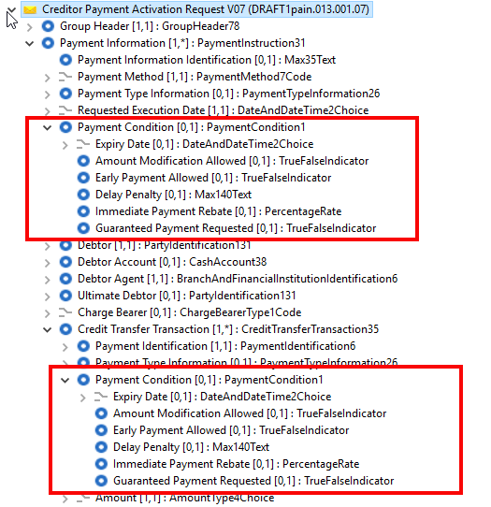
- In the CreditorPaymentActivationRequest (pain.014):
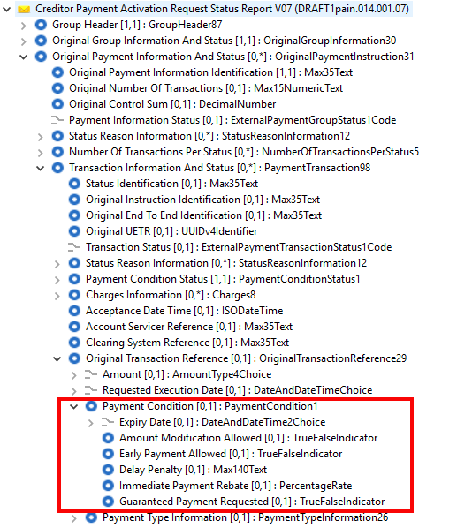
Payment Condition Status:
- In the CreditorPaymentActivationRequest (pain.014):
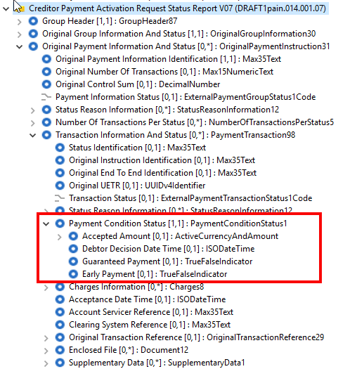
Note for the Payments SEG: During the evaluation call, the possibility to add an ExpectedEarlyPaymentDate has been evoked by a representative of the Payments SEG, subject to further questions to be sent to the submitter of the change request. However, there was no follow up during this summer and no question has been asked to the submitter. Therefore, if the point is still relevant, the EPC representatives (submitter of the change request) are ready provide clarification during the final review based on questions previously received, if the discussion is still needed. Otherwise this note will be fully removed from the final version of the MCR.
- Exclusive presence rule of each of the elements present in the PaymentCondition element in the pain.013:
If it is used at Payment Information level, it cannot be used at Credit Transfer Transaction Level and vice versa. If used at Level 2, the element applies to each individual transaction included in the Credit Transfer Transaction section.
- Remark: as per ISO 20022 modelling guidelines, the indicators should all be mandatory, however we propose to add a Usage in all indicator, indicating that when absence the default value of the indicator is False.

Proposed timing:
The submitting organisation confirms that it can implement the requested changes in the requested timing.

Timing | - As requested

Final decision of the SEG(s):
This section is not to be taken care of by the submitting organisation. It will be completed in due time by the SEG(s) in charge of the related ISO 20022 messages.
Approve
Comments:

Reject
Reason for rejection:

Change request CR00748: Add an optional cash account alias
This chapter must be completed for every change request that the submitting organisation has been requested to implement.

Origin of the request:
A.1 Submitter: The New Payment System Operator (NPSO) United Kingdom
A.2 Contact person(s): Helen Bygrave helen.bygrave@newpso.uk +44 (0)20 3217 8398
James Whittle, Director, International Standards and Services james.whittle@newpso.uk +44 (0)20 3217 8209
A.3 Sponsors: Bank of England Real Time Gross Settlement (RTGS) Renewal Programme
Neil Pearston, Analyst, neil.pearston@bankofengland.co.uk + 44 (0) 20 3461 4893

Related messages:
- pacs.002.001.09 - FIToFIPaymentStatusReportV09
- pacs.003.001.07 – FIToFICustomerDirectDebitV07
- pacs.004.001.08 - PaymentReturnV08
- pacs.007.001.08 - FIToFIPaymentReversalV08
- pacs.008.001.07 - FIToFICustomerCreditTransferV07
- pacs.009.001.07 - FinancialInstitutionCreditTransferV07
- pacs.010.001.02 - FinancialInstitutionDirectDebitV02
- pacs.028.001.02 - FIToFIPaymentStatusRequestV02

- pain.001.001.08 - CustomerCreditTransferInitiationV08
- pain.002.001.09 - CustomerPaymentStatusReportV09
- pain.007.001.08 - CustomerPaymentReversalV08
- pain.008.001.07 - CustomerDirectDebitInitiationV07

- camt.052.001.07 - BankToCustomerAccountReportV07
- camt.053.001.07 - BankToCustomerStatementV07
- camt.054.001.07 - BankToCustomerDebitCreditNotificationV07
- camt.056.001.07 - FIToFIPaymentCancellationRequestV07
- camt.060.001.04 - AccountReportingRequestV04

Description of the change request:
For Debtor and Creditor account introduce an optional field to reference an alias for the account. Create a new external code list to record valid alias identification schemes.

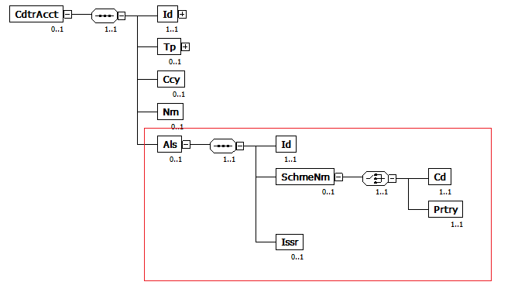
Submitter has requested an amendment of the change request on 22 August 2018 with following update:
New proposal:
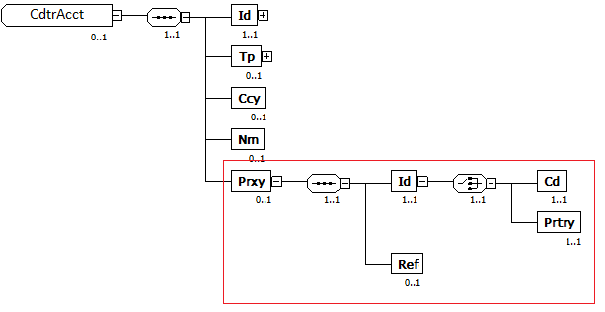

Purpose of the change:
With the introduction of additional ways of identifying an account, such as mobile phone number, used by PAYM in the UK, and other person to person mobile payments currently being investigated in Europe, there is a need to provide an alias to an account to carry this information. Such an alias is required to be carried throughout the payment chain to identify both the underlying true account and how the account was identified.
An account alias may not always be personal to the account holder. For example, it may in the future, be linked to the International Mobile Equipment Identity (IMEI) number of their mobile phone or even to a retailer’s point of sale terminal. Because of this, we feel that this information should be carried with the account details rather than the account owner’s details.
Crucially the account alias will allow payments to be initiated and processed without the involved parties actually knowing the underlying bank account numbers, which for the purposes of clearing and settlement are essential.
It may not be the alias itself that is carried in the message but rather a reference to that alias thus protecting the underlying information. For example credit card PANs could be tokenised so that these numbers no longer have to be carried as references.

Urgency of the request:
It is proposed to include this change request in the next regular maintenance cycle.

Business examples:

An IMEI is directly used as an alias to reference the account.
<CdtrAcct>
<Id>
<IBAN> DE89 3704 0044 0532 0130 00</IBAN>
</Id>
<Tp>
<Cd>CACC</Cd>
</Tp>
<Ccy>EUR</Ccy>
<Als>
<Id>990000862471854</Id>
<SchmeNm>
<Cd>IMEI</Cd>
</SchmeNm>
</Als>
</CdtrAcct>

An underlying reference to an alias is used to reference the account.
<CdtrAcct>
<Id>
<IBAN>FR14 2004 1010 0505 0001 3M02 606</IBAN>
</Id>
<Tp>
<Cd>CACC</Cd>
</Tp>
<Ccy>EUR</Ccy>
<Als>
<Id>ALRF1234567890</Id>
<SchmeNm>
<Cd>ALRF</Cd>
</SchmeNm>
</Als>
</CdtrAcct>

A point of sale terminal ID is used as an alias to reference the account.
<CdtrAcct>
<Id>
<Other>
<Id>12345678</Id>
</Other>
</Id>
<Tp>
<Cd>CACC</Cd>
</Tp>
<Ccy>GBP</Ccy>
<Als>
<Id> POS_ID_123456789</Id>
<SchmeNm>
<Cd>POST</Cd>
</SchmeNm>
</Als>
</CdtrAcct>

SEG/TSG recommendation:
This section is not to be taken care of by the submitter of the change request. It will be completed in due time by the SEG(s) in charge of the related ISO 20022 messages or the TSG for changes related to the BAH.

Consider |  | X | Timing
 |  |  | - Next yearly cycle: 2018/2019  (the change will be considered for implementation in the yearly maintenance cycle which starts in 2018 and completes with the publication of new message versions in the spring of 2019) |  | X
- At the occasion of the next maintenance of the messages
(the change will be considered for implementation, but does not justify maintenance of the messages in its own right – will be pending until more critical change requests are received for the messages)
- Urgent unscheduled
(the change justifies an urgent implementation outside of the normal yearly cycle)
 |  |  | - Other timing:
Comments:

Reject
Reason for rejection:

Impact analysis and type of impact:
Following the detailed analysis of the impact of the changes to the existing messages, we did not identify further impacted messages. The below list provides the full list of impacted messages:

Messages for which the change was requested in the change request:
- Bank-to-Customer Cash Management message set
  - BankToCustomerAccountReportV07 (camt.052.001.07)
  - BankToCustomerStatementV07 (camt.053.001.07)
  - BankToCustomerDebitCreditNotificationV07 (camt.054.001.07)
  - AccountReportingRequestV04 (camt.060.001.04)
- Notification to Receive message set
  - NotificationToReceiveStatusReportV05 (camt.059.001.05)
- Payments Clearing and Settlement
  - FIToFIPaymentStatusReportV09 (pacs.002.001.09)
  - FIToFICustomerDirectDebitV07 (pacs.003.001.07)
  - PaymentReturnV08 (pacs.004.001.08)
  - FIToFIPaymentReversalV08 (pacs.007.001.08)
  - FIToFICustomerCreditTransferV07 (pacs.008.001.07)
  - FinancialInstitutionCreditTransferV07 (pacs.009.001.07)
  - FinancialInstitutionDirectDebitV02 (pacs.010.001.02)
  - FIToFIPaymentStatusRequestV02 (pacs.028.001.02)
- Payments Initiation message set
  - CustomerCreditTransferInitiationV08 (pain.001.001.08)
  - CustomerPaymentStatusReportV09 (pain.002.001.09)
  - CustomerPaymentReversalV08 (pain.007.001.08)
  - CustomerDirectDebitInitiationV07 (pain.008.001.07)
- Creditor Payment Activation Request message
  - CreditorPaymentActivationRequestV06 (pain.013.001.06)
  - CreditorPaymentActivationRequestStatusReportV06 (pain.014.001.06)
Additional messages impacted, for which the change has not been explicitly requested. If we want to keep a consistent component throughout all payments messages, the change request would also have to be implemented.
- Bank Account Management message set
  - AccountOpeningRequestV02 (acmt.007.001.02)
  - AccountOpeningAmendmentRequestV02 (acmt.008.001.02)
  - AccountReportV02 (acmt.014.001.02)
- Account Switching message set
  - AccountSwitchInformationRequestV01 (acmt.027.001.01)
  - AccountSwitchInformationResponseV01 (acmt.028.001.01)
  - AccountSwitchCancelExistingPaymentV01 (acmt.029.001.01)
  - AccountSwitchRequestRedirectionV01 (acmt.030.001.01)
  - AccountSwitchRequestBalanceTransferV01 (acmt.031.001.01)
  - AccountSwitchBalanceTransferAcknowledgementV01 (acmt.032.001.01)
  - AccountSwitchRequestPaymentV01 (acmt.034.001.01)
  - Authorities Financial Investigations
  - InformationRequestOpeningV01 (auth.001.001.01)
  - InformationRequestResponseV01 (auth.002.001.01)
- Cross-Border Transactions Currency Control Reporting message set
  - ContractRegistrationStatementV01 (auth.022.001.01)
  - PaymentRegulatoryInformationNotificationV01 (auth.024.001.01)
- Cash Management message set (candidate messages)
  - ReturnAccountV07 (camt.004.001.07)
  - ReturnTransactionV07 (camt.006.001.07)
  - ReturnMemberV03 (camt.014.001.03)
  - ModifyStandingOrderV05 (camt.024.001.05)
  - LiquidityCreditTransferV04 (camt.050.001.04)
  - LiquidityDebitTransferV04 (camt.051.001.04)
  - GetStandingOrderV02 (camt.069.001.02)
  - ReturnStandingOrderV03 (camt.070.001.03)
  - DeleteStandingOrderV02 (camt.071.001.02)
- Exceptions and Investigations message set
  - UnableToApplyV06 (camt.026.001.06)
  - ClaimNonReceiptV06 (camt.027.001.06)
  - AdditionalPaymentInformationV08 (camt.028.001.08)
  - ResolutionOfInvestigationV08 (camt.029.001.08)
  - DebitAuthorisationRequestV06 (camt.037.001.06)
  - CustomerPaymentCancellationRequestV07 (camt.055.001.07)
  - FIToFIPaymentCancellationRequestV07 (camt.056.001.07)
  - RequestToModifyPaymentV05 (camt.087.001.05)
- Notification to Receive message set
  - NotificationToReceiveV05 (camt.057.001.05)
  - NotificationToReceiveCancellationAdviceV05 (camt.058.001.05)
- Bank Services Billing message set
  - BankServicesBillingStatementV02 (camt.086.001.02)
- Payments Mandates message set
  - MandateInitiationRequestV05 (pain.009.001.05)
  - MandateAmendmentRequestV05 (pain.010.001.05)
  - MandateCancellationRequestV05 (pain.011.001.05)
  - MandateAcceptanceReportV05 (pain.012.001.05)
  - MandateCopyRequestV01 (pain.017.001.01)
  - MandateSuspensionRequestV01 (pain.018.001.01)
- Stand-Alone Remittance Advice
  - RemittanceAdviceV03 (remt.001.001.03)

The severity of the impact of the proposed change for the message users should be indicated in the table below (either “no impact”, “conditional’ or “mandatory”).
Type of impact
 | No impact | The change(s) will not impact the schema (the version number will not change) and will not impact the business applications of any users, e.g. the clarification of a definition
X | Conditional | The change(s) will impact the schema (at least the version number) and the business applications of certain users but not all, e.g. the addition of an optional component
 | Mandatory | The change(s) will impact the schema and the business applications of all users, e.g. addition of a mandatory component.

Proposed implementation:
We support the implementation of the change request with an alternative proposal to following in coordination with the submitter of the change request, resulting in the following structure:
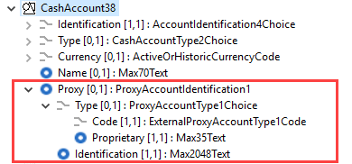
- Attached is an exhaustive list of the Xpath for all Proxy elements which need to be added to the messages.

Proposed timing:
The submitting organisation confirms that it can implement the requested changes in the requested timing, with following considerations:
- For the messages listed in the “Related messages” section, that is, which have been requested by the submitter of this change request or any other change request in this maintenance change request document (except for CR00751), we propose to implement the change in all messages which are part of the impacted message set during this maintenance cycle.
- For all other messages in the message sets only identified through the impact analysis, we propose to implement the change only at the occasion of the next maintenance of the messages, that is, the change will be approved by the SEG for implementation, but does not justify maintenance of the messages in its own right. It will be pending implementation until more critical change requests are received for the messages.
List of message sets in which the change will be implemented during this cycle:
- Bank-to-Customer Cash Management message set
- Payments Clearing and Settlement message set
- Payments Initiation message set
- Creditor Payment Activation Request message set
- Cash Management message set
- Exceptions and Investigations message set
- Notification to Receive message set
- Business Application Header (under the responsibility of the ISO 20022 TSG)

List of message sets in which the change will NOT be implemented during this cycle:
- Bank Account Management message set
- Change or Verify Account Identification message set
- Account Switching message set
- Authorities Financial Investigations message set
- Cross-Border Transactions Currency Control Reporting
- Bank Services Billing
- Payments Mandates message set
- Stand-Alone Remittance Advice

Timing | - As requested (taking into account the above considerations)

Final decision of the SEG(s):
This section is not to be taken care of by the submitting organisation. It will be completed in due time by the SEG(s) in charge of the related ISO 20022 messages.
Approve
Comments:

Reject
Reason for rejection:

Change request CR00749: Add tracker data elements
This chapter must be completed for every change request that the submitting organisation has been requested to implement.

Origin of the request:
A.1 Submitter:
SWIFT (SWIFT gpi)
A.2 Contact person:
Dominique Forceville/SWIFT/ +32.2.655.49.48
A.3 Sponsors:

Related messages:
pain.002.001.09

Description of the change request:
Context:
Today, the pain.002 is used by Debtor Agents to report status updates related to their corporate customers’ pain.001 payment initiations. Those updates are usually limited to the internal processing of the payment at the Debtor Agents’ side (accept/reject).
SWIFT gpi introduced ‘end-to-end’ interbank payments tracking allowing involved parties to receive regular updates during the life cycle of the payment transaction. These updates provide information about ‘amount transferred or credited’, ‘date & time of transfer or credit’, ‘location’, ‘status’, ‘charge bearer’, ‘deducts’, and FX information’. Each update also includes a historic overview of the information available until the point in time the update is provided.
The new elements that are subject of this request have already been introduced in the currently used version of the pain.002 (pain.002.001.03) via workarounds. CGI MP and an ISO expert group (of gpi banks/corporates) that SWIFT founded have approved these workarounds for version 3.
This change request is targeted to enhance the current pain.002.001.09 (and to go to version 10) allowing Debtor Agents to use it to convey the “interbank status information” (that they receive from the SWIFT gpi Tracker) to their corporate customer via “structured fields”.
Depending on the use case, for one specific gpi payment transaction, Debtor Agents may receive several updates from the Tracker and as such Debtor Agents may send several pain.002 messages to their corporate customers at different moments in time.

Status updates to the corporate customers with a pain.002 should include information about:
- the status & status reason,
- the status originator,
- the date/time when the confirmation to the SWIFT gpi Tracker was generated by the status originator, or the date/time when the creditor was credited and could use the funds (as confirmed by the status originator to the SWIFT gpi Tracker)
- the cash amount transferred in the interbank space (which can change in every leg) or cash amount credited on the creditor’s account,
- the instructed amount,
- the charge bearer (DEBT, CRED, SHAR),
- the deducted charges per involved agent,
- the FX related details (if FX occurred).
Some of the above elements (status/reason, status originator and instructed amount) are existing elements in the pain.002. The other elements currently do not exist in the pain.002 and are therefore subject of this change request.
CHANGE 1: Inclusion of new element ‘Confirmed Date and Time’

Element Name | Element Definition | Multiplicity | DataType | Proposed Location
Confirmed Date and Time  Tag: ConfdDtTm | - Point in time¹ when an agent provides a pending status update to the tracking system  - Point in time² when the creditor has been credited and can use the funds (as confirmed to the tracking system by the creditor agent). | [0..1] | ISO date and time | Level 3, in ‘Transaction Information and Status’ after ‘Status Reason Information’
¹‘Creation Date and Time’ in the Group Header cannot be used as it is the Date and Time when the pain.002 was created. The Date and Time that is to be reflected here is the date and time when the status originator provided a status update to the tracking system.
²‘Interbank Settlement Date’ in ‘Original Transaction Reference’ cannot be used as it is the possibly different from the date (and time) the funds were credited on the creditor’s account. Interbank Settlement Date is also lacking the ‘Time’ element.
CHANGE 2: Inclusion of new element ‘Confirmed Amount’

Element Name | Element Definition | Multiplicity | DataType | Proposed Location
Confirmed Amount¹  Tag: ConfdAmt | Amount confirmed to the tracking system by the agent. For example: Amount credited on the creditor’s account (after possible deducts) | [0..1] | ActiveCurrencyAndAmount | Level 3, in ‘Transaction Information and Status’ after ‘Status Reason Information’
¹‘Interbank Settlement Amount’ in the Original Transaction Reference cannot be used for the following reasons:
a. ‘Interbank Settlement Amount’ reflects the amount exchanged in the pacs.008 with the Creditor Agent. The amount that needs to be reflected here in ‘Confirmed Amount’ is the credited amount, confirmed to the tracking system by the Creditor Agent, after possible deducts.
b. ‘Confirmed Amount’ is also provided by the Tracker to inform about the amount that is transferred through the transaction chain. This amount could be equal to the ‘Interbank Settlement Amount’ but not in all cases.

CHANGE 3: Inclusion of new element ‘Interbank Transaction Information’.

Element Name | Element Definition | Multiplicity | DataType | Proposed Location
Interbank Transaction Information  Tag: IntrBkTxnInf | Provides chronological interbank transaction information per agent involved in the transaction chain. | [0..1] | Includes further element (see below) | Level 3, in ‘Transaction Information and Status’ after ‘Status Reason Information’

Element included in ‘Interbank Transaction Information’

Element Name | Element Definition | Multiplicity | DataType | Proposed Location
TrackedAgent  Tag: TrckdAgt | Provides transaction information for specific agent involved in the transaction chain. | [1..n] | Includes other elements (see below) | Level 4, in ‘Interbank Transaction Information’

Elements included in ‘TrackedAgent’

Element Name | Element Definition | Multiplicity | DataType | Proposed Location
Agent  Tag: Agt | Identification of a financial institution. | [1..1] | BranchAndFinancialInstitutionIdentification5 | Level 5, in ‘TrackedAgent’
Charge Bearer  Tag: ChrgBr | Specifies which party/parties bears the charges associated with the processing of the payment transaction. | [0..1] | ChargeBearerType1Code  (DEBT, CRED, SHAR) | Level 5, in ‘TrackedAgent’
ChargesInformation¹  Tag: ChrgsInf | Provides information on the charges to be paid by the charge bearer(s) related to the payment transaction. | [0..1] | Charges2 without the ‘Agent’ part. | Level 5, in ‘TrackedAgent’
ForeignExchangeDetails  Tag: FXDtls | Specifies the exchange rate details between two currencies. | [0..1] | Structure including: Source Currency, Target Currency, Exchange Rate and Unit Currency. | Level 5, in ‘TrackedAgent’
¹The existing element ‘Charges Information’ cannot be used as the definition clearly indicates that it is exclusively used in ‘reject use cases’. The ‘Charges Information’ inside the new ‘Interbank Transaction Information/Tracked Agent’ reflects the ‘deduct’ that a particular agent has performed on its leg of the payment transaction.

Schema (just provided for clarity and as such xml tags have not been used)
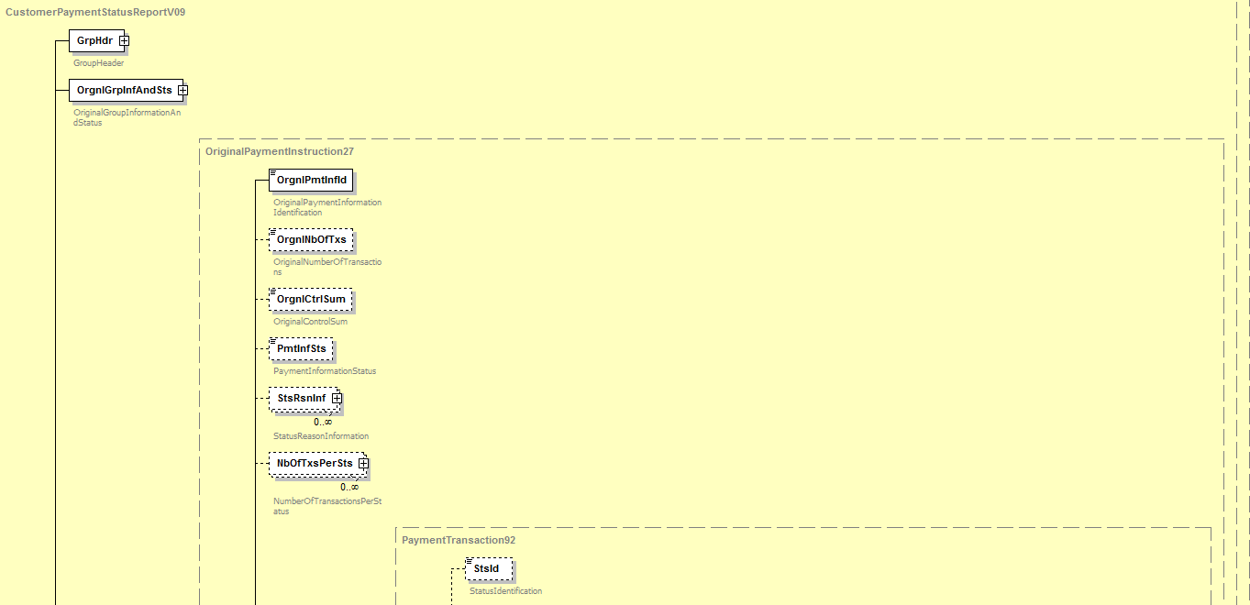
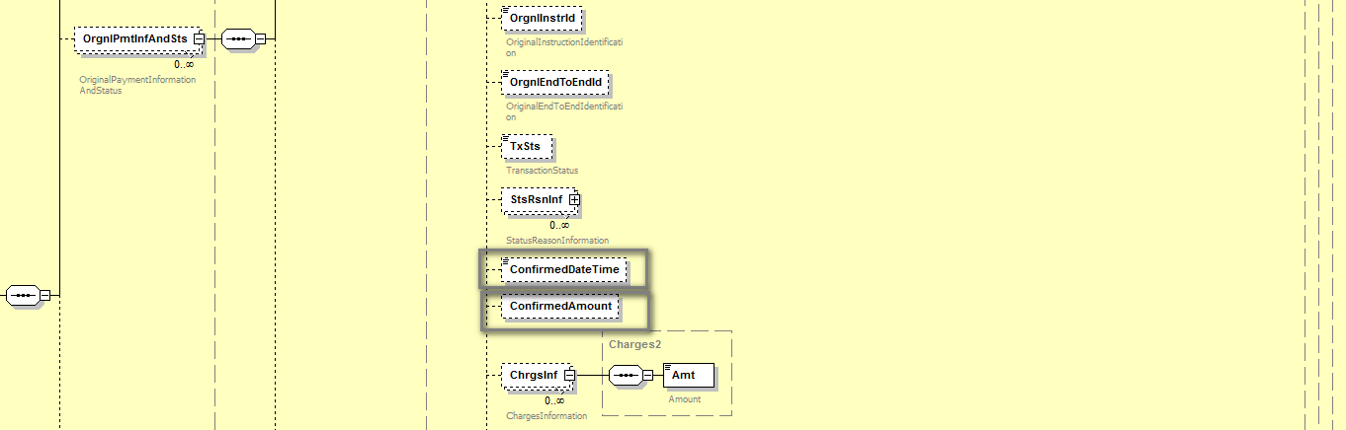
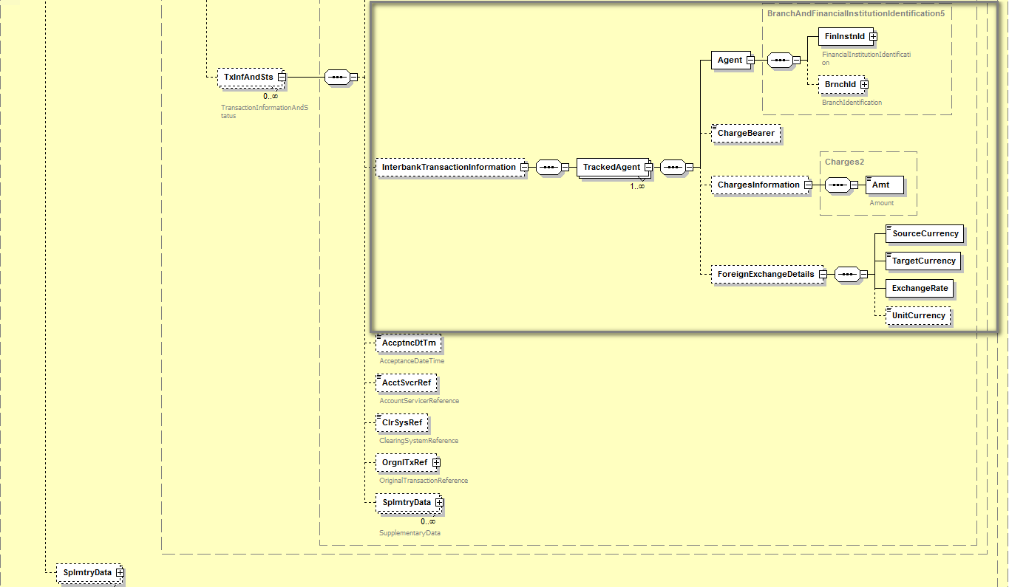

Purpose of the change:
Enhance the pain.002 to allow (multi-banked) corporates to benefit from “standardization” of ISO bank-to-corporate flows for tracking and confirmation of payments in corporate back-office systems. These flows should be automated and fully integrated in ERP and TMS systems.

Urgency of the request: SR2019

Business examples:
Business example:
Business example based on gpi customer payment transaction denominated in USD with Interbank Settlement Date 23 June 2018, involving a corporate (debtor) CORPBEBB and three gpi banks (BANABEBB is the Debtor Agent, BANBUS33 is the Intermediary Agent and BANCFRPP is the Creditor Agent). The Debtor Agent receives two Tracker updates (at different times) regarding this transaction and provides its corporate with two separate pain.002 messages.
Details of first pain.002:
Status: The transaction is confirmed as “received” by creditor agent, but the creditor agent has not confirmed the credit on the creditor’s account (yet).
Instructed amount: 1000 USD
Confirmed amount: 970 USD
Charge bearer: CRED.
Charge information: first gpi bank (deduct: 20 USD), second gpi bank (deduct: 10 USD). No deduct by third bank yet as payment is only “received” by third bank).
Confirmed Date and time: Date and Time when Tracker was updated (that is when the Tracker got acknowledgement that the payment was received at the Creditor Agent): 2018-06-23 at 09:30:11 (UTC)
Creation Date and time: Date and Time when BANABEBB (as Debtor Agent) produced the pain.002 and sent it to its corporate customer: 2018-06-23 at 09:35:00 (UTC)
FX: N/A

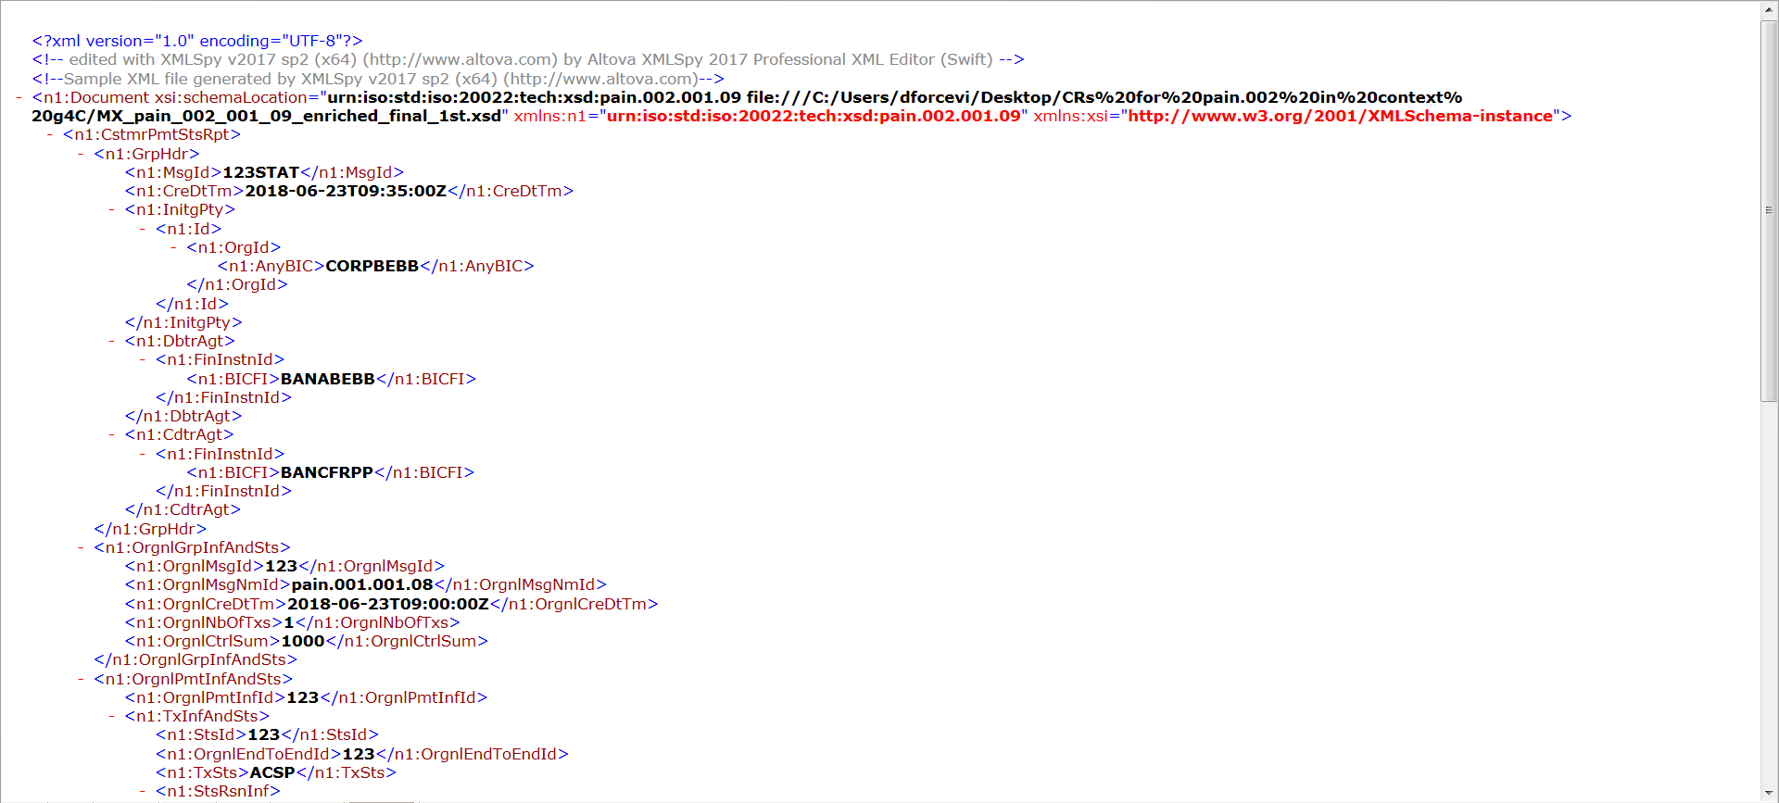
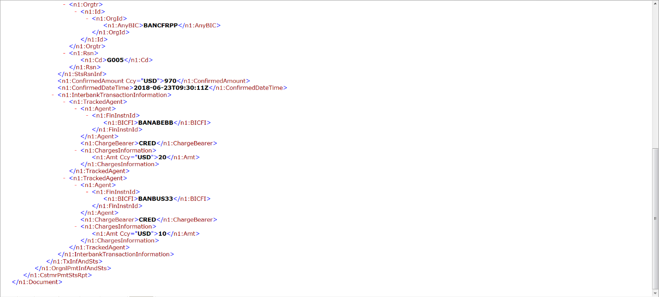
Details of second pain.002:
Status: The Creditor Agent confirmed credit to the creditor’s account.
Instructed amount: 1000 USD
Confirmed amount: 965 USD
Charge bearer: CRED.
Charge information: first gpi bank (deduct: 20 USD), second gpi bank (deduct: 10 USD) and third gpi bank (deduct: 5 USD).
Confirmed Date and time: Date and Time confirmed by the Creditor Agent when the creditor account was credited and Creditor could use the funds. 2018-06-23 at 11:35:27 (UTC)
Creation Date and time: Date and Time when BANABEBB (as Debtor Agent) produced the pain.002 and sent it to its corporate customer: 2018-06-23 at 11:40:00 (UTC)

FX: N/A

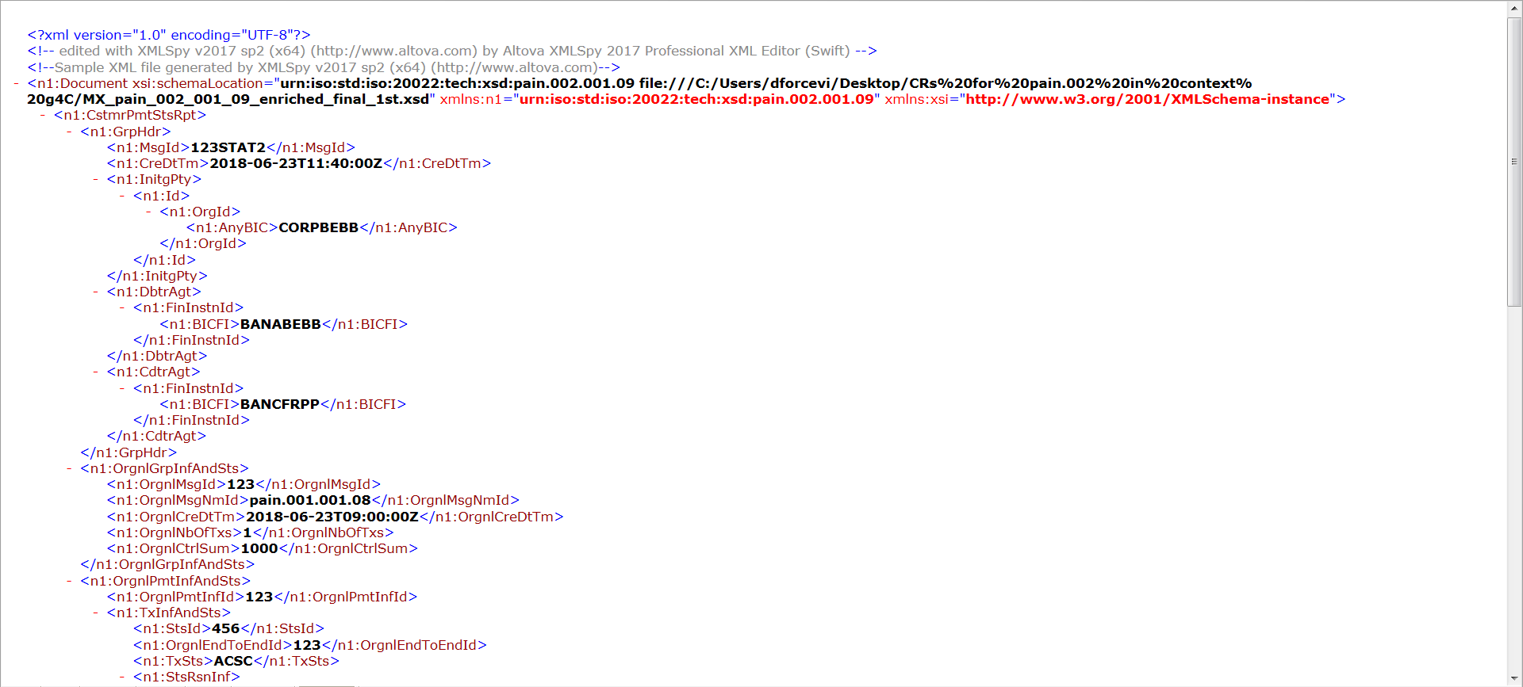
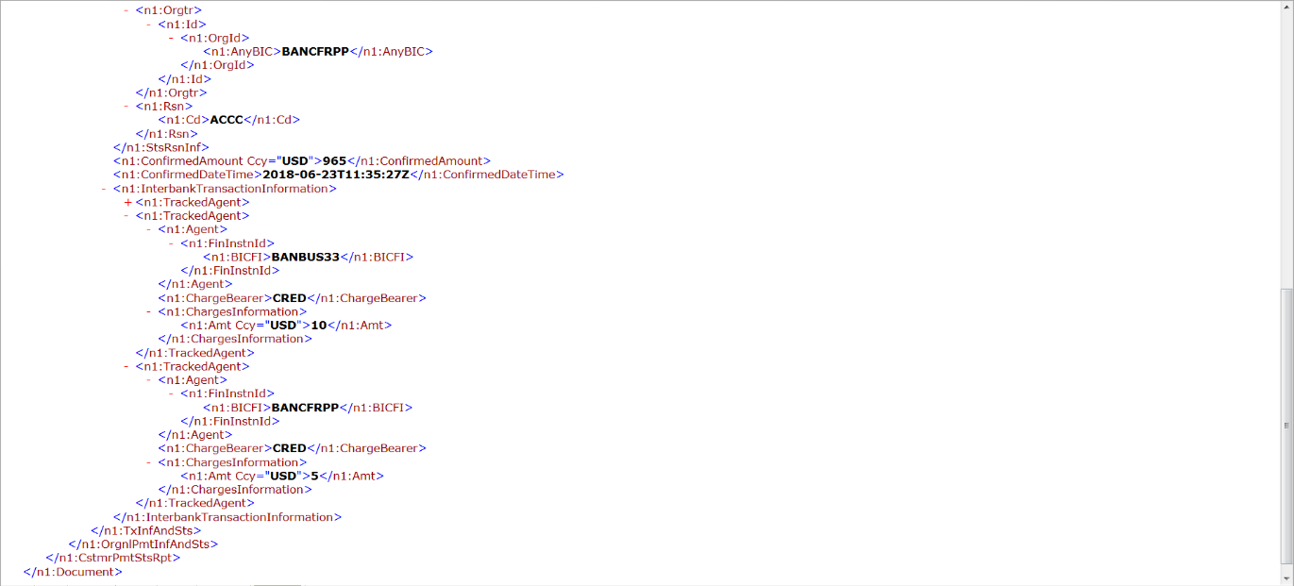

SEG/TSG recommendation:
This section is not to be taken care of by the submitter of the change request. It will be completed in due time by the SEG(s) in charge of the related ISO 20022 messages or the TSG for changes related to the BAH.

Consider |  | X | Timing
 |  |  | - Next yearly cycle: 2018/2019  (the change will be considered for implementation in the yearly maintenance cycle which starts in 2018 and completes with the publication of new message versions in the spring of 2019) |  | X
- At the occasion of the next maintenance of the messages
(the change will be considered for implementation, but does not justify maintenance of the messages in its own right – will be pending until more critical change requests are received for the messages)
- Urgent unscheduled
(the change justifies an urgent implementation outside of the normal yearly cycle)
 |  |  | - Other timing:
Comments:

Reject
Reason for rejection:

Impact analysis and type of impact:
Following the detailed analysis of the impact of the changes to the existing messages, we did not identify further impacted messages. The below list provides the full list of impacted messages:

Messages for which the change was requested in the change request:
- Payment Initiation message set
  - CustomerPaymentStatusReportV09 (pain.002.001.09)
The severity of the impact of the proposed change for the message users should be indicated in the table below (either “no impact”, “conditional’ or “mandatory”).
Type of impact
 | No impact | The change(s) will not impact the schema (the version number will not change) and will not impact the business applications of any users, e.g. the clarification of a definition
X | Conditional | The change(s) will impact the schema (at least the version number) and the business applications of certain users but not all, e.g. the addition of an optional component
 | Mandatory | The change(s) will impact the schema and the business applications of all users, e.g. addition of a mandatory component.

Proposed implementation:
We support the implementation of the change request with an alternative proposal to group the newly required elements into a single block, as previously agreed with the submitter of the change request, resulting in the following structure:
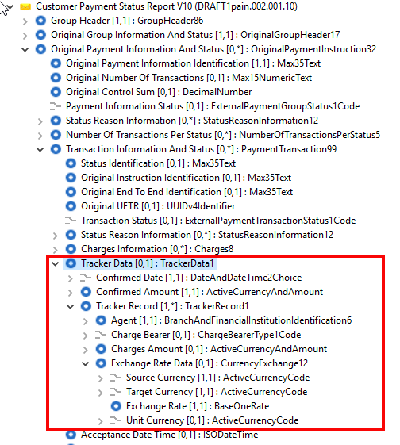

Proposed timing:
The submitting organisation confirms that it can implement the requested changes in the requested timing.

Timing | - As requested

Final decision of the SEG(s):
This section is not to be taken care of by the submitting organisation. It will be completed in due time by the SEG(s) in charge of the related ISO 20022 messages.
Approve
Comments:

Reject
Reason for rejection:

Change request CR00751: Modify BIC datatype
This chapter must be completed for every change request that the submitting organisation has been requested to implement.

Origin of the request:
A.1 Submitter: ISO 20022 Registration Authority.
A.2 Contact person: Karin Deridder (iso20022ra@iso20022.org)
A.3 Sponsors: N/A

Related messages:
All message definitions that use the AnyBICIdentifier or the BICIdentifier or the BICNonFIIdentifier.
The following message sets and messages are impacted.
Account Switching
Message Identifier | AnyBICIdentifier | BICFIIdentifier | BICNonFIIdentifier
acmt.027.001.01 | x | x
acmt.028.001.01 | x | x
acmt.029.001.01 | x | x
acmt.030.001.01 | x | x
acmt.031.001.01 | x | x
acmt.032.001.01 | x | x
acmt.034.001.01 | x | x
Authorities Financial Investigations
Message Identifier | AnyBICIdentifier | BICFIIdentifier | BICNonFIIdentifier
auth.001.001.01 | x | x
auth.002.001.01 | x | x
Bank Account Management
Message Identifier | AnyBICIdentifier | BICFIIdentifier | BICNonFIIdentifier
acmt.007.001.02 | x | x
acmt.008.001.02 | x | x
acmt.009.001.02 | x | x
acmt.010.001.02 | x | x
acmt.011.001.02 | x | x
acmt.012.001.02 | x | x
acmt.013.001.02 | x | x
acmt.014.001.02 | x | x
acmt.015.001.02 | x | x
acmt.016.001.02 | x | x
acmt.017.001.02 | x | x
acmt.018.001.02 | x | x
acmt.019.001.02 | x | x
acmt.020.001.02 | x | x
acmt.021.001.02 | x | x
Bank-to-Customer Cash Management
Message Identifier | AnyBICIdentifier | BICFIIdentifier | BICNonFIIdentifier
camt.052.001.07 | x | x
camt.053.001.07 | x | x
camt.054.001.07 | x | x
camt.060.001.04 | x | x
Bank Services Billing
Message Identifier | AnyBICIdentifier | BICFIIdentifier | BICNonFIIdentifier
camt.086.001.02 | x | x
Change/Verify Account Identification
Message Identifier | AnyBICIdentifier | BICFIIdentifier | BICNonFIIdentifier
acmt.022.001.02 | x | x
acmt.023.001.02 | x | x
acmt.024.001.02 | x | x
Creditor Payment Activation Request
Message Identifier | AnyBICIdentifier | BICFIIdentifier | BICNonFIIdentifier
pain.013.001.06 | x | x
pain.014.001.06 | x | x
Cross-border Transaction Currency Control Reporting (CTCCR)
Message Identifier | AnyBICIdentifier | BICFIIdentifier | BICNonFIIdentifier
auth.018.001.01 | x | x
auth.019.001.01 | x | x
auth.020.001.01 | x | x
auth.021.001.01 | x | x
auth.022.001.01 | x | x
auth.023.001.01 | x | x
auth.024.001.01 | x | x
auth.025.001.01 | x | x
auth.026.001.01 | x | x
auth.027.001.01 | x | x
Exceptions and Investigations
Message Identifier | AnyBICIdentifier | BICFIIdentifier | BICNonFIIdentifier
camt.026.001.06 | x | x
camt.027.001.06 | x | x
camt.028.001.08 | x | x
camt.029.001.08 | x | x
camt.030.001.04 | x | x
camt.031.001.05 | x | x
camt.032.001.03 | x | x
camt.033.001.05 | x | x
camt.034.001.05 | x | x
camt.035.001.04 | x | x
camt.036.001.04 | x | x
camt.037.001.06 | x | x
camt.038.001.03 | x | x
camt.039.001.04 | x | x
camt.055.001.07 | x | x
camt.056.001.07 | x | x
camt.087.001.05 | x | x
Notification to Receive
Message Identifier | AnyBICIdentifier | BICFIIdentifier | BICNonFIIdentifier
camt.057.001.05 | x | x
camt.058.001.05 | x | x
camt.059.001.05 | x | x
Payments Clearing and Settlement
Message Identifier | AnyBICIdentifier | BICFIIdentifier | BICNonFIIdentifier
pacs.002.001.09 | x | x
pacs.003.001.07 | x | x
pacs.004.001.08 | x | x
pacs.007.001.08 | x | x
pacs.008.001.07 | x | x
pacs.009.001.07 | x | x
pacs.010.001.02 |  | x
pacs.028.001.02 | x | x
Payments Initiation
Message Identifier | AnyBICIdentifier | BICFIIdentifier | BICNonFIIdentifier
pain.001.001.08 | x | x
pain.002.001.09 | x | x
pain.007.001.08 | x | x
pain.008.001.07 | x | x
Payments Mandates
Message Identifier | AnyBICIdentifier | BICFIIdentifier | BICNonFIIdentifier
pain.009.001.05 | x | x
pain.010.001.05 | x | x
pain.011.001.05 | x | x
pain.012.001.05 | x | x
pain.017.001.01 | x | x
pain.018.001.01 | x | x
Stand-alone Remittance Advice
Message Identifier | AnyBICIdentifier | BICFIIdentifier | BICNonFIIdentifier
remt.001.001.03 | x | x
remt.002.001.01 | x | x
Central Counterparty Clearing (CCP Clearing
Message Identifier | AnyBICIdentifier | BICFIIdentifier | BICNonFIIdentifier
secl.001.001.03 | x
secl.002.001.03 | x
secl.003.001.03 | x
secl.004.001.03 | x
secl.005.001.02 | x
secl.006.001.02 | x
secl.007.001.03 | x
secl.008.001.03 | x
secl.009.001.03 | x
secl.010.001.03 | x
Collateral Management
Message Identifier | AnyBICIdentifier | BICFIIdentifier | BICNonFIIdentifier
colr.003.001.04 | x
colr.004.001.04 | x
colr.005.001.04 | x
colr.006.001.04 | x
colr.007.001.05 | x
colr.008.001.05 | x
colr.009.001.04 | x
colr.010.001.04 | x
colr.011.001.04 | x
colr.012.001.04 | x
colr.013.001.04 | x
colr.014.001.04 | x
colr.015.001.04 | x
colr.016.001.03 | x
Corporate Actions
Message Identifier | AnyBICIdentifier | BICFIIdentifier | BICNonFIIdentifier
seev.031.001.08 | x
seev.033.001.08 | x
seev.034.001.09 | x
seev.035.001.09 | x
seev.036.001.09 | x | x
seev.037.001.09 | x
seev.038.001.04 | x
seev.039.001.08 | x
seev.040.001.07 | x
seev.041.001.08 | x
seev.042.001.07 | x
seev.044.001.08 | x
Corporate Actions Variant 002
Message Identifier | AnyBICIdentifier | BICFIIdentifier | BICNonFIIdentifier
seev.031.002.08 | x
seev.033.002.08 | x
seev.034.002.09 | x
seev.035.002.09 | x
seev.036.002.09 | x | x
seev.037.002.09 | x
seev.038.002.04 | x
seev.039.002.08 | x
seev.040.002.07 | x
seev.041.002.08 | x
seev.042.002.07 | x
seev.044.002.08 | x
Financial Instruments and Transactions Regulatory Reporting
(Transactions and Financial Instruments Data Reporting)
N/A
Investment Funds
Message Identifier | AnyBICIdentifier | BICFIIdentifier | BICNonFIIdentifier
acmt.001.001.07 | x | x
acmt.002.001.07 | x | x
acmt.003.001.07 | x | x
acmt.005.001.05 | x
acmt.006.001.06 | x
camt.040.001.04 | x
camt.041.001.04 | x
camt.042.001.04 | x
camt.043.001.04 | x
camt.044.001.03 | x
camt.045.001.03 | x
reda.001.001.04 | x
reda.002.001.04 | x
reda.005.001.02 | x
semt.001.001.03 | x
semt.002.001.02 | x
semt.003.001.02 | x
semt.004.001.02 | x
semt.005.001.02 | x
semt.006.001.03 | x
semt.007.001.03 | x
sese.001.001.08 | x
sese.002.001.08 | x
sese.003.001.08 | x
sese.004.001.08 | x
sese.005.001.08 | x
sese.006.001.08 | x
sese.007.001.08 | x
sese.008.001.08 | x
sese.009.001.06 | x
sese.010.001.06 | x
sese.011.001.06 | x
sese.012.001.08 | x | x
sese.013.001.08 | x | x
sese.014.001.08 | x
sese.018.001.06 | x
sese.019.001.05 | x
setr.001.001.04 | x | x
setr.002.001.04 | x
setr.003.001.04 | x | x
setr.004.001.04 | x | x
setr.005.001.04 | x
setr.006.001.04 | x | x
setr.007.001.04 | x | x
setr.008.001.04 | x
setr.009.001.04 | x | x
setr.010.001.04 | x | x
setr.011.001.04 | x
setr.012.001.04 | x | x
setr.013.001.04 | x | x
setr.014.001.04 | x
setr.015.001.04 | x | x
setr.016.001.04 | x
setr.017.001.04 | x
setr.018.001.04 | x
setr.047.001.02 | x
setr.049.001.02 | x
setr.051.001.02 | x
setr.053.001.02 | x
setr.055.001.02 | x
setr.057.001.02 | x
setr.058.001.02 | x
Issuers' Agents Communication
Message Identifier | AnyBICIdentifier | BICFIIdentifier | BICNonFIIdentifier
seev.009.001.01 | x
seev.010.001.01 | x
seev.011.001.01 | x
seev.012.001.01 | x
seev.013.001.01 | x
seev.014.001.01 | x
seev.015.001.01 | x
seev.016.001.01 | x
seev.017.001.01 | x
seev.018.001.01 | x
seev.019.001.01 | x
seev.020.001.01 | x
seev.021.001.01 | x
seev.022.001.01 | x
seev.023.001.01 | x
seev.024.001.01 | x
seev.025.001.01 | x
seev.026.001.01 | x
seev.027.001.01 | x
seev.028.001.01 | x
seev.029.001.01 | x
seev.030.001.01 | x
Money Market Statistical Reporting
N/A
Post Trade Matching
Message Identifier | AnyBICIdentifier | BICFIIdentifier | BICNonFIIdentifier
semt.023.001.01 | x
setr.027.001.03 | x |  | x
setr.029.001.01 | x
setr.030.001.01 | x
setr.044.001.02 | x
Proxy Voting
Message Identifier | AnyBICIdentifier | BICFIIdentifier | BICNonFIIdentifier
seev.001.001.05 | x
seev.002.001.05 | x
seev.003.001.05 | x
seev.004.001.05 | x
seev.005.001.05 | x
seev.007.001.05 | x
seev.008.001.05 | x
Settlement and Reconciliation
Message Identifier | AnyBICIdentifier | BICFIIdentifier | BICNonFIIdentifier
semt.002.001.09 | x
semt.003.001.09 | x
semt.013.001.04 | x
semt.014.001.05 | x
semt.015.001.07 | x
semt.016.001.07 | x
semt.017.001.08 | x
semt.018.001.09 | x
semt.019.001.07 | x
semt.020.001.05 | x
semt.021.001.06 | x
semt.022.001.03 | x
sese.020.001.05 | x
sese.021.001.04 | x
sese.022.001.04 | x
sese.023.001.08 | x | x
sese.024.001.09 | x
sese.025.001.08 | x | x
sese.026.001.07 | x | x
sese.027.001.05 | x
sese.028.001.07 | x | x
sese.029.001.04 | x
sese.030.001.07 | x
sese.031.001.07 | x
sese.032.001.08 | x | x
sese.033.001.08 | x | x
sese.034.001.07 | x
sese.035.001.08 | x | x
sese.036.001.06 | x
sese.037.001.05 | x
sese.038.001.06 | x | x
sese.039.001.04 | x
sese.040.001.02 | x
Settlement and Reconciliation Variant 002
Message Identifier | AnyBICIdentifier | BICFIIdentifier | BICNonFIIdentifier
semt.002.002.09 | x
semt.003.002.09 | x
semt.013.002.04 | x
semt.014.002.05 | x
semt.015.002.07 | x
semt.016.002.07 | x
semt.017.002.08 | x
semt.018.002.09 | x
semt.019.002.07 | x
semt.020.002.05 | x
semt.021.002.06 | x
semt.022.002.03 | x
sese.020.002.05 | x
sese.021.002.04 | x
sese.022.002.04 | x
sese.023.002.08 | x | x
sese.024.002.09 | x
sese.025.002.08 | x | x
sese.026.002.07 | x | x
sese.027.002.05 | x
sese.028.002.07 | x | x
sese.029.002.04 | x
sese.030.002.07 | x
sese.031.002.07 | x
sese.032.002.08 | x | x
sese.033.002.08 | x | x
sese.034.002.07 | x
sese.035.002.08 | x | x
sese.036.002.06 | x
sese.037.002.05 | x
sese.038.002.06 | x | x
sese.039.002.04 | x
sese.040.002.02 | x
Standing Settlement Instructions for Securities, Payments and FX
Message Identifier | AnyBICIdentifier | BICFIIdentifier | BICNonFIIdentifier
reda.056.001.01 | x | x
reda.057.001.01 | x
reda.058.001.01 | x
reda.059.001.01 | x
Total Portolio Valuation Report
N/A
Transparency of Holdings
Message Identifier | AnyBICIdentifier | BICFIIdentifier | BICNonFIIdentifier
semt.041.001.02 | x
semt.042.001.01 | x
Demand Guarantees and Standby Letters of Credit
Message Identifier | AnyBICIdentifier | BICFIIdentifier | BICNonFIIdentifier
tsin.005.001.01 | x
tsrv.001.001.01 | x
tsrv.002.001.01 | x
tsrv.003.001.01 | x
tsrv.004.001.01 | x
tsrv.005.001.01 | x
tsrv.006.001.01 | x
tsrv.007.001.01 | x
tsrv.008.001.01 | x
tsrv.009.001.01 | x
tsrv.010.001.01 | x
tsrv.011.001.01 | x
tsrv.012.001.01 | x
tsrv.013.001.01 | x | x
tsrv.014.001.01 | x
tsrv.015.001.01 | x
tsrv.016.001.01 | x
tsrv.017.001.01 | x
tsrv.018.001.01 | x | x
tsrv.019.001.01 | x | x
Factoring Services
Message Identifier | AnyBICIdentifier | BICFIIdentifier | BICNonFIIdentifier
tsin.006.001.01 | x | x
tsin.007.001.01 | x | x
tsin.008.001.01 | x | x
tsin.009.001.01 | x | x
tsin.010.001.01 | x | x
tsin.011.001.01 | x | x
tsin.012.001.01 | x | x
tsin.013.001.01 | x | x
tsmt.053.001.01 | x | x
tsmt.054.001.01 | x | x
tsmt.055.001.01 | x | x
Invoice Financing Request
N/A
Invoice Tax Report
Message Identifier | AnyBICIdentifier | BICFIIdentifier | BICNonFIIdentifier
auth.034.001.01 | x
Trade Services Management
N/A
ATM Interface for Transaction Processing and ATM Management
Message Identifier | AnyBICIdentifier | BICFIIdentifier | BICNonFIIdentifier
catp.001.001.02 | x
catp.002.001.02 | x
catp.003.001.02 | x
catp.006.001.02 | x
catp.007.001.02 | x
catp.012.001.01 | x
catp.013.001.01 | x
catp.014.001.01 | x
catp.016.001.01 | x
catp.017.001.01 | x
Card Payments Exchanges - Acceptor to Acquirer
Message Identifier | AnyBICIdentifier | BICFIIdentifier | BICNonFIIdentifier
caaa.001.001.07 | x
caaa.003.001.07 | x
caaa.005.001.07 | x
caaa.007.001.07 | x
caaa.011.001.07 | x
Card Payments Exchanges - Terminal Management
N/A
FX Post Trade Trade Capture
Message Identifier | AnyBICIdentifier | BICFIIdentifier | BICNonFIIdentifier
fxtr.031.001.01 | x
FX Post Trade Confirmation
Message Identifier | AnyBICIdentifier | BICFIIdentifier | BICNonFIIdentifier
fxtr.034.001.01 | x
fxtr.035.001.01 | x
fxtr.036.001.01 | x
fxtr.037.001.01 | x
Post Trade Foreign Exchange
Message Identifier | AnyBICIdentifier | BICFIIdentifier | BICNonFIIdentifier
admi.017.001.01 | x
camt.061.001.02 | x
camt.062.001.03 | x
camt.088.001.01 | x
fxtr.008.001.06 | x
fxtr.014.001.04 | x
fxtr.015.001.04 | x
fxtr.016.001.04 | x
fxtr.017.001.04 | x
fxtr.030.001.04 | x
reda.060.001.01 | x
reda.061.001.01 | x
Business Application Header (BAH)
Message Identifier | AnyBICIdentifier | BICFIIdentifier | BICNonFIIdentifier
head.001.001.01 | x | x

Description of the change request:
- Change the pattern of datatype AnyBICIdentifier from:
  - [A-Z]{6,6}[A-Z2-9][A-NP-Z0-9]([A-Z0-9]{3,3}){0,1}
To:
  - [A-Z0-9]{4,4}[A-Z]{2,2}[A-Z0-9]{2,2}([A-Z0-9]{3,3}){0,1}
- Change the pattern of datatype BICFIIdentifier from:
  - [A-Z]{6,6}[A-Z2-9][A-NP-Z0-9]([A-Z0-9]{3,3}){0,1}
To:
  - [A-Z0-9]{4,4}[A-Z]{2,2}[A-Z0-9]{2,2}([A-Z0-9]{3,3}){0,1}
- Change the pattern of datatype BICNonFIIdentifier from:
  - [A-Z]{6,6}[A-Z2-9][A-NP-Z0-9]([A-Z0-9]{3,3}){0,1}
To:
  - [A-Z0-9]{4,4}[A-Z]{2,2}[A-Z0-9]{2,2}([A-Z0-9]{3,3}){0,1}
For this purpose, the RA has created three new datatypes:
- AnyBICDec2014Identifier
- BICFIDec2014Identifier
- BICNonFIDec2014Identifier
And, to avoid further re-use of the current datatypes, the RA has changed the registration status of the current AnyBICIdentifier , BICFIIdentifier and BICNonFIIdentifier to “Obsolete”.

Purpose of the change:
The patterns of the current datatypes AnyBICIdentifier , BICFIIdentifier and BICNonFIIdentifier are not fully aligned with the patterns described in ISO 9362.

Urgency of the request:
Because the current datatypes have been marked as “obsolete”, all new messages will have to use the new datatypes.
All existing messages that use these datatypes will need to be updated at the occasion of their next maintenance (i.e. if another CR impacts these messages), unless decided otherwise by the relevant SEG/TSG.

Business examples:
N/A

SEG/TSG recommendation:
This section is not to be taken care of by the submitter of the change request. It will be completed in due time by the SEG(s) in charge of the related ISO 20022 messages or the TSG for changes related to the BAH.

Consider |  | X | Timing
- Next yearly cycle: 2018/2019
(the change will be considered for implementation in the yearly maintenance cycle which starts in 2018 and completes with the publication of new message versions in the spring of 2019)
 |  |  | - At the occasion of the next maintenance of the messages  (the change will be considered for implementation, but does not justify maintenance of the messages in its own right – will be pending until more critical change requests are received for the messages) |  | X
- Urgent unscheduled
(the change justifies an urgent implementation outside of the normal yearly cycle)
 |  |  | - Other timing:
Comments:

Reject
Reason for rejection:

Impact analysis and type of impact:
Following the detailed analysis of the impact of the changes to the existing messages, we did not identify further impacted messages. The below list provides the full list of impacted messages:

Messages for which the change was requested in the change request:
- Account Switching
  - AccountSwitchInformationRequestV01 (acmt.027.001.01)
  - AccountSwitchInformationResponseV01 (acmt.028.001.01)
  - AccountSwitchCancelExistingPaymentV01 (acmt.029.001.01)
  - AccountSwitchRequestRedirectionV01 (acmt.030.001.01)
  - AccountSwitchRequestBalanceTransferV01 (acmt.031.001.01)
  - AccountSwitchBalanceTransferAcknowledgementV01 (acmt.032.001.01)
  - AccountSwitchRequestPaymentV01 (acmt.034.001.01)
- Authorities Financial Investigations message set
  - InformationRequestOpeningV01 (auth.001.001.01)
  - InformationRequestResponseV01 (auth.002.001.01)
- Bank Account Management message set
  - AccountOpeningRequestV02 (acmt.007.001.02)
  - AccountOpeningAmendmentRequestV02 (acmt.008.001.02)
  - AccountOpeningAdditionalInformationRequestV02 (acmt.009.001.02)
  - AccountRequestAcknowledgementV02 (acmt.010.001.02)
  - AccountRequestRejectionV02 (acmt.011.001.02)
  - AccountAdditionalInformationRequestV02 (acmt.012.001.02)
  - AccountReportRequestV02 (acmt.013.001.02)
  - AccountReportV02 (acmt.014.001.02)
  - AccountExcludedMandateMaintenanceRequestV02 (acmt.015.001.02)
  - AccountExcludedMandateMaintenanceAmendmentRequestV02 (acmt.016.001.02)
  - AccountMandateMaintenanceRequestV02 (acmt.017.001.02)
  - AccountMandateMaintenanceAmendmentRequestV02 (acmt.018.001.02)
  - AccountClosingRequestV02 (acmt.019.001.02)
  - AccountClosingAmendmentRequestV02 (acmt.020.001.02)
  - AccountClosingAdditionalInformationRequestV02 (acmt.021.001.02)
- Bank Services Billing message set
  - BankServicesBillingStatementV02 (camt.086.001.02)
- Bank-to-Customer Cash Management message set
  - BankToCustomerAccountReportV07 (camt.052.001.07)
  - BankToCustomerStatementV07 (camt.053.001.07)
  - BankToCustomerDebitCreditNotificationV07 (camt.054.001.07)
  - AccountReportingRequestV04 (camt.060.001.04)
- Business Application Header message set
  - BusinessApplicationHeaderV01 (head.001.001.01)
- Cash Management message set
  - ReturnAccountV07 (camt.004.001.07)
  - GetTransactionV07 (camt.005.001.07)
  - ReturnTransactionV07 (camt.006.001.07)
  - ModifyTransactionV07 (camt.007.001.07)
  - GetLimitV06 (camt.009.001.06)
  - ReturnLimitV07 (camt.010.001.07)
  - ModifyLimitV06 (camt.011.001.06)
  - DeleteLimitV06 (camt.012.001.06)
  - GetMemberV03 (camt.013.001.03)
  - ReturnMemberV03 (camt.014.001.03)
  - ModifyMemberV03 (camt.015.001.03)
  - BackupPaymentV06 (camt.023.001.06)
  - ModifyStandingOrderV05 (camt.024.001.05)
  - ReceiptV04 (camt.025.001.04)
  - GetReservationV04 (camt.046.001.04)
  - ReturnReservationV05 (camt.047.001.05)
  - ModifyReservationV04 (camt.048.001.04)
  - DeleteReservationV04 (camt.049.001.04)
  - LiquidityCreditTransferV04 (camt.050.001.04)
  - LiquidityDebitTransferV04 (camt.051.001.04)
  - GetStandingOrderV02 (camt.069.001.02)
  - ReturnStandingOrderV03 (camt.070.001.03)
  - Change or Verify Account Identification message set
  - IdentificationModificationAdviceV02 (acmt.022.001.02)
  - IdentificationVerificationRequestV02 (acmt.023.001.02)
  - IdentificationVerificationReportV02 (acmt.024.001.02)
  - Creditor Payment Activation Request message set
  - CreditorPaymentActivationRequestV06 (pain.013.001.06)
  - CreditorPaymentActivationRequestStatusReportV06 (pain.014.001.06)
- Cross-Border Transactions Currency Control Reporting
  - ContractRegistrationRequestV01 (auth.018.001.01)
  - ContractRegistrationConfirmationV01 (auth.019.001.01)
  - ContractRegistrationClosureRequestV01 (auth.020.001.01)
  - ContractRegistrationAmendmentRequestV01 (auth.021.001.01)
  - ContractRegistrationStatementV01 (auth.022.001.01)
  - ContractRegistrationStatementRequestV01 (auth.023.001.01)
  - PaymentRegulatoryInformationNotificationV01 (auth.024.001.01)
  - CurrencyControlSupportingDocumentDeliveryV01 (auth.025.001.01)
  - CurrencyControlRequestOrLetterV01 (auth.026.001.01)
  - CurrencyControlStatusAdviceV01 (auth.027.001.01)
- Exceptions and Investigations message set
  - UnableToApplyV06 (camt.026.001.06)
  - ClaimNonReceiptV06 (camt.027.001.06)
  - AdditionalPaymentInformationV08 (camt.028.001.08)
  - ResolutionOfInvestigationV08 (camt.029.001.08)
  - NotificationOfCaseAssignmentV04 (camt.030.001.04)
  - RejectInvestigationV05 (camt.031.001.05)
  - CancelCaseAssignmentV03 (camt.032.001.03)
  - RequestForDuplicateV05 (camt.033.001.05)
  - DuplicateV05 (camt.034.001.05)
  - ProprietaryFormatInvestigationV04 (camt.035.001.04)
  - DebitAuthorisationResponseV04 (camt.036.001.04)
  - DebitAuthorisationRequestV06 (camt.037.001.06)
  - CaseStatusReportRequestV03 (camt.038.001.03)
  - CaseStatusReportV04 (camt.039.001.04)
  - CustomerPaymentCancellationRequestV07 (camt.055.001.07)
  - FIToFIPaymentCancellationRequestV07 (camt.056.001.07)
  - RequestToModifyPaymentV05 (camt.087.001.05)
- Notification to Receive message set
  - NotificationToReceiveV05 (camt.057.001.05)
  - NotificationToReceiveCancellationAdviceV05 (camt.058.001.05)
  - NotificationToReceiveStatusReportV05 (camt.059.001.05)
- Payments Clearing and Settlement message set
  - FIToFIPaymentStatusReportV09 (pacs.002.001.09)
  - FIToFICustomerDirectDebitV07 (pacs.003.001.07)
  - PaymentReturnV08 (pacs.004.001.08)
  - FIToFIPaymentReversalV08 (pacs.007.001.08)
  - FIToFICustomerCreditTransferV07 (pacs.008.001.07)
  - FinancialInstitutionCreditTransferV07 (pacs.009.001.07)
  - FinancialInstitutionDirectDebitV02 (pacs.010.001.02)
  - FIToFIPaymentStatusRequestV02 (pacs.028.001.02)
- Payments Initiation message set
  - CustomerCreditTransferInitiationV08 (pain.001.001.08)
  - CustomerPaymentStatusReportV09 (pain.002.001.09)
  - CustomerPaymentReversalV08 (pain.007.001.08)
  - CustomerDirectDebitInitiationV07 (pain.008.001.07)
- Payment Mandates message set
  - MandateInitiationRequestV05 (pain.009.001.05)
  - MandateAmendmentRequestV05 (pain.010.001.05)
  - MandateCancellationRequestV05 (pain.011.001.05)
  - MandateAcceptanceReportV05 (pain.012.001.05)
  - MandateCopyRequestV01 (pain.017.001.01)
  - MandateSuspensionRequestV01 (pain.018.001.01)
- Stand-Alone Remittance Advice message set
  - RemittanceAdviceV03 (remt.001.001.03)
  - RemittanceLocationAdviceV01 (remt.002.001.01)
The severity of the impact of the proposed change for the message users should be indicated in the table below (either “no impact”, “conditional’ or “mandatory”).
Type of impact
 | No impact | The change(s) will not impact the schema (the version number will not change) and will not impact the business applications of any users, e.g. the clarification of a definition
X | Conditional | The change(s) will impact the schema (at least the version number) and the business applications of certain users but not all, e.g. the addition of an optional component
 | Mandatory | The change(s) will impact the schema and the business applications of all users, e.g. addition of a mandatory component.

Proposed implementation:
We support the implementation of the change request, resulting in the following structure:
- For the update of the party identification using the base PartyIdentification43 and PartyIdentification125 components, the following update is proposed, through the use of the new PartyIdentification131
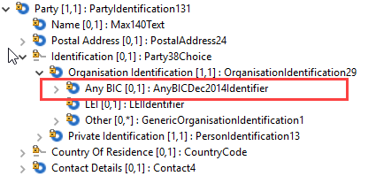
- For the update of the agent identification using the base BranchAndFinancialInstitutionIdentification5 component, the following update is proposed, through the use of the new BranchAndFinancialInstitutionIdentification5
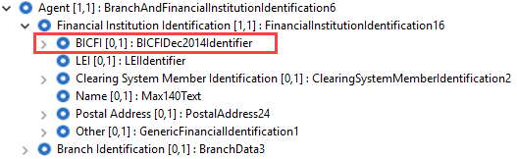
- For the rare cases in the Payments messages, where the above base components are not used, the elements will be updated to use the newly defined data types.
- In attachment, you will find an exhaustive list of the Xpath for all BIC elements which should be updated in the messages.

Proposed timing:
The submitting organisation confirms that it can implement the requested changes in the requested timing, with following considerations:
- For the messages listed in the “Related messages” section, that is, which have been requested by the submitter of any other critical change request in this maintenance change request document, we propose to implement the change in all messages which are part of the impacted message set during this maintenance cycle.
- For all other messages in the message sets only identified through the impact analysis, we propose to implement the change only at the occasion of the next maintenance of the messages, that is, the change will be approved by the SEG for implementation, but does not justify maintenance of the messages in its own right. It will be pending implementation until more critical change requests are received for the messages.
List of message sets in which the change will be implemented during this cycle:
- Bank-to-Customer Cash Management message set
- Payments Clearing and Settlement message set
- Payments Initiation message set
- Creditor Payment Activation Request message set
- Cash Management message set
- Exceptions and Investigations message set
- Notification to Receive message set
- Business Application Header (under the responsibility of the TSG)
List of message sets in which the change will NOT be implemented during this cycle:
- Account Switching message set
- Bank Account Management message set
- Change or Verify Account Identification message set
- Authorities Financial Investigations message set
- Cross-Border Transactions Currency Control Reporting message set
- Notification to Receive message set
- Payments Mandates message set
- Stand-Alone Remittance Advice message set

Timing | - As requested (taking into account the above considerations)

Final decision of the SEG(s):
This section is not to be taken care of by the submitting organisation. It will be completed in due time by the SEG(s) in charge of the related ISO 20022 messages.
Approve
Comments:

Reject
Reason for rejection:

Change request CR00755: Modify OriginalNextAgent cardinality

Origin of the request:
A.1 Submitter:
SWIFT

A.2 Contact person:
Mrs Evelyne Piron – evelyne.piron@swift.com

Related messages:
camt.029 – ResolutionOfInvestigation

Description of the change request:
For the maintenance 2018, a change request was submitted by the EPC for the addition of elements to cater for the Claim Non Receipt process.
Extract from maintenance 2018 Change Request:
“The EPC 2017 SCT Rulebook v1.0 requires that the Request to Modify Payment message (camt.087) and the ResolutionOfInvestigation (camt.029) and the ClaimNonReceipt (camt.027) contain the complete set of information transported in the underlying payment instruction that is being modified.
Additionally, the camt.029 which must confirm or reject the Request to Modify Payment must also transport compensation and charges information which are currently missing.”
The Change request was approved and the required elements were added in the aforementioned messages.
In the camt.029, we had to add the element “ClaimNonReceiptDetails” as shown below:
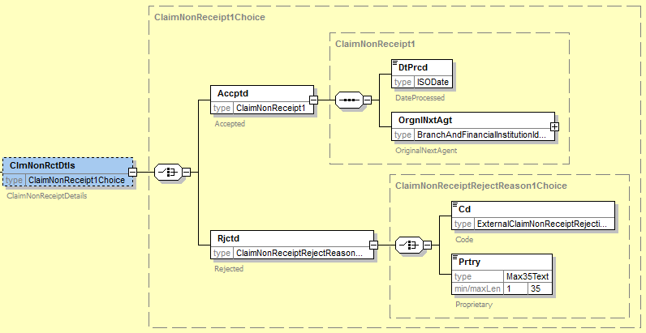
The element OriginalNextAgent has been added as a mandatory element as wrongly indicated in the CR when it should have been added as an optional.

Purpose of the change:
Correction to be done after changes implemented for Payments Maintenance 2017/2018.

Urgency of the request:
It is proposed to include this change request in the next regular maintenance cycle.

Business examples:
N/A

SEG/TSG recommendation:
This section is not to be taken care of by the submitter of the change request. It will be completed in due time by the SEG(s) in charge of the related ISO 20022 messages or the TSG for changes related to the BAH.

Consider |  | X | Timing
 |  |  | - Next yearly cycle: 2018/2019  (the change will be considered for implementation in the yearly maintenance cycle which starts in 2018 and completes with the publication of new message versions in the spring of 2019) |  | X
- At the occasion of the next maintenance of the messages
(the change will be considered for implementation, but does not justify maintenance of the messages in its own right – will be pending until more critical change requests are received for the messages)
- Urgent unscheduled
(the change justifies an urgent implementation outside of the normal yearly cycle)
 |  |  | - Other timing:
Comments:

Reject
Reason for rejection:

Impact analysis and type of impact:
Following the detailed analysis of the impact of the changes to the existing messages, we did not identify further impacted messages. The below list provides the full list of impacted messages:

Messages for which the change was requested:
- Exceptions and Investigations message set
  - ResolutionOfInvestigationV08 (camt.029.001.08)
The severity of the impact of the proposed change for the message users should be indicated in the table below (either “no impact”, “conditional’ or “mandatory”).
Type of impact
 | No impact | The change(s) will not impact the schema (the version number will not change) and will not impact the business applications of any users, e.g. the clarification of a definition
X | Conditional | The change(s) will impact the schema (at least the version number) and the business applications of certain users but not all, e.g. the addition of an optional component
 | Mandatory | The change(s) will impact the schema and the business applications of all users, e.g. addition of a mandatory component.

Proposed implementation:
We support the implementation of the change request, resulting in the following structure:
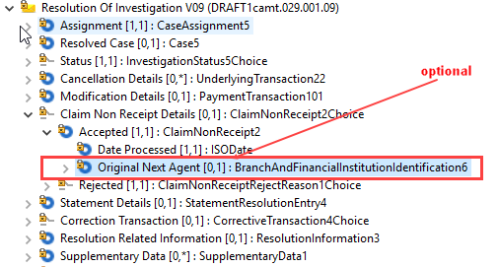

Proposed timing:
The submitting organisation confirms that it can implement the requested changes in the requested timing.

Timing | - As requested

Final decision of the SEG(s):
This section is not to be taken care of by the submitting organisation. It will be completed in due time by the SEG(s) in charge of the related ISO 20022 messages.
Approve
Comments:

Reject
Reason for rejection:

ECB’s Euro Retail Payments Board, see the ERPB statement published in November 2017: (link ERPB Statement, page 3)
Report of the ERPB Working Group on EIPP - November 2017
ECB’s Euro Retail Payments Board, see the ERPB statement published in November 2017: (link ERPB Statement, page 3)
Report of the ERPB Working Group on EIPP - November 2017

